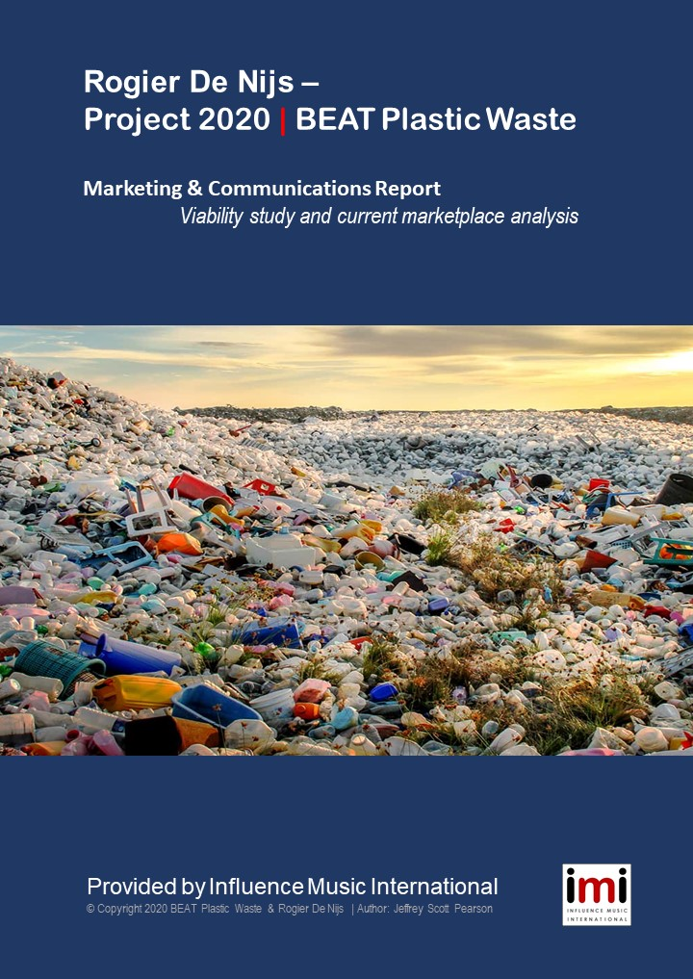

Contents | BEAT Plastic Waste - 2020 & Beyond . Marketing & Communications Plan
.
Page 2 | Table of Contents
Page 3 | Introduction
Page 4 | Biography of Rogier De Nijs
Page 5 | Goals: What is Rogier De Nijs trying to do?
Page 6 | The Big Picture: BEAT Plastic Waste
Page 6 | Primary Objectives: Our Main Goals
Page 7 | Section One – The Music
Page 8 | The Water Creatures
Page 9 | BPW – Soundtrack of the Plastic Age
Page 10 | Musique Plastic Explained
Page 11 | Musique Plastique 2.0 Update
Page 12 | Section Two – The Marketing
Page 13 | Marketing Tools
Page 14 | Essential Digital Marketing Items
Page 14 | Essential Offline & Print Items
Page 15 | Understanding Target Groups
Page 16 | Professional Target Groups
Page 17 | Public Target Groups
Page 20 | Online Media Marketing Goals
Page 21 | Streaming & Airplay Targets
Page 22 | News Making – Getting Media Attention
Page 23 | Section Three – The Money
Page 24 | Merch Table Essentials
Page 26 | Music Performance Essentials
Page 33 | Booking & Management
Page 34 – 40 Premiere Concert Agenda
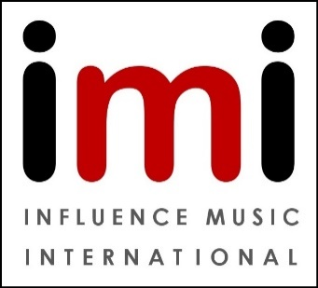

Introduction –

Pollution is harming the planet we live on. Disrespect for our mother earth has already affected our lives in terrible ways; from the Deepwater Horizon, Fukushima and Chernobyl disasters to the ‘burning’ Amazon, the ‘melting’ ice caps and the ‘changing’ climate. With volumes of hard evidence it is now impossible to ignore this global contamination. The impact of this thoughtless human activity can clearly be seen in the dying oceans which cover 70% of the earths’ surface.
Oil spills do permanent damage to ecosystems and sea life. Overfishing, reef destruction, global warming and rising sea levels are all undeniable signs of our environmental mismanagement. The most obvious consequence are the millions of tons of plastic waste, filling garbage dumps and spoiling the landscape. In the ocean, huge islands of rubbish float in the struggling seas and litter our coasts and beaches with waves of trash, chemicals and debris.
But maybe the tide is changing. Recently, a heightened awareness about this garbage nightmare has captured the attention of scientists, politicians and the public at large. Countries all over the earth are beginning to pass laws which enact severe restrictions over the way we treat our oceans. After Greta Thunberg shamed the world about the pollution crisis, a dialogue spanning generations was created and a groundswell of support is rising. Millions of families have taken to the streets protesting the abuse of this planet worldwide. Even here in Holland, young Boyan Slat’s Ocean Cleanup crew is attacking plastic waste head on, putting a big spotlight on this issue like never before.
It was this urgent reality that has inspired Dutch activist/musician Rogier De Nijs to use his passion, his talent and his network of creative professionals to create a stage performance and public awareness program to actually help defeat the floating menace.
BEAT Plastic Waste has become both a catch phrase and a call-to-action to keep these eternal plastics from destroying our seas. With the help of enlightened supporters, dedicated partners and talented performers, Rogier De Nijs has developed a compelling public awareness campaign to help stop the madness.
Rogier De Nijs commissioned this marketing report to explain his various original music products from concept to performance. It also explores how the message of controlling plastic waste shaped both the presentation and the content of these different shows. It also explores how De Nijs is in a unique position to capitalize on the recent publicity about the environment - and why now is the right time to expand and connect incidental projects to a organization with consistent output a and to finally help BEAT Plastic Waste!

Biography –

Rogier De Nijs has been a music maker from the start. He tapped out rhythms on soap boxes as a child, then drummed his way into the high school punk rock band. He then focused on music as a career at conservatory, evolving into a virtuoso performer. Since graduation he has had many years of musical adventures that read like a storybook.
He has pounded out rhythms dangling in mid air as part of a circus troupe in Columbia. He has taken the stage in the cold snow of Norway, and the summer heat of Cyprus. He has played on stilts in Latvia, on the beach in Turkey, in a parade in Den Bosch, in a factory in Tilburg and while floating down a river with The Water Creatures.
In short, Rogier has been constantly evolving - fascinating international audiences with his exciting percussion grooves and passionate performances for more than 20 years.
In concerts, the results can be truly transcendent. Each performance is tailor made for the location whether indoor or outdoor. The show becomes harmonious with their surroundings, through live improvisation, spontaneous movement and personal fan engagement. “Every show is unique,” says De Nijs, “because every location (and audience) is unique.”
This open approach has fostered a wide variety of fruitful collaborations over the years, from jazz musicians and urban rappers to visual artists and even scientists. Through exploring these various collaborations Rogier has made the transition from adventurous freelancer and independent musician, to serious a 'music-maker' motivated by current social issues.
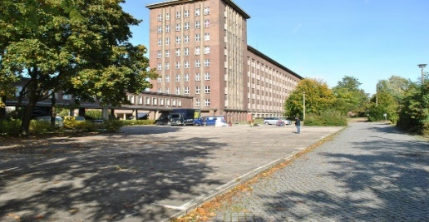
He lives in Brabant part time, but his current workspace is at Funkhaus Berlin, inside the historic GDR radio headquarters building below. Inspired by the cultural freedom of the German capital, Rogier is working on a fresh repertoire and a new stage show this year. He is also gearing up to record a full studio album of original music for release in late 2020 as Rogier De Nijs: BEAT Plastic Waste – Soundtrack of the Plastic Age.

“Every performance is an artistic message” according to De Nijs, “A performance helps me to raise awareness…to bring this problem to the our attention…my music is the most powerful tool at my disposal.”

Goals - What is Rogier De Nijs trying to do?
.
The Mission – 'Music-maker' Rogier De Nijs shares his music to move people and inspire a new understanding of current environmental and social problems. ‘Moving’ has two meanings here. The first is literal, as in joyful dancing and movement, a common reaction to a Rogier De Nijs performance. The second is figurative, as to inspire, to activate and to ‘move’ people to act and resolve this terrible pollution problem.
To achieve this, De Nijs has created ‘BEAT Plastic Waste’, a professional organization based on his vision for the next few years. This marketing overview is our roadmap to the future with lessons from the past. In this plan we acknowledge the time, resources and logistics necessary to create a self sustaining musical company that can perform for nearly anywhere, in any venue, within any decent budget. We have organized these requirements into three main concepts which we explore in detail: The Music, The Message & The Money.
In this first section, The Music, we consider all the musical products the maestro has to offer, and the logistics and resources required to present them. ‘The Water Creatures’ concerts and similar live performances are evaluated and explained. We’ll look into the history, agenda and objectives of the Musique Plastique program, and finish with a discussion about the upcoming recording sessions with the group, which should culminate with the release of a new album in late 2020.
In the next part, The Marketing, we check the marketing and communication means needed to make this project a reality, starting with promotional methods, both online and traditional. Then, we evaluate our visual products as seen on You Tube, Twitter and Instagram; and the six minute ‘Musique Plastique’ documentary film made with Jan van der Ven. The report explains the timeline and labors needed to effectively connect with our fan base, the music press and the public. Finally, we reveal the end game of our promotions with specific target numbers and benchmarks: centered around respecting the movement, supporting Rogier and stopping the plastics.
And finally The Money touches upon the actual economics essential to the success of our mission. This incomplete section should include an examination of the current marketplace, an overview of potential revenue sources (and resources), a look into individual and corporate sponsorships, a discussion of grants and crowdfunding options, an analysis of expenses and liabilities (with refined projections), an outline of short and long term fiscal goals and ending with a set of clear financial objectives to pursue. Let us hope that additional funding can be secured to complete this important conclusion.

The Big Picture: BEAT Plastic Waste
To begin this journey we must know not only where we’re going, but why – so we must agree on our ultimate goals, our ‘primary objectives’. From this point on, all the topics & information presented will be in service to achieving one, some or all of these results listed below:

The Primary Objectives: Our Main Goals.

- Expand brand awareness, fan engagement and promotional opportunities through social networks, broadcast media and a robust online presence. .
- Spread the ideological message about active conservation by scaling up live performances to increase audience reach

- Make more BPW music available for download and purchase, both from contractors (like Amazon, iTunes or CD Baby) and directly from the artist (DIY). .
- Obtain enough private funds, grants or crowdfunding to record an original album in 2020 and release it through professional channels.

- Set up Rogier De Nijs recognizable figure in the eco-cultural landscape, building a reputation as a gifted performer tackling current social issues. .
- Become a financially stable organization by providing solid entertainment choices with environmentally responsible messaging.
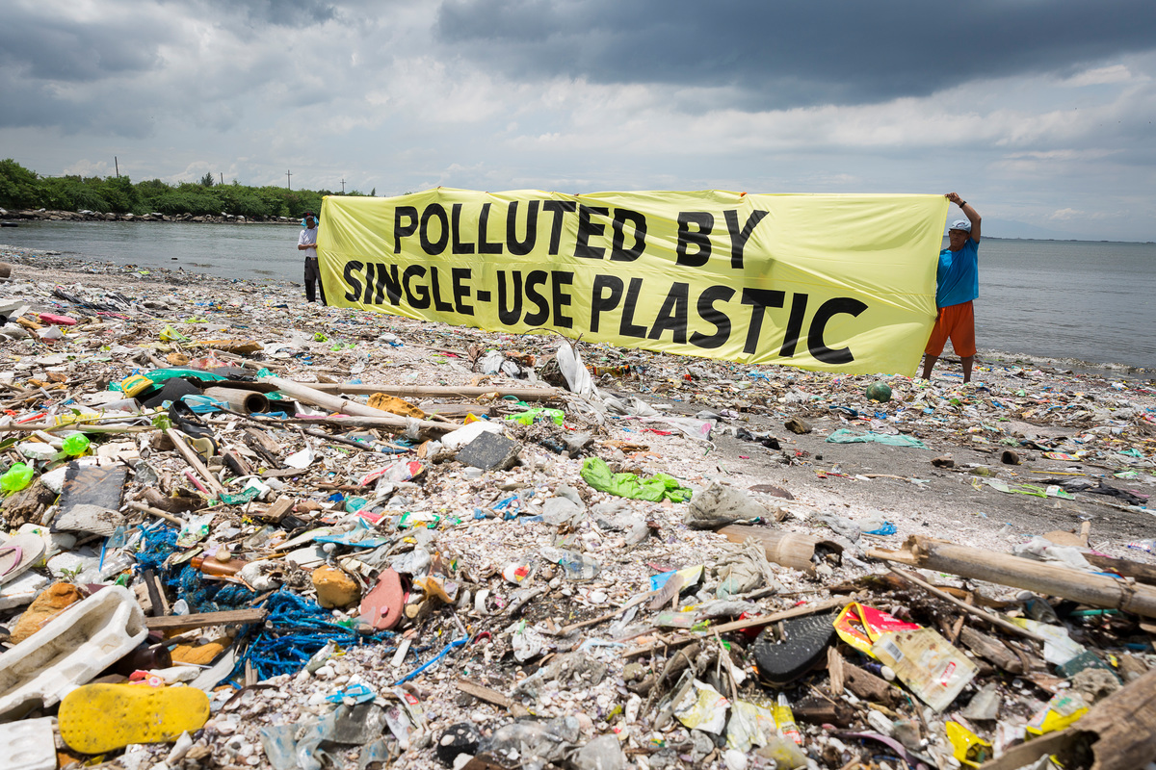

Section One - The Music

It’s hard to describe the music of Rogier De Nijs in words, it’s really an experience. Rogier’s songs are absolutely original, not just because of their composition but because they are played on unique self-made instruments! His drums are not standard equipment but various plastic buckets, water bottles and PVC pipes that De Nijs has collected and adapted to create a surprisingly beautiful tones. These distinctive instruments create an sonic texture that acts as a ‘musical signature’ for the maestro. His concerts transform the music making experience by creating something beautiful from something that seemed to lost it value: Plastic Waste.
With these homemade musical tools, Rogier creates primal yet precise polyrhythms, like those called sacred by tribal cultures worldwide, mainly long form percussion studies. Characteristics of his sound include detailed improvisation on top of a solid, world music groove. In concert, his music pulses with waves of new percussive melodies washing over established rhythmic material in a constantly changing symphony.
The Rogier Effect
The hypnotic ebb and flow of these ancient drum patterns can transform audience members to a higher state of consciousness. The listeners focus on these sacred rhythms and accepts their musical energy as a meditation. This advanced mental state fosters mindfulness, which allows people to be more accepting of new ideas.
When fans enter this relaxed ‘gezellig’ state it becomes the perfect environment where peace and understanding can be experienced - not just discussed. It is at this critical point that Rogier De Nijs hopes to change minds, inspire action and BEAT Plastic Waste!
Music Performance Goals for 2020 and Beyond
This year Rogier intends on further exploring his music through three main projects that will be finished by the end of the year. These include:
- Organizing an aggressive concert schedule for ‘The Water Creatures’ with as many performances as possible during touring season (May-Oct 2020)
- Writing, recording and releasing the first full album recorded with instruments made from plastic waste as artist “Rogier De Nijs”
- Creating an expanded Musique Plastique show with new production elements
.
Let us look at the various musical products Rogier has developed and consider the different challenges and opportunities presented. These are specifically ‘The Water Creatures’, BEAT Plastic Waste and the upcoming “Musique Plastique 2.0.”.

The Water Creatures

Since 2014, Rogier has enjoyed an amazing partnership with Dick Dijkman, Guy Pek, Frank Verhoeven, Sylvan Amoureus, Tim Vermulst, and Sjaak van Dam. Together these activist musicians form ‘The Water Creatures’, a percussion collective best described by the story they tell.
In a post-apocalyptic world swamped with plastic waste, only The Water Creatures have survived. Now they rise from the chaos of the polluted oceans, still covered in filth and entangled plastic debris. Their struggle to survive in their habitat serves as a warning to save our habitat while there is still time. It is a dark lesson about the folly of man and the failure of society to protect us from ourselves . But the show is also a tribute to those who are sacrificing to save the earth now, a story of hope to those who are willing to listen, understand and act with passion.

A ‘Water Creatures’ concert is about making music with plastic waste. Their performance demonstrates that the plastic is not only for recycling, but that you can tell a story with it!
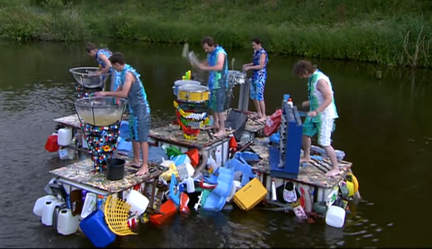
Like the instruments they play, the costumes the band mates wear are all made from plastic waste too. Their outfits were made from discarded grocery bags and if you look closely you may recognize the colors and logos of familiar supermarkets. Their floating stage resembles the plastic soup as well, built from buckets, bottles, household items and fuel cans.

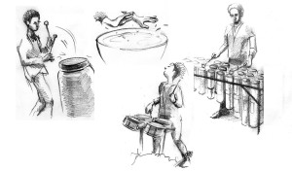
The Water Creatures embrace whatever location they perform in and they can adapt to many surroundings. The musicians transform their live show into a work of performance art that can be enjoyed on many levels, without always needing a traditional venue. Sometimes they actually perform on the water, floating on a raft of trash like those already fouling our oceans.
It is these outdoor shows that seem to have the greatest effect on fans, and each is an absolutely unique experience.

BEAT Plastic Waste - Soundtrack of the Plastic Age

Today geologists speak of a new era - The Plasticine. Freely translated, the Plasticine age is a new geological period in which we find plastic as a 'raw material' in the earth not exactly something to be proud of. As De Nijs said in 2019 “I feel it’s is my job as a musician to do something about this.”

That is why Rogier De Nijs is excited to report he is planning a new recording project for 2020. Once the funding for it can be established, it will be the first album especially written for and performed on instruments made from plastic waste.

“Since the premiere of my show ‘Water Creatures: Floating in the Plastic Soup’
in 2015, I have been making music with plastic waste. I use music to draw attention
to the issue of plastic pollution in a special way. Because I don't want to conform to
the disposable society in which we now live, my goal is to prove that I can make an album of contemporary music with something that has lost it’s value, plastic waste.
It is a statement against our disposable culture, an album as a soundtrack of our
era, the 'Plasticine'.”

The album, BEAT Plastic Waste: Soundtrack of the Plastic Age, is a personal mix of eclectic influences including pop, classical, jazz and world music. It’s his musical commentary on a major social problem; the huge amount of plastic waste that is ruining the earth. To fund this recording, Rogier is starting a crowd funding campaign on 27th of January, 2020. He spoke about it recently…

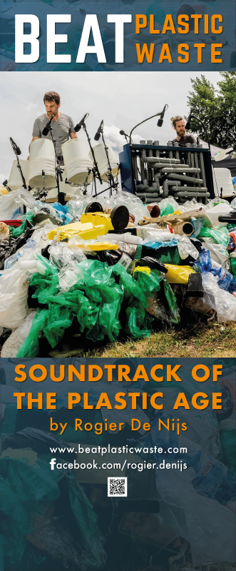
“I will record a full-length album with musical instruments that I have made from plastic waste. The compositions recorded for the album are a mix of organic beats, beautiful atmospheric impressions and raw, energetic performances. The album will be recorded with the help of professional musicians & technicians, resulting in an authentic album of the highest quality. The album will be digitally released worldwide, as well as on vinyl and compact disc.”

The crowdfunding campaign for the album goes online on the 27th of January, 2020. First, the campaign will focus on Rogier’s inner circle and his network in Germany, mainly in Berlin. Then it moves to the Netherlands. When combined with other income, sponsorships and grant money, the album project could be created, recorded and released by the end of the year.

Musique Plastique Explained

With the Musique Plastique program, music maker Rogier De Nijs draws attention to one of the greatest threats to our environment: plastic pollution. Developed in 2018, the production is environmentally themed and has several different elements that can be tailor made to fit the setting and crowd at each venue. These four elements are an original film screening, a live music concert event, a revealing presentation and an important audience dialogue.
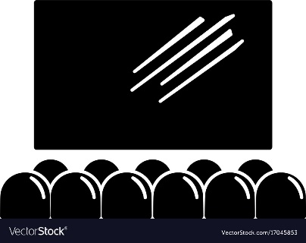
The film, co-produced with Jan van der Ven, shows Rogier at work in an old Tilburg factory building creating beautiful music from plastic waste. In it, he discusses his vision of the plastic waste crisis and the future. Filmed surrounded by abandoned industrial elements, the link to our disposable society is clear. The huge space also influences the scope, the timbre and even the sounds made from his unique drums and devices.
During the live performance, Rogier seeks to take his audience on a musical trip. He experiments with different kinds of discarded objects as instruments - played with mallets, sticks, tubes and even bare hands. With dynamic tunes like ‘Boiling the Soup’ and ‘I Feel Plastic’ the maestro tells his story with energy and passion. Other songs invite audience interaction to help focus the experience for the listener.
There is also a revealing presentation when the maestro narrates a short slide show that combines his artistic motivation with his hard earned knowledge of ecology and conservation. Rogier speaks of “reappreciating” discarded plastic waste with a new life through new methods. He reveals the inspiration behind using his special music as a communication device to highlight important social issues.
Finally there is his audience dialogue, a discussion of the hard choices and practical changes required to solve this crisis. Part fact-finding mission and part lively debate, this informative public discourse unveils his message of personal responsibility and local solutions. ..

Musique Plastique 2.0 Update
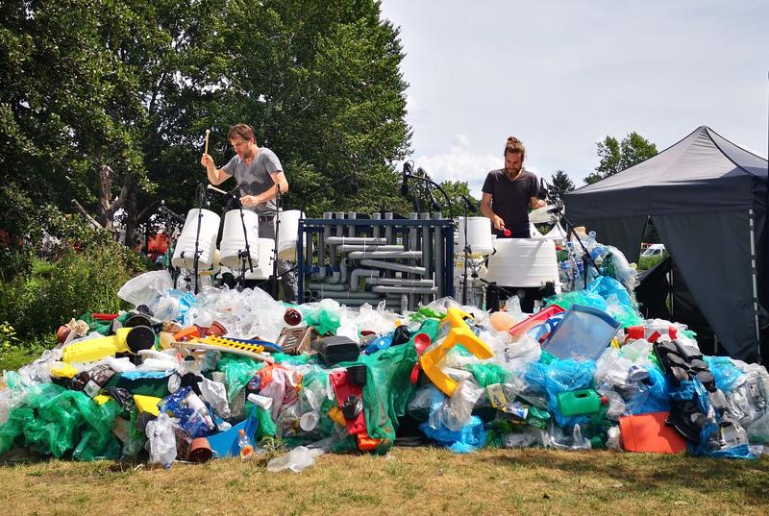
In 2019, the Musique Plastique program was presented publically after the release of a related EP and short documentary film. Parts of the program, like the presentation and audience dialog will be naturally updated every once in a while. However for the live performance Rogier plans to develop this idea into a full length performance for 2021 and beyond. The current working title is ‘Musique Plastique 2.0’.
His motivation is to create a more intimate show suitable for midsize theaters and larger festivals. Recording sessions with The Water Creatures members, now scheduled for the fall of 2020, will be key in this development. The Musique Plastique 2.0 show will include several songs from the album that were composed with the new show in mind.
2020 Performance Sales Targets – Rogier De Nijs

– Go from 10 shows per year to 20 shows per year; / (10 for Water Creatures, 10 for Musique Plastique)
– 5 of these shows should be in the German market exclusively
– Physical sales of new album from Merch table: >200 Online:>150
– Extend network of patrons and organizers from 50 to 200 in 2020

Summary: The Music Section

This next year will certainly be an important one for the music of Rogier De Nijs; but with the proper support and funding our goals are concrete, realistic and measurable. The trio of 1) more performances, 2) new recordings and 3) a new stage show will increase the marketability and scalability of the De Nijs product across the board.
Next we look at the marketing efforts required to ensure our success, and the timeline, resources and action items needed to make BEAT Plastic Waste a reality!

Section Two – The Marketing

There is a new marketing and communications plan for 2020 and beyond. The composer and his partners have created this sustainable plan to ensure maximum visibility and brand awareness for BEAT Plastic Waste and Rogier De Nijs. The end game here is still to address our primary goals: to expand awareness, broaden his audience, release more music, create new music, become a financially stable organization and help Rogier save the planet of course!

Brand Image

The core of our marketing strategy focuses is on the distinctive qualities of Rogier De Nijs as a spokesman for movement against plastic waste. The composer uses his concerts as a means of building trust with the audience through a shared positive experience, his music. The people feel connected, relaxed and open minded.
He enhances that relationship by addressing the audience in an honest and personal way as he performs. In person, his passion is obvious due to his natural energy and charisma. Connections are often made after the concert finale by bumping into fans after the show. By ‘working’ the crowd Rogier becomes an ambassador against this pollution.
Through musical performances the ambassador seeks to inspire people by sharing in the urgency of the crisis and explaining the consequences. Often his efforts are rewarded with personal philanthropy, partnerships, and responsibility through action. The public will get to know De Nijs as an emissary of the plastic waste issue and Rogier’s name, face, logo and music should become synonymous with the BEAT Plastic Waste movement.
This elevated status is essential for building a public persona that is respected, trusted and even loved. Revealing Rogier as a mild mannered environmental ‘rock star’ is central to our public relations campaign. A consistent image among all the marketing elements is key to our success so each move must be considered in this context.
This public image must be communicated in the right way and at the right moment to be effective. Much of his performance can be captured on video and posted online (websites, social media, podcasts, newsletter), or shared with pictures in printed material (business cards, flyers, company brochures) or online. But it is important that we push fans to the live show, to attend performances. YouTube videos, live recordings and published articles are just tools to increase our audience, not the primary goal itself.

Marketing Tools –

Advertising methods and means have evolved quickly in the music and entertainment industry. Many of our best marketing tools are new and technically sophisticated, and there are endless innovations that require our constant attention and understanding to be effective. This section offers a brief overview of the most important elements.
Overall, the watchword for our promotions should be credibility and consistency. All public announcements should come directly from the artist and his team - not bookers, venues or a clichéd public relations campaign. It is also important to establish a clear messaging path; a procedure in place that encourages good communication with all the members of the team. This could be as simple as requiring group emails to as complex as a dedicated online calendar, Google Docs instrument or an exclusive Excel matrix.

Marketing Strategy Overview

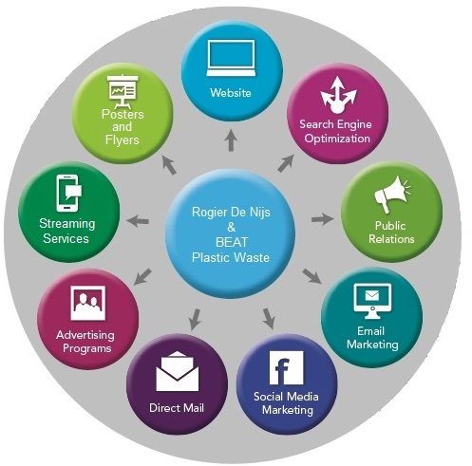
Our marketing plan revolves around a central strategy that promotes Rogier De Nijs as a figurehead and authority. Each approach has a position that serves that purpose for our primary objectives.

Our Main Marketing Toolkit:

- Primary Website
[www.BEATPlasticWaste.com]
- Search Engine Optimization
- Public Relations
- Email Marketing
- Social Media Marketing
- Direct Mail
- Advertising Programs
- Streaming Services
- Posters and Flyers

While it is beyond the scope of this report to explain the details of each of these options, certain techniques must be customized and developed to be effective as a campaign. Below is a list of essential media that needs our attention.

Essential Digital Marketing Items -

Cyber Newsletter - As mentioned before, a bimonthly e-newsletter written in both Dutch & German. Responsibility for these regular releases needs to be assigned to a team member or an intern as soon as possible.
Electronic Press Kit (EPK) - An updated and compelling EPK (Electronic Press Kit) is essential so we can provide venues, press and organizers the tools they need to promote the shows. A full description of a pro EPK is listed in the marketing section
Update the Video - The old video trailer for ‘The Water Creatures’ needs updating and a repost on YouTube. It is vital Rogier De Nijs name be associated with the re-release.
Update our Website - We must revamp our website and make navigation intuitive. Sections for a blog, news, the tour schedule, ticket schemes, artist info, email lists, media links and the EPK should all be included and explained clearly online. A separate online merchandise shop will be added by summer 2020.
Maximize our SEO – We must optimize the search engine feature by reworked keywords, metatags and updates. Feature the new functionalities like ticketing or merchandise through rescripting frameworks and streamlining processes.
Maximize our Social Networking - Obtain more followers through regular postings, some scheduled updates, sponsored ads and cross promotion. Work with partners to share stories, links and information. This may require a dedicated person like an intern or contractor as it will require attention on a weekly basis.
BTS Media - “Behind the Scenes” media refers to the creation of short, low production value snippets of Rogier’s activities for social media. This includes travel, recording sessions, set-up videos, blog and vlog style diary entries and candid mobile phone pictures. The key here is to seem engaged, busy and creative in an organic way.

Other Offline & Print Promotional Ideas -

- Show off your flyers & posters made from recycled paper & ‘green’ printing inks - Design one flyer in several languages; it’s both practical & ‘international’ looking - Create ‘customizable’ posters (with open space) of standard sizes (A2, A3, A4) - Design and create several tall vinyl promotional banners with BPW info - Design and print 500 professional 2 sided business cards on recycled paper - Expand our networking by arranging for fan meet-ups before performances or while visiting relevant congresses, conferences, fairs and festivals.

Understanding Our Target Groups -

So far in practice Rogier focuses mostly on a known group of fans interested in the BPW brand. These include industry professionals, music connoisseurs, culture makers and socially aware people. They have an affinity for the efforts of Rogier De Nijs and often work in similar creative industries.
This core group is looking for an experience in which knowledge and art go hand in hand. They expect an exciting program where they can gain inspiration from new ideas and leave surprised. They are relevant, involved and loyal fans that choose quality over quantity. Both the performances and the underlying message must appeal to this loyal visitor group.
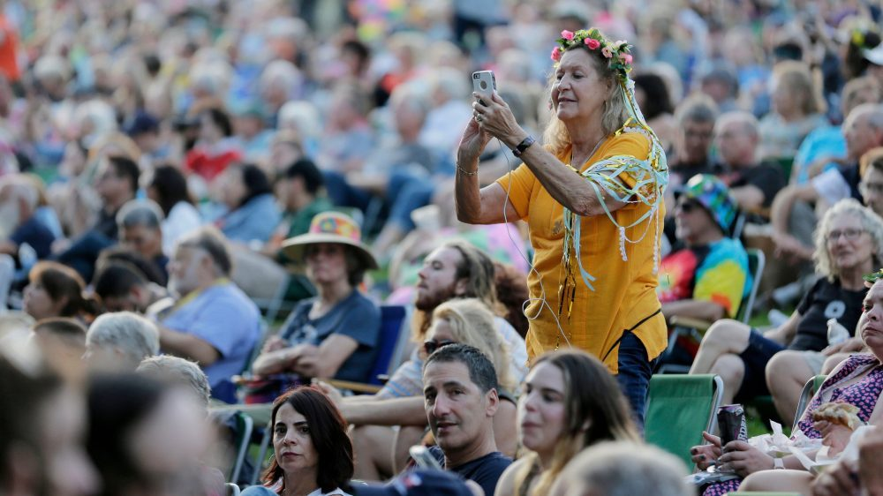

But to be sustainable, the show must appeal to a wider audience of socially involved citizens, concert lovers and environmental activists, young and old. Courting these fans provides the opportunity to reach even more target groups beyond this small cluster.

Who Are Our Target Groups?
Many questions must be addressed about the market for Rogier De Nijs and his products. In this section we answer the following:
- Who are the main fans and their sub groups, with a description of each
- Where can these people be found, both online and in organizations
- How we reach them, and with what tools (both online and off)
- Why we reach out to them and how they help our cause.
In short, there are two main groups: Professional Contacts and Public Contacts
Professional Contacts:
Programmers/Organizers/Mediators (Music & Art) Programmers/Organizers/Mediators (Others) Press & Media Business Network Rogier Potential Corporate Partners and Potential Social Partners, Government & Governmental Institutions, NGOs (Non-Governmental Organizations) Commerce/Industry Friends & Family of Rogier De Nijs Fans/Followers of Rogier De Nijs, the Water Creatures or his music Concert Fans & Festival Attendees Digital Music Lovers Record Store Staff, Customers & Record Collectors

Public Contacts:
Socially Responsible Citizens and Environmental Activists Social Media Contacts Rogier’s Colleagues Teachers and Students

Rogier has detailed record of names and personal data formatted as an Excel sheet with easy email implementation to send to select persons or groups. This accurate list is vital for Rogier's music business network and should be updated consistently as mentioned before.
In the matrix below, target groups are divided under professional and public, with: Description (what), Reach (how), Means (tools).

Professional Target Groups -

Programmers/Organizers/Mediators (music and art focus)
Description: | Stage, festivals & club programmers. Performance artists /street theaters.
Reach: | Offline: at festivals, showcases etc. Online: on Linkedin, Google
Means: | Through connections, via direct mail, social media updates, website, registrations.
Programmers/Organizers/Mediators (all other situations)
Description: | Organizers of events, congresses & conferences about sustainability, energy transition, climate, science, politics etc.
Reach: | Offline: at congresses. Online: on Linkedin, Google
Means: | Through a connection, phone calls, direct email, social media updates & website

Press & Media
Description: | Music press and media with social themes (climate & environment) (newspapers, trade journals, eco newspaper, specialty magazines,) online and offline also radio / TV / podcasts
Reach: | At press conferences, personal interviews and their workplace
Means: | Via phone calls, direct email ( → example; 'Template Press Release')
Other Interested Parties
Description: | – Rogier’s Business Network  – (Potential) Corporate Partners & (Potential) Social Partners – Funders, patrons & subsidizers – Government Institutions – national / state / provincial / municipality  – NGOs: nature & environment organizations, social organizations, etc.  – Commerce/Industry: waste processors, plastic makers, soft drinks industry
Reach: | Offline: at their workplace & meetings | Online: Linkedin & Direct Email
Means: | Through a personal connection, targeted phone call, direct mail, active social media fans, followers on Spotify, Soundcloud, YouTube etc.

Public Target Groups -

Friends & Family of Rogier De Nijs
Description: | Friends, family and associates of Rogier De Nijs
Reach: | Through personal contact, face to face, direct personal emails
Means: | Word of mouth, phone calls, direct email, flyers, social media
Fans of the Water Creatures, Rogier De Nijs and his music
Description: | Small socially aware group, moving in a small circuit, not very active online
Reach: | Via live moments & connected to online media following Rogier and his projects. Using active updates thru his own media, and during public moments
Means: | Word of mouth, unique flyers, posters, banners, social media platforms
Concert Fans / Festival Attendees
Description: | Festivalgoers, new fans and casual passers-by who seek information after being affected by Rogier's message, his presentation or a live performance.
Reach: | Via online & offline media that follow Rogier and his projects, active updates on social media, music & festival platforms, public live concert pleas
Means: | Via traditional methods as; merch table, email list, small flyers, business cards, promo posters, stage banners and online/offline press releases
Digital Music Lovers / Streaming Followers
Description: | This is a small group who found Rogier’s music via streaming platforms such as Deezer, Tidal, Pandora, Spotify, Amazon & Apple Music. Also iTunes purchases.
Reach: | All BPW promotions should mention the top participating streaming platforms with hotlinks or at least a logo.
Means: | Inclusion in ‘Play Lists’, urge ‘following’ Rogier De Nijs, make mention in social media posts, online forums and press releases.

Specific Music Lovers
Description: | Music lovers of specific genres of music like ‘rare grooves’, Steve Riech, Max Roach, Varèse & music from STOMP!, ‘DrumStruck’ & The Blue Man Group
Reach: | Specific festivals like Tromp or Glamorgan & TV shows like Vrije Geluiden
Means: | Press mailings to select magazines (offline) & press coverage  Online: Posting on special social media groups: Vinyl Diggers, New Music etc.
.
Record Store Customers & Staff
Description: | Record store scene. Customers, DJs, producers, record collectors and staff
Reach: | At record/CD stores, 2nd hand record markets, through specific magazines  via online music sites that Rogier and his projects follow, through active updates on social media, music platforms and the local bulletin board.
Means: | Via in store unique flyers, cool posters and face to face. Charming the staff with ‘bling’, free tickets and special merch, not a bad idea –connected people talk!
Socially Responsible Citizens and Environmental Activists
Description: | Socially Responsible Citizens and Environmental Activists
Reach: | At demonstrations, sustainablity events, specific social media groups with environment themes and eco-bloggers. Check universities, on/offline magazines like National Geographic, ClimateWire and SustainEurope. Regional newspapers like Volkskrant, Groene Amsterdammer, Het Parool etc.
Means: | Via flyers & posters, word of mouth, “meet on the street”, flyers at “green” businesses and employers, through flyers and visits to environmental/outdoor clubs, hiking gear stores & protest rallies. Selected ecology blogs & websites

Social Media Contacts
Description: | All connections to this media savvy group are online, not geographically limited. These fans ‘found’ us online, sometimes linked, sometimes luck.
Reach: | Exclusively online through Facebook, Instagram, Twitter and YouTube
Means: | Personal online responses to posts, active updates on socal media

Online Media Marketing Goals –

The matrix above shows that more than 75% of our contacts to our target audience will be through the website, email and social media. Therefore we must briefly look at the major social media platforms and determine our path. It is important to set goals for these efforts that are scalable and measurable. The main online media we use are:
- Facebook – Social networking website with user interaction & comment
- Instagram – Free, photo-sharing app/social network platform owned by Facebook
- Linked-In – Profile based business and professional networking platform
- Twitter – Social microblogging service allows fans to post short notes called tweets.
The BeatPlasticWaste website, while not a social platform, is still vital to effective communication with patrons online and are part of the promotion process
Direct Email is used for our DE/NL bimonthly e-newsletter and focused dialogue
YouTube, Vevo & other video services have a social media aspect as well, for example you can share, post comments & subscribe to artist channels like Twitter
Streaming Services – Spotify, Deezer, Tidal and other streamers have an online social component as well; like shared playlists, comments and ‘followers’

Social Network Targets:
Efforts to increase the audience numbers of these platforms are important to spreading our message about Rogier and BPW. In light of this, the following social networking goals have been established as realistic and achievable.
- 1000 Facebook followers by the end of 2020
- 500 Instagram followers by the end of 2020
Redacted
by client
for privacy
- 300 Twitter followers by the end of 2020
- 225 Linked In followers by the end of 2020
- 2,500 BPW Website visitors by June 2020, and 5000 by January 2020
- 500 Direct Mail Newsletter readers by the end of 2020from a mailing list of 100
(300 newsletter readers in the Dutch market: the Netherlands & Vlaanderen)
(200 newsletter readers in the German market: Germany, Switzerland, Austria)
- 5000 YouTube views of the new, revised video - within 3 months of posting.

Streaming & Airplay Targets:
The following radio airplay and streaming numbers reflect a sample range for an unpromoted single release in NL of an English language vocal track: “Beat Plastic Waste” in the middle of the fourth quarter (Mid-November 2020)

Satellite & Terrestrial Radio Services

- 2,500 Sirius XM Satellite Radio plays by the end of 2021
Redacted
by client
for privacy
- 100 Dutch Terrestrial Radio airplays by the end of 2020 - 500 Dutch Terrestrial Radio airplays by the end of 2021
- 100 Dutch Online Radio webplays by the end of 2020 - 1500 Dutch Online Radio webplays by the end of 2021 [ [Includes Q Music, Veronica, NPO Radio, Radio 538, SkyRadio etc.]

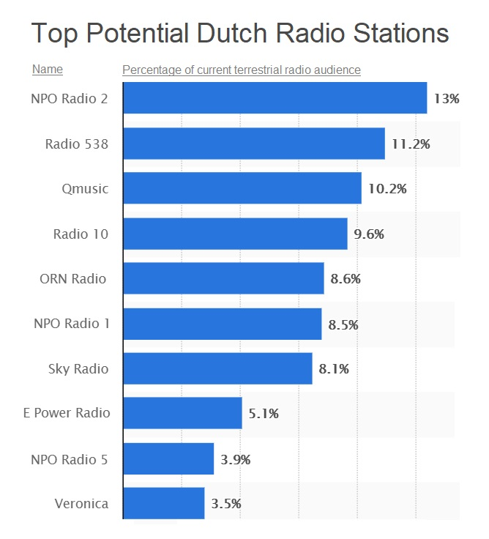
Online & Music Streaming Services

- 3000 Spotify streams by the end of 2020 - 9000 Spotify streams by the end of 2021
- 800 Spotify followers by the end of 2020 - 4000 Spotify followers by the end of 2021
Redacted
by client
for privacy
- 2500 Deezer streams by the end of 2020 - 8000 Deezer streams by the end of 2021
- 250 Deezer fan adds by the end of 2020 - 800 Deezer fan adds by the end of 2021
- 300 Twitter listens by the end of 2020 - 2000 Twitter listens by the end of 2021
- 500 Direct Mail Newsletter readers
(300 newsletter readers in the Dutch market: the Netherlands & Vlaanderen)
(200 newsletter readers in the German market: Germany, Switzerland, Austria)
- 5000 YouTube views of the new, revised video, within 3 months of posting.
These targets are samples only; a fully realized business plan would be required to more accurately reflect the actual numbers. Statistical variations and collection procedures might also affect precise and measurable projections.

News Making – Getting Media Attention
Given the social importance and urgency of Rogier De Nijs' work, ‘making news’ is good. Journalists are eager to report on urgent issues like climate change, pollution and the environment. Our team should provide regional news outlets with stories that will serve both their readership and the Beat Plastic Waste cause.
For example, we will send the local press photos and news copy that paints Rogier as a guide to conservation, an eco-cowboy that is coming into town to perform, inform and change behavior. A great relationship with the local music press is vital and partnerships could develop as well.
(Possible media partners include De Groene Amsterdammer, NRC, De Volkskrant and Vrij Nederland, but also VPRO Magazine and De Correspondent. Regional Newspapers like Brabants Dagblad also.)

Media Preparation
The following ideas should be considered for a successful press media experience.
- Arrange for a major interview with Rogier De Nijs in a glossy magazine or national newspaper about your new project. (eg Music Maker, Zuiderlucht, Volkskrant)

- Organize TV appearances, news and radio shows. Synchronize these stories with gigs, events and music releases.

- Create an amazing new set of promotional photographs and short video clips are essential for local news clips. Pictures should be generic enough to be used for many purposes, so avoid dates, landmarks or specific signage that reveals distracting details. Most should already be in the 2020 BPW/EPK.

- Set up a digital newsletter in two languages, NL & DE with the latest BPW news, links, blogs and social media updates. Send out the latest edition via email blast every two months to aforesaid target audiences.

- Create a mail template for business contacts. Keep in mind Rogier De Nijs ‘personal’ approach, he is face of the organization, so this is essential.

- Strategic messaging through the purchase of online advertising via Google & Facebook Ad’s / AdWords / Google Banners etc. with the goal of more online visibility for the aforementioned target audiences.

- Prepare and contact a list of partners, media, press and platforms that will benefit from our promotions.

Section Three – The Money
Rogier De Nijs, The Water Creatures and the Beat Plastic Waste team have set financial independence as one of their most important goals. Like all enterprises, upfront funding and costs must be accounted against profits to be sustainable. This section explores revenue and sources, as well as projections of future income.
Income Sources

- Merch Booth Sales – Mostly wearable, recyclable and creative souvenirs
- Website Sales – Internet purchases of our creative ‘green’ promotional items
- Sample Library – Sales of ‘sample packs’ and the BPW virtual instruments
- Live Event Sales – Ticket sales, workshop & performance fees, both off/online
- Synchronization – Royalties, commercial usage, TV / film fees
- Music Recording Sales – CDs/vinyl/USB at gigs & retail stores; also downloads
- Streaming Income – Monies from Spotify, Deezer, YouTube, Tidal etc.
- Sponsorships – Government, corporate grants, donations, crowdfunding etc.
- Sheet Music – Academic versions of Rogier’s complex percussion arrangements

Next, we break down these funding sources, analyze revenues and make projections.

1. Merch Booth Sales – Fans will buy merchandise to support a cause or purchase a keepsake. How can a band know how much income to expect from this source?
Unfortunately, this is income is impossible to predict very accurately. Research has shown that many factors affect sales and while some are obvious, others are not. For example, a study by LiveNation showed the distance of the merch table to the stage was an important factor, as was the number of items offered. More obvious factors include crowd and venue size, quality of the merch, the genre of music and pricing. Less obvious factors include the time of day, queue length, signage and ticket price.
Forecast – The percentage of fans buying merch on site averages to about 5% (+/- 2pts) and the average amount spent on these souvenirs in 2018 was about €xx per person. Assuming the data is correct we can make the following projections:
Audience / Buyers | Revenue  Redacted  by client  for privacy | Cost (25%) | Profit
200 fans / 10 buyers | €110 | €27 | €83
400 fans / 20 buyers | €220 | €55 | €165
800 fans / 40 buyers | €440 | €110 | €330
1600 fans / 80 buyers | €880 | €220 | €660
If an average performance has xxx attendees, the range of profit from the merch table can be estimated at between €xxx €xxx per show. Bands can double these numbers with excellent creative designs, good signage and well organized show promotions. Below are more best practices for point-of-purchase concert sales.

Merch Table Essentials -

Guests, patrons and music fans expect there to be keepsakes and info about their concert experience easily available at every gig. The ‘merch table’ should become an perfect island of sanity for newly converted fans.

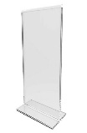
Design & print a table skirt - The appearance of the merchandise stand is important, it should reflect effort and class. This would include a table skirt banner, ideally customized with colors and logo consistent with your branding.

Buy 2 clear plastic table stand ups – Set up two Lucite table stand ups where we can post timely information in an elegant way. These things are cheap, sturdy and useful. Great for announcing show times, local connections and contact info. A

Design & order cool business cards – It’s ‘old school’ but creative business cards are still an effective communication device. Cards are rarely thrown away, so they serve as a constant tiny advertisement. Small and inexpensive, use recycled card stock and eco-friendly inks and help save the planet too.
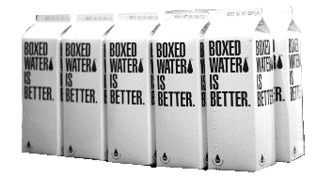
Consider boxed water as a sale item – At outdoor gigs, having cool water for sale is great for hot fans and makes money. Boxed water is a natural fit and they can custom print anything you want on the packages. Buy in volume for more profit.
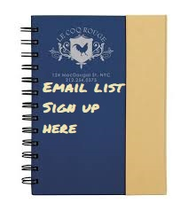
Provide a notebook for emails – A sturdy notebook with open pages should be used to invite fans to provide us their email address. Even though an iPad or laptop would be more efficient, use the binder to demonstrate popularity. People like joining respected organizations and a notebook with hundreds of contacts illustrates this nicely. It also allows people to sign up while the staff is busy or if the booth is unmanned. It would be best to find one made of recycled natural materials

Sell unusual stuff – Another way to increase sales is to offer super unique items that would be hard to find anywhere else. Artistic items like jewelry, original art or craftworks are great. These recycled umbrellas are another example.

2. Website Sales – Some fans, internet surfers and supporters will buy merchandise, music and tickets from a band website, so a successful artist must have a strong online presence.
The first issue should be choosing what to sell, a question best asked of the fans themselves. Ask them through social media, emails and direct engagement what they want.
Here is a list of possible products: Wearables | Stickers | Baby Items | Phone Cases w/logo | Recycled Drum Sticks | Signed Albums | Signed Posters | Handwritten Lyrics | Music Lessons | Percussion Sheet Music | Fan Club Membership | Custom Voice Mail | Ringtones | Buttons | Patches | Recycled Umbrellas | EcoPens | Signed CDs
After selecting what to offer on the site, the ‘store’ concept must be electronically integrated into your website by an IT professional. Be sure sales will justify this expense, a new band probably shouldn’t spend a thousand euro setting up an online store that will sell nine items a year.
To maximize profits, host your own ticket sales, music downloads and merchandise if possible; rather than using an aggregator like iTunes, Google Music or Amazon. The website should have clear illustrations and descriptions of each item. Prices should be carefully considered to take into account shipping and packaging costs while achieving the highest profit possible.
The goal for any website is to get a lot of visitors. Some guests consume media (YouTube, Vevo etc) while other guests provide media (Facebook, Twitter etc.) Consumers outnumber providers 10 to 1, so we want to target that group for online purchases.
Forecast – Projections of band website income are nearly impossible because of the number of variables involved. Therefore we work backwards and deduct what the numbers should be.
Web Visits /Buyers | Revenue | - 25% Costs | Profit
200 visitors / 5 buyers | €125 | €30 | €95
400 visitors / 10 buyers | €250 | €63 | €187
800 visitors / 20 buyers | €500 | €125 | €350
1600 visitors / 40 buyers | €1000 | €220 | €660
Online, a thousand unique visitors a month is considered a successful band website. On average, xxx % of your web fans will actually buy something. The average amount spent on an online purchase is slightly over $xx (€ xx euro). The chart below shows the situation
Projected income based on number of monthly website visitors

Redacted
by client
for privacy

.

3. SSample Pack Sales – Rogier De Nijs and the Water Creatures play almost three dozen handmade instruments during a performance. These instruments have a unique sound that is appealing to other composers and musicians worldwide. Passive income can be made by “sampling” these sounds for playback on a keyboard or electronic drum pad. Several similar performers like The Blue Man Group and Rush drummer Neil Peart have made collections of their drums available to create virtual instruments for sale as musical software. Large European companies like Spectrasonics, Native Instruments, and Spinnin’ Records in Hilversum have made good profits by distributing these digital assets online.
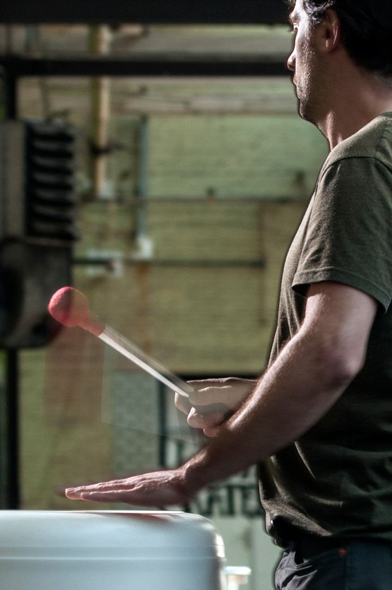
It is very likely some profit could be made by sampling Rogier’s original sonic inventions as a collection and selling them over the internet as a ‘sample pack’. These virtual instruments could be a slow but consistent source of income, especially as his popularity increases. The fact that his sounds cannot be duplicated is a truly unique selling point in this industry – fresh sample packs are highly sought after by famous producers and artists looking for that ‘cutting edge vibe’ in their productions
Sampling Statistics | Time and Set Up Cost | Software Sale Price | Number to sell for ROI | Projected Sales | Projected Sales Profits
1 Virtual Instrument 88 keys/3 layers | €600 . 2 months  Redacted  by client  for privacy | €30 . €50 | ..20 units …12 units | 300 units 1150 units | €8,400 ...€3,900
5 VR Instruments 88 keys/3 layers | €2500 . 3 months | €100 . .. €200 | .. 25 units …13 units | 200 units 1100 units | €17,500 ...€17,500
10 VR Instruments 88 keys/3 layers | €4000 . 4 months | €250 . .. €350 | .. 16 units …12 units | 150 units 1100 units | €37,500 ...€31,000
Of course this endeavor would require some investment not only of money but time (recording, editing) expertise (formatting, programming) and marketing (product design, distribution) to succeed, but the end profit has the potential to be substantial.

Forecast – Let’s look at the viability of virtual instruments as a profitable item. First, let’s define terms. Sampling statistics refers to a 3 layered (soft, med, hard) instrument with a full keyboard. Time and set up cost is the amount paid to the developer to format & create the software. Number to sell for ROI is the number of units that must be sold to break-even. Each package lists two price points and a cautious guess as to real world online sales.

4. Live Events Sales – As a performing artist, Rogier De Nijs depends on concert fees and/or ticket sales for his livelihood. Currently he offers three main programs which feature live performance.

- The “Water Creatures” in concert – This 45-60 minute stage show is an ensemble performance of the percussion music of Rogier De Nijs. Depending on location variables a adequate PA will be required. 'Plastic Soup on Stage'

- “Floating in the Plastic Soup” – This program combines a Water Creatures concert with entire Musique Plastique concept, performed floating on a plastic raft on a river or lake after a film & discussion. Extra staff and set-up included

- The “Musique Plastique” Show – This four part presentation may require a sound system and a video beamer. The program may include an opening dialogue, a musical performance, a special film and an interactive audience discussion. Musique Plastique fee: Duo/with technician €1000 or solo/without technician

This financials section has been reDacted at the request of the client

Live Music Performance Essentials –

The following is a list of plans, items and procedures that will need to be in place before major touring or performances can recommence.

Sound System – A small, portable sound system is an essential resource for the BPW team. A battery powered option with at least two inputs for a mic & a source is ideal.

Beamer –A high intensity beamer should be purchased for the new Musique Plastique show. A battery powered option would be optimal. Link.

Introduction – Script, record and produce a one-minute recorded introduction about the ‘The Water Creatures’ story in a least 3 languages. Have it ready online or on CD

Crowd Plan – Script and organize audience participation with clear goals, realistic expectations and a basic agenda. Sort out the materials, time and manpower needed to carry out the plan. Consider games with prizes, singalongs, call & response, drum circles and dancing flash mobs.

Cyber Sharing – Several mobile apps allow audiences with cell phones to reply to questions, quizzes and surveys instantly through their device. Results can be displayed for the sake of discussion, information and deepening crowd engagement. There is a need to research these applications or perhaps even design our own!

Workshops – Giving a workshop before the show works on so many levels it should be attempted often. It can be an income source depending on the scale and venue. Small groups also give Rogier the opportunity to connect deeply with participants, therefore increasing influence and credibility. Kids are engaged by building instruments from plastic waste and then playing them in a drum circle. These extra VIP meet ups need to be planned and required materials sorted ahead of time at each gig.

Internships – The ambitious agenda BPW has planned needs a team to succeed, so the help on an intern or two could be dramatic. We will contact schools, eco-organizations and clubs about getting some extra manpower to perform vital but routine tasks – too many to mention here. Be aware some training and supervision will be required to fully utilize our volunteers, and we should factor in those extra resources.

5. Synchronization Income – In a world which produces thousands of films and videos every month, synchronization income ( or ‘sync’ ) has become serious business. Broadly defined, sync is the underscore or theme music used in almost every television program and film. In the last ten years, providing soundtracks for dramas, comedies, documentaries and reality shows has become a highly sought after income source for composers, songwriters and recording artists.
Influence Music International sees sync as another passive income source. To secure this revenue, the new BPW album planned for 2020 must become a reality. After the CD has been recorded, the music within must be ‘published’ by an aggregator, record label, distributor or music publisher. Published music has stakeholders beyond the composer(s) so part of a publisher’s job is placing songs & music into TV shows.
The income from sync is two-fold. First, there is a modest up front fee for the right to use the master license which usually goes to the publisher. Later, royalty income is generated; specifically monies paid by TV networks, movie studios and broadcasters (radio, satellite, cable) for the right to use (or synchronize) music for a show. In addition to luck, the three keys to successful sync income are:
1) Creating useful and compelling instrumental music track that lends itself to visuals
2) A very connected placement team that can place cues in popular shows and media
3) A highly motivated music publisher that will ‘work’ the songs for years, not weeks
Forecast – Provided these three important elements are in place, let’s look at the potential of synchronization income in 6 real world scenarios. Income is based on 18 months.
Case Three – A song is on an American sports show broadcast on NBC 8 times over Easter weekend
Synchronization Fee €500 Royalty (per broadcast) €455 Royalty (8 episodes) €3640 T Total Income: €4140
Case Six - An instrumental track is used on a popular YouTube program with a quarter million views . Synchronization Fee €50 Royalty (per play) €.0008 Royalty (250,000) €199 T Total Income: €249
Case Five – A vocal pop song is used for the credits of a French feature film and on the CD soundtrack
Synchronization Fee €2000 Royalty (FR theatrical) €5500 Royalty (Hotel/Cable) €1200 Royalty (CD/Radio/TV) €750 Total Income: €9450

Case Four – A track is used as a theme for a British sit-com that runs for 4 seasons on international television.
Synchronization Fee : €1000 Royalty (avg broadcast) : €230 Royalty (52 episodes) : €11,960 Royalty (re-runs/Int’l) : €47,680 Total Income: €60,640

Case One – A cue is placed in a Dutch documentary and is broadcast once on NPO1 at 20:00 Saturday night and once Friday at 18:00
Synchronization Fee : €100 Royalty (per broadcast) : €185
Total Income: €285 €3540 Total Income: €185

Case Two – A cue is used as a theme for a German drama which is broadcast weekly in DE for 3 months.
Synchronization Fee €150 Royalty (per broadcast) €295 Royalty (13 episode) €3540
Total Income: €3540

6. Music Sales / Recordings – Contrary to popular belief, people still buy recordings of music – on CDs, on vinyl and downloaded from the internet. But it is true that physical sales are only a small part of a musicians income stream. For the sake of brevity we will not include the cost of recording and mixing master tracks so our analysis we be based on manufacture and distribution only.

Vinyl – There is still a collectors market for rare, vintage or specialized vinyl, but there is not much demand for new LP records. In the Netherlands about 29,000 albums were bought in 2018. An unknown Dutch band might move 50-80 units during a season of 20 shows at €15 a disc, making about €300 in total.
Forecast - Unfortunately that figure does not begin to cover the cost of pressing 300 LPs which would be €1000 at a minimum, so vinyl cannot be recommended.

Compact Discs – While in CD market is small in The Netherlands some people still buy them abroad, especially in Germany. The best numbers available state 50 million CDs were sold in 2018 in Germany, about 9 million in Holland. But many of these were used CDs, and some were priced far below retail so the figures are misleading.
Forecast - Pressing a physical CD is important for many reasons beyond sales and Influence Music International advocates a small run of 1000 units in a paper sleeve be made available through the website online and at each performance. Over a season of 20 shows BPW might expect to sell 12 CDs per show at €15. Metadata also indicates each major performance can translate into an additional 3-5 CDs bought online before or after the concert.
All together, Rogier might expect to make between €5000-€7000 in CD sales (300 units) over a season of 20 European shows. The cost for creating these 300 discs is €300 so this is a profitable venture.

Online Downloads – Sadly what was once the savior of the music industry now barely has a presence. iTunes, CD Baby and Bandcamp are all good online vendors that cost less than €100 altogether to hold an album worth of material in their store one year.
Forecast - Research shows that only 5 out of every 1000 fans will buy a download, now priced at €1 per song or €9 per album. Assuming an audience of 20,000 for the season, only about 100 downloads would be bought, just about the break even point for the platform, so the income is minimal.

7. Streaming – Currently streaming is the most popular way to listen to music for most people all only the world. Artists get paid a tiny royalty for each play through streaming services like the ones below. They work with the local PRO (BUMA in NL, GEMMA in DE, ASCAP in the US) to pay musicians four times a year.
While Spotify is by far the largest with over 200 million subscribers, they do not pay the best compared to smaller streamers. But smaller streamers don’t have as many subscribers so they don’t always write bigger checks. The worst of them all is YouTube, the most popular streaming service in the world. It also pays the lowest royalty rate of all, five times lower than the next worst, Spotify.

. Streaming 100. 1000 10,000 100,000 … Service plays plays plays plays
Spotify | .44 | 4.37 | 43.70 | 437.00
Deezer | .68 | 6.76 | 67.60 | 676.00
Apple Music | .74 | 7.35 | 73.50 | 735.00
Tidal | 1.25 | 12.50 | 125.00 | 1,250.00
YouTube | .07 | .69 | 6.90 | 69.00
Napster | 1.09 | 19.00  Amount in dollars based on streams of 30 seconds per play minimum . played in the contiguous in the United States in late December 2019 | 190.00 | 1,900.00

Forecast – It is very important that the new album by Rogier de Nijs and BEAT Plastic Waste (scheduled for release in late 2020) is also included on Spotify with adequate promotions. IMI suggests that at least two tracks on the album have a vocal element with a famous guest vocalist if possible. These tracks would be released as singles in advance of the record release in December.
I also advise putting € 100 into direct Spotify promotions to get things started.

8. Sponsorships – Income from corporate benefactors was almost unknown before the millennium, but now it is commonplace. Whether a celebrity endorsement or a live event partnership, music sponsorship is a marketing technique whose aim is to achieve brand awareness (and increased sales) through helping to fund music productions. Especially at live events, new studies point to it as one the most lucrative strategies for a brand to engage with customers and raise awareness (and sales),.but the reasons why companies sponsor music events are different:
- Brand awareness: Music festivals such as Coachella, Glastonbury and Bonnaroo welcome nearly 250,000 concert goers and tens of millions watching broadcasts worldwide, providing brands the chance of an international association with a fashionable event adored by music lovers everywhere.
- Brand loyalty: Music festival attendees appreciate brands who sponsor an event, opening a window to customer loyalty. This can carry over into sales long after the performance.
- Direct sales: Take a beer company - what better occasion than a music festival for advertising its products and generating a lot of venue revenue?
- Premium prices: Music festival consumers spent a lot of money to be there, so vendors can sell products with a higher markup than usual. (Think €25 T-Shirts!)
Since 2000, most major companies and institutions have a sponsorship strategy to entertain promotional opportunities. This lead to the development of several styles of support including:
- Venue Sponsorship – This focuses on a very targeted group, concert goers, which can allow companies to offer products and brands specifically tailored for the audience. Think of all the beer, soda and fast food signs you see in clubs and theaters. Performers can take a clue from these patrons, but venue sponsors are about fans, not artists.
.
- Band Sponsorship – In contrast to a venue sponsor, band sponsors are usually one or two large companies (or organizations) supporting a specific musical group for a certain period of time, usually an entire album and tour. Often reserved for larger acts, targeted band sponsorship can occur at any level, especially if the band and brand images align.

- Artist Sponsorship – This consists mainly of product or brand endorsements by key performers, both onstage and online. Artists lend their image, brand and even their music to a company or organization for a limited time for a flat fee. Unlike a band sponsorship, artist support might include recording costs, special appearances, sponsored travel, company promotions or even charity events built around the brand. Think Beyoncé with Pepsi and Martin Garrix with Foot Locker. And this doesn’t include all the clothing lines by rappers or social media sponsors like Instagram and Twitter.

Forecast – Influence Music advises the BEAT Plastic Waste team to pursue sponsorships with passion. Because of the environmental / ecological aspect of the project, more potential supporters can be approached than normal. Aligning their brand on the ‘right side’ of the current pollution crisis has value beyond sales figures. And while it is beyond the scope of this report to predict specifics, support beyond €10,000 is completely realistic if not far beyond that.
Redacted
by client
for privacy

Recommendations -
Redacted
by client
for privacy
Income Source | Income Range | Investment | Projected Revenue
Merch Booth Sales | € | € | €
Website Sales | € | € | €
Sample Library | € | €  Redacted  by client  for privacy | €
Live Event / Ticket Sales | € | € | €
Synchronization | € | € | €
Music Recording Sales | € | € | €
Streaming Income | € | € | €
Sponsorships | € | € | €
Sheet Music | € | € | €

This part of the report is redacted at the request of the client.

Below is a sample six month agenda for a new original album release in The Netherlands with a premiere show and full media support.
6 MONTHS BEFORE RELEASE | Status
Finish Studio Recording  Action – Target date for all recording for all tracks to be complete  Why – This date marks the start of the album release process in Europe  Who – Rogier, his creative team and band members | ❑ Passed   Started   Complete
5 MONTHS BEFORE RELEASE | Status
Finish Mastering Recordings  Action – Target date for all tracks and alternative mixes to be completed  Why – Mastering in preparation for duplication and public release  Who – Rogier, his management team, the creative team and band members | ❑ Passed   Started   Complete
4 MONTHS BEFORE RELEASE | Status
Select Art Direction / Graphic Design Team  Action – Decide on visual PR campaign – incl agenda & budget  Why – Agree on team, vision & images for press & promotional work  Who – Rogier, certain team members, major stakeholders and designers | ❑ Passed   Started   Complete
4 MONTHS BEFORE RELEASE | Status
Schedule & Arrange Video Shoots  Action – Arrange for rentals, transportation, sets and lighting to shoot promotional video, include ‘behind the scenes’ footage & interview clips  Why – Create needed content for the EPK, promotional videos and news  Who – Rogier, the band, a director/videographer and location/lighting crew | ❑ Passed   Started   Complete
3 MONTHS BEFORE RELEASE | Status
Complete Album Art & Poster / Flyer Design  Action – Finish CD/Vinyl cover design, set up posters, select images  Why – Preparation for print media, establish ‘branding’ images / media  Who – Rogier, Scott, a graphic designer and the art director | ❑ Passed   Started   Complete
3 MONTHS BEFORE RELEASE | Status
Replicate CDs / 12’ Vinyl Release  Action – Create digital/analog masters, make labeling, print & assemble  Why – Submit final recordings for mass duplication, prepare radio single  Who – The duplication team, Rogier and the promotions manager | ❑ Passed   Started   Complete

2.5 MONTHS BEFORE RELEASE | Status
Create Final Image Bank / Style Guide  Action – Select the best promotional photos and videos clips for the EPK Decide on brand fonts/colors/images & make ‘style guide’ for promoters.  Why – Motivate press to do interviews , establish name/image branding  Who - Professional press, online bloggers, select journalists, bookers, agents | ❑ Passed   Started   Complete
2 MONTHS BEFORE RELEASE | Status
Stage Show / Merch Table Preparation  Action – Print show/merch table banners, collect sale items, sign CDs/LPs  Why – Have merch ready to sell at premiere show, design/print signage  Who – Rogier, the management & promotions team, merch vendors | ❑ Passed   Started   Complete
6 WEEKS BEFORE RELEASE | Status
Print Media Deadline  Action – Design and send posters/flyers/backstage laminates to printer  Why – Prepare needed paper promotions for print, and then distribution  Who – Selected major media outlets, magazine, TV/radio people, bookers | ❑ Passed   Started   Complete
5 WEEKS BEFORE RELEASE | Status
EPK Distribution  Action – Send major press, venue and VIPs electronic press kit access  Why – Encourage interest, interviews, arrange radio/TV appearances  Who – Selected major media outlets, magazines, TV/radio, bookers | ❑ Passed   Started   Complete
5 WEEKS BEFORE RELEASE | Status
Taster Email Promo  Action – Send out a one page press release with one photo and the band story. Include all possible contact info, brand with logo and style guide  Why – Motivate press to do interviews , begin name/image branding  Who – Rogier, professional press, online bloggers, journalist, bookers/agents | ❑ Passed   Started   Complete
5 WEEKS BEFORE RELEASE | Status
Print Promotions Begin - Phase I  Action – Begin flyer distribution indoors to eco-friendly businesses, major employers, colleges, malls, museums, libraries, bus & train stations  Why – Encourage show attendence, brand building, raise issue awareness  Who – Hired promo/flyer companies, resident fans, local street team | ❑ Passed   Started   Complete

5 WEEKS BEFORE RELEASE | Status
Direct Media Contacts  Action – Contact media (TV/radio/krant) directly by phone, connect and write follow-up email to nurse the relationship. Start local, near venue  Why – Motivate press, establish event, seek interviews/feature articles  Who – Rogier, professional press, online bloggers and selected journalists | ❑ Passed   Started   Complete
5 WEEKS BEFORE RELEASE | Status
VIP Invitation Mail  Action – Invite a select group of influencers, VIPs and press to event by mail. Include backstage passes, tickets, t-shirt, CD/LP anything to bribe!  Why – Expand network, win over key fans, build name/image branding  Who – Bookers, agents, festival directors, corporate reps, NGOs, potential commercial, social and sponsorship partners | ❑ Passed   Started   Complete
4.5 WEEKS BEFORE RELEASE | Status
Release Party Venue Preparation  Action – Physically visit venue, photograph stage, lightboard & mix desk  Why – Troubleshoot security, parking, venue and logistical issues early  Who – Bookers, agents, festival directors, corporate reps, NGOs, potential commercial, social and sponsorship partners | ❑ Passed   Started   Complete
4.5 WEEKS BEFORE RELEASE | Status
Print Promotions Continue - Phase II  Action – During venue visit, distribute flyers/posters in local cafes/shops  Indoors near venue, bathrooms, near parking areas, community boards  Why – Inform natives, excite local business, raise brand/issue awareness  Who – Rogier, the band/tech team, venue staff, local vendors, street team | ❑ Passed   Started   Complete
4 WEEKS BEFORE RELEASE | Status
Social Network Marketing - Phase I | Social media  Action – Post a teaser on Facebook/Instagram/Twitter with notice of the album release date (save the date) and general premiere party details  Why – To begin building a social media presence through image and logo branding, issue awareness & to encourage interest / ticket sales / support  Who – Rogier, Scott & social media influencers Also: Fans,family & followers | ❑ Passed   Started   Complete

3 WEEKS BEFORE RELEASE | Status
Print Promotions Continue - Phase III | Street Team  Action – Organize street team, hang posters (outside) distribute flyers (inside) at certain cafes, eco-businesses, libraries, music stores and venue  Why – This is your main public promotions push to natives and locals  Who – Street team members, super fans, local friends and patrons | ❑ Passed   Started   Complete
2 WEEKS BEFORE RELEASE | Status
Social Media Marketing – Phase II | Facebook  Action – Post a one paragraph promo notice on Facebook using photo #1  Why – To build on earlier teaser marketing with larger ad, photo and logo  To encourage event attendance, support the BPW cause & visit the website  Who – Rogier, Scott & social media influencers Also: Fans, family & followers | ❑ Passed   Started   Complete
2 WEEKS BEFORE RELEASE | Status
Social Media Marketing – Phase II | Instagram  Action – Post a one picture promo notice on Instagram using photo #1  Why – To build on earlier teaser marketing with larger ad, photo and logo  To encourage event attendance, support the BPW cause & visit the website  Who – Rogier, Scott & social media influencers Also: Fans, family & followers | ❑ Passed   Started   Complete
2 WEEKS BEFORE RELEASE | Status
Social Media Marketing – Phase II | Twitter  Action – Post a 140 character notice on Twitter using photo #1 & logo  Why – To build on earlier teaser marketing with larger ad, photo and logo  To encourage event attendance, support the BPW cause & visit the website  Who – Rogier, Scott & social media influencers Also: Fans, family & followers | ❑ Passed   Started   Complete
2 WEEKS BEFORE RELEASE | Status
Social Media Marketing – Phase II | Linked-In  Action – Post a paragraph notice on Linked-In using photo #1 & the logo  Why – To build on earlier teaser marketing with larger ad, photo and logo  To encourage event attendance, support the BPW cause & visit the website  Who – Rogier, Scott & social media influencers Also: Fans, family & followers | ❑ Passed   Started   Complete
10 DAYS BEFORE RELEASE | Status
Print Promotions End – Phase IV  Action – Deliver final batch of flyers, to concert venue, libraries, record/CD stores, ticket outlets, museums, sporting venues, weekend festivals, etc.  Why – This is the final push for the general public to become issue aware and event attendees.  Who – Rogier, Scott & street team members. Also: Fans, family & followers | ❑ Passed   Started   Complete

10 DAYS BEFORE RELEASE | Status
Mail Out Signed Pre-Release Hard Copies | CDs & Vinyl  Action – Mail freshly printed CDs & vinyl to pre-sale buyers, band & team members, major supporters and premiere venue staff  Why – Build excitement about the BPW issue, the band & the new album  Who – Only major press, VIPs, reviewers, venue, band & team members | ❑ Passed   Started   Complete
7 DAYS BEFORE RELEASE | Status
Social Media Marketing – Phase III | Facebook Push  Action – Post a hard Facebook push with big fonts and photo #2 w/logo  Why – To build on earlier marketing with a new photo and better text  To encourage event attendance, support the BPW cause & visit the website  Who – Rogier, Scott & social media influencers Also: Fans, family & followers | ❑ Passed   Started   Complete
7 DAYS BEFORE RELEASE | Status
Social Media Marketing – Phase III | Instagram Push  Action – Post a new picture promo on Instagram, using photo #2 & logo  Why – To build on earlier social media with a new photo and support plea  To encourage event attendance, support the BPW cause & visit the website  Who – Rogier, Scott & social media influencers Also: Fans, family & followers | ❑ Passed   Started   Complete
7 DAYS BEFORE RELEASE | Status
Social Media Marketing – Phase III | Twitter Push  Action – Post a new 140 character Twitter post using photo #2 w/logo  Why – To build on earlier social media with a new photo and support plea  To encourage event attendance, support the BPW cause & visit the website  Who – Rogier, Scott & social media influencers Also: Fans, family & followers | ❑ Passed   Started   Complete
7 DAYS BEFORE RELEASE | Status
Social Media Marketing – Phase III | Linked-In Push  Action – Post a paragraph notice on Linked-In using photo #2 & the logo  Why – To build on earlier social media with a new photo and support plea  To encourage event attendance, support the BPW cause & visit the website  Who – Rogier, Scott & social media influencers Also: Fans, family & followers | ❑ Passed   Started   Complete
7 DAYS BEFORE RELEASE | Status
Distribute Promotional Hard Copies | CDs & Vinyl  Action – Send freshly printed CDs & vinyl to press, radio/TV/record stores  Why – Build excitement about the BPW issue, the band & the new album  Who – Only major press, VIPs, reviewers, critics, music bloggers, super fans | ❑ Passed   Started   Complete

7-3 DAYS BEFORE RELEASE | Status
Final Media Interviews  Action – Hold press interviews over the phone, email or written questions  Why – Attract fans with timely dialog about local issues & the BPW event  Who – Rogier, Local reporters, local radio, regional TV, popular bloggers | ❑ Passed   Started   Complete
2 DAYS BEFORE RELEASE | Status
Social Media Marketing – Phase IV | Facebook Kicker  Action – Post a Facebook notice with show reminder & photo #1 w/logo  Why – To make a final push for late-planners & casual social media users  To encourage event attendance, support the BPW cause & visit the website  Who – Rogier, Scott & social media influencers Also: Fans, family & followers | ❑ Passed   Started   Complete
2 DAYS BEFORE RELEASE | Status
Social Media Marketing – Phase IV | Instagram Kicker  Action – Post a old picture promo on Instagram, using photo #1 & logo  Why – To make a final push for late-planners & casual social media users  To encourage event attendance, support the BPW cause & visit the website  Who – Rogier, Scott & social media influencers Also: Fans, family & followers | ❑ Passed   Started   Complete
2 DAYS BEFORE RELEASE | Status
Social Media Marketing – Phase IV | Twitter Kicker  Action – Post a new 140 character Twitter post using old photo #1 w/logo  Why – To make a final push for late-planners & casual social media users  To encourage event attendance, support the BPW cause & visit the website  Who – Rogier, Scott & social media influencers Also: Fans, family & followers | ❑ Passed   Started   Complete
2 DAYS BEFORE RELEASE | Status
Social Media Marketing – Phase IV | Linked-In Kicker  Action – Post a reminder notice on Linked-In using old photo #1 & logo  Why – To make a final push for late-planners & casual social media users  To encourage event attendance, support the BPW cause & visit the website  Who – Rogier, Scott & social media influencers Also: Fans, family & followers | ❑ Passed   Started   Complete
1 DAY BEFORE RELEASE | Status
Live Media Interviews – Radio, TV & Facebook Live  Action – Do morning/drive time radio chats, local TV news appearances, live press interviews over the phone and Facebook live promotions  Why – Attract fans with timely dialog about the album & the BPW event  Who – Rogier, Local reporters, local radio, regional TV, Facebook fans | ❑ Passed   Started   Complete

1 DAY BEFORE RELEASE | Status
Social Media Marketing – Phase V | Facebook Promo  Action – Last Facebook post with strong “Tomorrow!” kicker with logo  Why – Make show & album info available directly (links), and stress a  special attraction: a raffle, an opening band, honored guest or a giveaway  Who – All social media subscribers surfing Facebook the day before release | ❑ Passed   Started   Complete
1 DAY BEFORE RELEASE | Status
Social Media Marketing – Phase V | Instagram Promo  Action – Last Instagram post with strong “Tomorrow!” kicker with logo  Why – Make show & album info available directly (links), and stress a  special attraction: a raffle, an opening band, honored guest or a giveaway  Who – All social media subscribers surfing Facebook the day before release | ❑ Passed   Started   Complete
1 DAY BEFORE RELEASE | Status
Social Media Marketing – Phase V | Twitter Promo  Action – Last Twitter post with strong “Tomorrow!” kicker with logo  Why – Make show & album info available directly (links), and stress a  special attraction: a raffle, an opening band, honored guest or a giveaway  Who – All social media subscribers surfing Facebook the day before release | ❑ Passed   Started   Complete
1 DAY BEFORE RELEASE | Status
Social Media Marketing – Phase V | Linked-In Promo  Action – Last Linked-In post with strong “Tomorrow!” kicker with logo  Why – Make show & album info available directly (links), and stress a  special attraction: a raffle, an opening band, honored guest or a giveaway  Who – All social media subscribers surfing Facebook the day before release | ❑ Passed   Started   Complete

This part of the report is redacted at the request of the client.

Redacted
by client
for privacy

Booking & Event Management

Paul Kaptein – Kaptein Productions
Impresariaat & Evenementenbureau Agent Talent Agent and Event Coordination
Bookings starting from 2020
www.KapteinProducties.nl
-------------------------------------------------------------------------------------------------------------------
Ton Green – GREEN M Artist Management
Business & managing consultancy for the music industry
www.GreenMArt.nl

-------------------------------------------------------------------------------------------------------------------

This report is solely intended for the committee that commissioned it, specifically the organization as listed below. Any use beyond communications about BPW, Rogier De Nijs, The Water Creatures, Musique Plastic and the related photographs, graphics and logos is strictly prohibited.

The Organization Performers
Rogier De Nijs Artistic & Business Leader Rogier De Nijs Dick Dijkman Marketing Design Frank Verhoeven Pim Pernet Production Engineering (1st tech) Dick Dijkman Bart Verzellenberg Production Technology (2nd tech) Tim Vermulst Scott Pearson Marketing/Communications Advisor Sjaak van Dam Paul Kaptein Talent Agency & Event Management Guy Pek Geert Overdam Fundraising Advisor Tom Groen Legal & Business Advisor

Below is en This part of the report is redacted at the request of the client.da for a new original album release

