“The Cat Who Went Round the World”
by
Jeffrey Scott Pearson
+31 6 11513379
ScottsMusic@Hotmail.com
https://scottsmusic.wixsite.com/storyteller
Date: Dec 9, 2025 Version 2.7
v v v v v v v v v
Note: This is a storybook, meant to be read aloud before bedtime. Chapters are 5-10 minutes each and I suggests two chapters a night.
If you are an evaluator, the words in red are advanced English and may required context or even a dictionary for B2 and under. This is intentional as a learning exercise.

This book begins in the autumn of 1673 in Utrecht. Twenty chapters later we end up back in the Dom City in the spring of 1675.
Beyond the fiction within, this book strives to be historically accurate for the most part as of 1670s, except with travel times and a few other details changed for storytelling purposes. If a reader detects a serious error or has comment, please bring it to my attention at Scottsmusic@hotmail.com
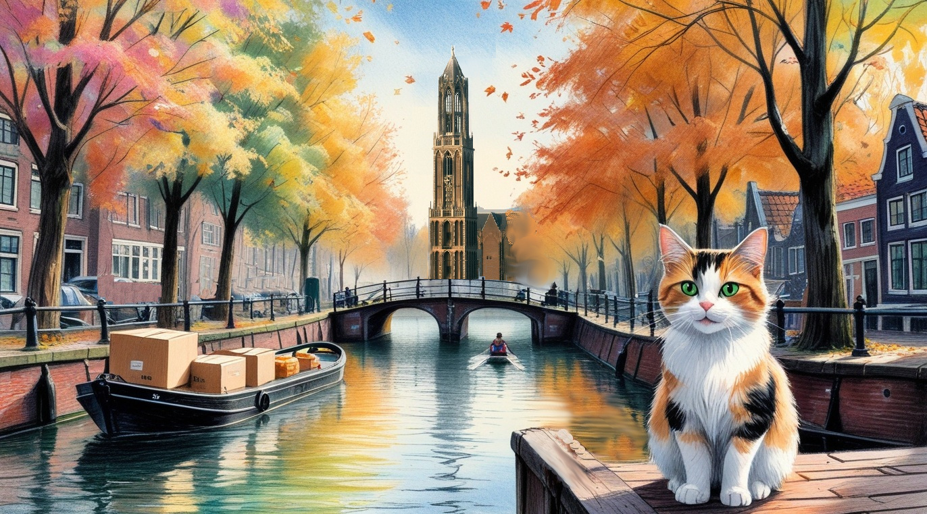
CHAPTER ONE – IN THE TREES
The story of a Renaissance cat trapped on a Dutch merchant ship
By
Jeffrey Scott Pearson

The Cat Who Went ‘Round the World
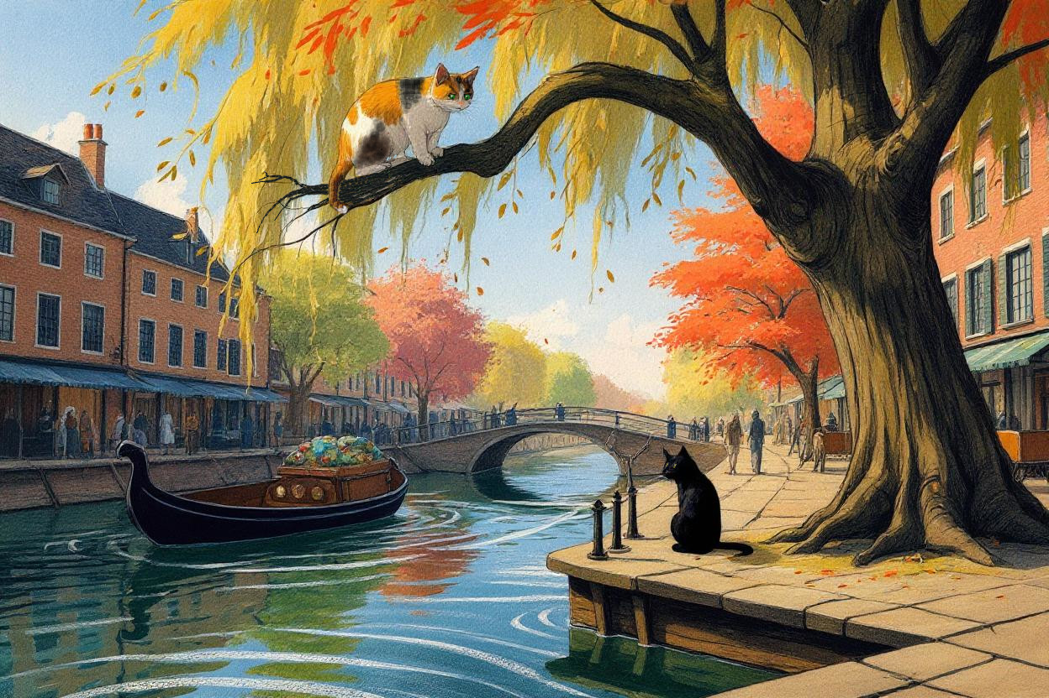
Reggie was up a tree again, waiting it out.
She had escaped by climbing into her favourite willow, safe from an enemy too old and too tired to chase her. The calico licked her paw and glared down at Shade, a scruffy black cat with a bad eye and an even worse attitude. Shade was the neighborhood bully, always guarding his patch of ground against any whiskered fool who dared cross the old canal bridge. This wasn’t the first time Reggie had taken shelter here, it wouldn’t be the last.
High in the branches, she heard the church bells ringing from the Dom Toren, Utrecht’s famous bell tower. She imagined the tall spire must hide a nest of rare birds, which explained these strange songs at all hours. The sounds inspired some people, but for Reggie they were simply comforting. Resting her head on her paw, she drifted into sleep beneath the warm autumn sun.
When she woke, Shade had wandered off in boredom. It was safe again, so Reggie climbed down from her refuge and headed home to see her favourite person, Gertruyd.
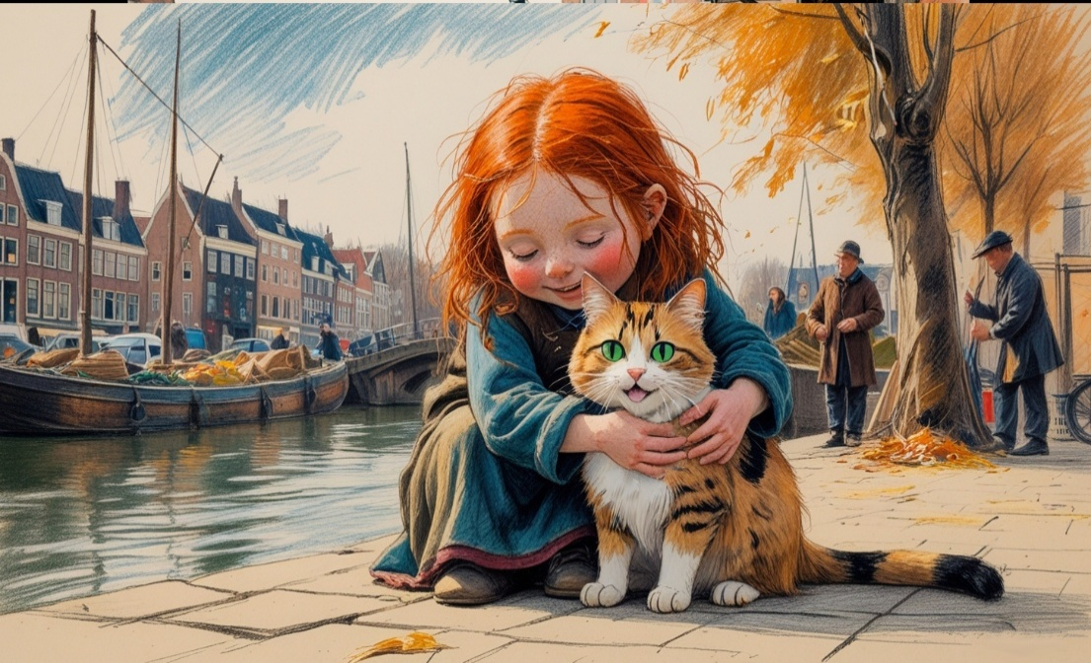
Bright and curious, Gertruyd was the redheaded firecracker of the Van Schaik household. One afternoon after school, she discovered Reggie and her brother as two abandoned kittens hiding under a canal bridge. She carried them home and secretly kept them in a firewood shed for nearly a month. By the time her parents found out, it was too late - the girl and the kittens had already become inseparable friends in a lonely and uncertain world.
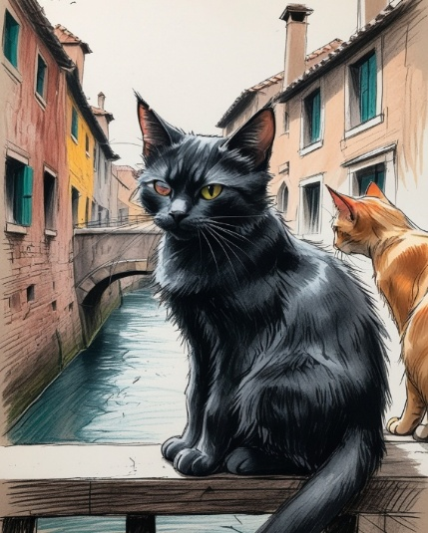
For this calico, that uncertain world included random hostility in the form of Shade and Crate, two local alley cats that made trouble a daily ritual.
With his bad eye and a scruffy coat, Shade looked every bit the villain, but his tabby sidekick Crate was more nervous than nasty. Together they shared a common enemy: Reggie. Her cheeky habits, endless curiosity, and clever tricks drove them crazy — especially the way she always managed to slip away from them. Worst of all, they envied her warm home and loving family, a life this troubled pair could only dream about.

The Van Schaiks eventually allowed the orphan kitties to stay, provided Gertruyd took care of them. She named them Reggie and Lucas after her friends in the neighborhood. While the pair looked alike, the siblings could not have been more different.
Lucas was a shy, orange and white homebody while Reggie was a bold calico, a free spirit ready for adventure. Although they both often curled up with Gertruyd at night, Reggie was an explorer at heart. Each morning, she slipped out of their home to patrol the misty, half-lit streets of Utrecht.
Reggie liked to watch the shopkeepers as they prepared for the day — sweeping their doorways, counting their goods, and chatting with neighbors while arranging their stalls. Behind the town stables, peasants fed pigs and goats, while chickens flapped and squawked in protest. As she moved toward the canals, the clang of a blacksmith’s hammer shattered the morning quiet, while golden sunlight stretched long shadows across the cobblestoned streets.

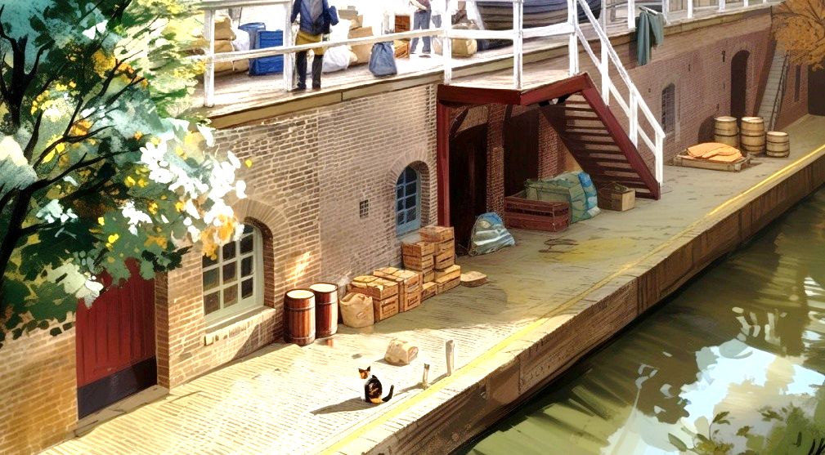
Down by the waterfront, some of the werfkelders (canal cellars) were already busy, so she was careful to sneak down to the landings without being seen. A fisherman was unloading baskets of shiny fish onto the wharf (landing), which immediately caught the feline’s attention. In a flash, the cat was off with a fresh haring in her mouth, completely unnoticed. She found a shady spot underneath a bridge span to watch the city unfold as she enjoyed her breakfast.
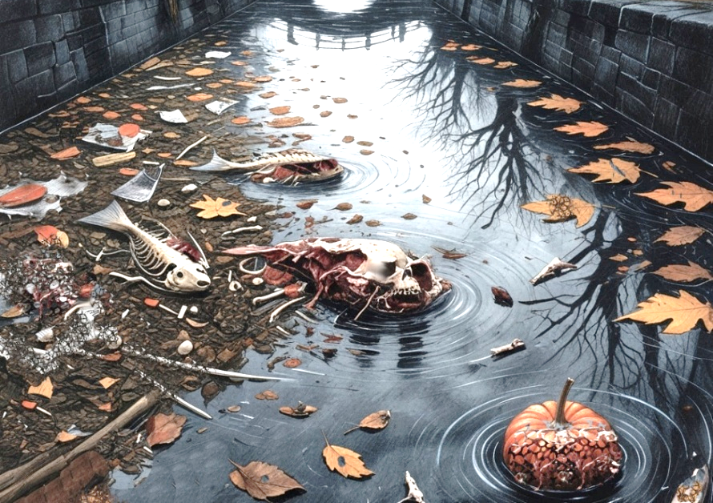
Just then, an old woman on the bridge dumped a bucket of sewage straight into the gracht (canal), nearly splashing her with the smelly sludge. It was a close call, for canal water is not only stinky, but deadly! Reggie couldn’t know about all the diseases floating in the waterway, but she knew it was unsafe. Nobody, man or beast, ever drank or swam in the canal, and those who did either got sick or died. From an early age she learned the gracht was a place to be feared and respected, and those who didn’t paid the price.

After breakfast and a brief cleaning, it was time to cross the Oudegracht (old canal), which was a problem with Shade’s patrols often haunting the bridges. But observing some clever squirrels had taught Reggie a hidden highway of branches overhead that offered safe passage through the treetops. In time, she became a gifted acrobat and spent hours up in the tree canopy, enjoying the height. Few of her furry friends learned the climbing arts so well, and her skills were recognised by critters on both sides of the city.
Of course, she wasn’t beloved by all the people, but she wasn’t harassed much either - especially since the Great Plague in 1636. Back then, when rats were suspected of carrying the Black Death, local cats became important soldiers in the fight against the disease. By controlling the rodent population, the pets saved the city from an infection that took a third of the population of Europe.

Since then, Utrecht’s cats were hailed as furry little heroes, and citizens allowed them full access to the city. Well, nearly full access - until Shade and his litter of alley cats became a problem – a problem to be avoided. Reggie was well aware of this, so she perched in a tree to consider her next move.
From atop the sprawling branches Reg saw busy traders bringing bags, boxes, and barrels onto bobbing boats. She wondered where all these things went, as they seemed to disappear past the end of the canal – never to be seen again.

In time, clouds darkened the skies and windy gusts chased the calico out of her tree onto the canal bank. There had been no sign of Shade all morning, so she jumped down and carefully followed one of the slow pakschuits (parcel boats) drifting down the channel towards the ‘Singel’ - a moat which encircled the whole city.

As the sky grew even darker, a few drops of rain touched her whiskers, so she raced up to the next bridge for shelter. She had never been this far up the gracht before, and could go no further because a kanaalsluis (canal lock) blocked her way at the end of the canal. The curious furball took shelter there for a while, cleaning herself again and watching boats disappear into the tunnel while waiting out the rain.

Once the shower passed she turned to leave when suddenly Shade and Crate appeared. Now she was trapped on the landing, with no way except to swim in that awful canal!

Shade squinted with his good eye and hissed, striking out with a bladed paw. Crate stayed behind the bully to block any escape, and voiced a low growl of warning. Shade arched his back and struck out again, his claw slicing deep into Reggie’s shoulder. She instantly recoiled in pain, nearly falling into the water.
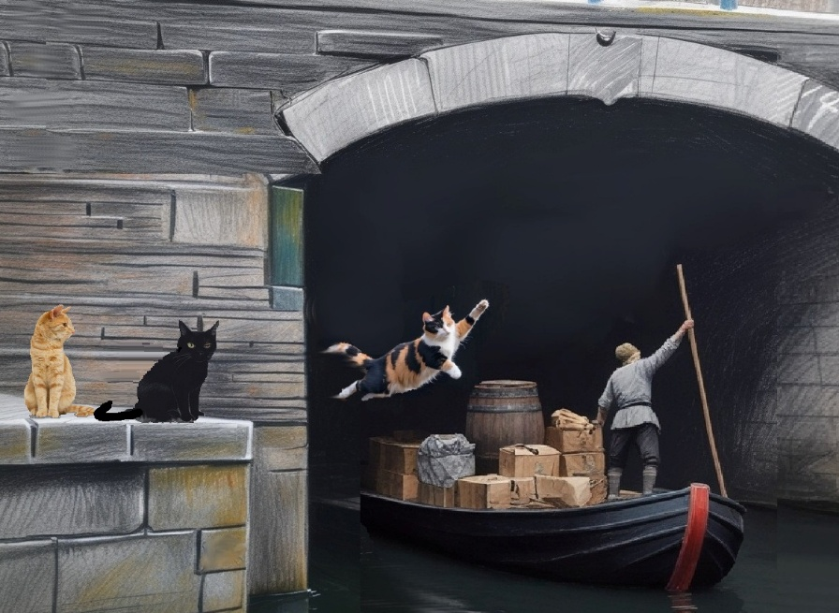
At the same time, the noisy canal lock opened again and the waiting parcel boats began to move forward through the tunnel. Just as the last craft slid under the span, Reggie leapt onboard and vanished into the darkness like a ghost.

The alley cats were stunned in disbelief at what had just happened with flattened ears, twitching tails and angry snarls. The Scratch Pack was left frustrated on the wharf as always, Reggie had escaped again.

CHAPTER TWO – A GREAT ADVENTURE

A
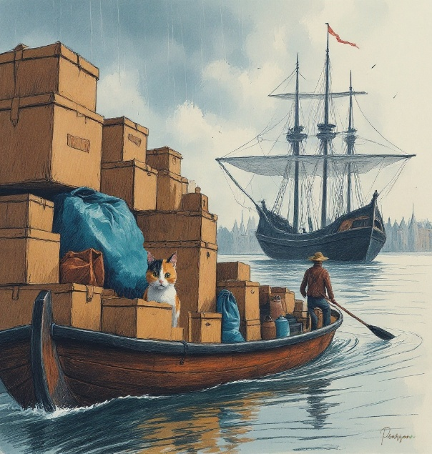
s grateful as she was to escape the Scratch Pack, Reggie was now more worried about her current situation. The little barge drifted into a cove, and the boatman steering it was so focused on his work he didn’t notice a cat onboard. Hidden among parcels and bags of grain, Reggie squeezed between boxes to avoid discovery.
In true Dutch fashion, the weather shifted quickly — the clouds gave way to a patch of blue sky framed by dark clouds. By now, the parcel boat was clearly headed away from the town and north onto a river. The animal became more frightened the further away it went from his world, but nothing could be done. As the strong Vecht current pulled them quickly upriver, a series of showers had the cat hiding under a tarp for much of the trip, but late in the afternoon, the parcel boat finally arrived at a different, much larger town with a huge, crowded harbour.
The river boat was clearly headed toward a massive three-masted frigate buzzing with sailors. The cat was overwhelmed by the amount of activity both in the marina and on the boat. She hid herself deeper amongst the cargo as the shadow of De Zeeroos eclipsed the setting sun.
When the overloaded pakschuit pulled up to the back of the ship, sailors opened a heavy wooden hatch. Sunlight poured into the hold, and Reggie froze at the sight of the enormous space. She stayed hidden as long as she could, but soon the packages around her disappeared, carried away by the crew. With only a few sacks of grain left, she had no choice: leap aboard or jump into the water.
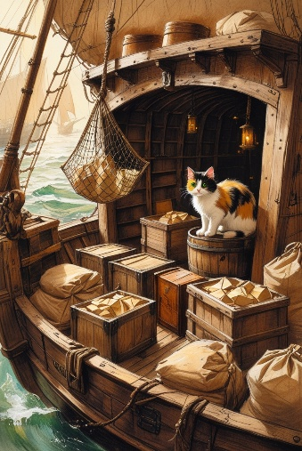
With perfect timing, the cat landed silently without notice and scampered underneath some sail cloth, out of harm’s way. The cargo door was closed and the stowaway was suddenly in a dark, enclosed chamber. The only light was from cracks between the hatches above. The sounds of movement and men continued for a while, but they faded as nightfall plunged the ship’s hold into complete blackness. Her fear gave way to exhaustion, and several times she nodded off in the night, only to wake up again in darkness and fall back asleep.
Finally, she awoke in the soft light of morning and the sounds of people toiling above her once again. But what she noticed most was the new noise – a constant rumble that had the whole ship vibrating.

As Reg considered this sound, the squeak of a field mouse immediately grabbed her full attention. In all this excitement she had forgotten to eat, and by this point she was ready for a meal. She stalked the little rodent in the half-light, moving in silence until she pounced and the chase came to its natural end.
After her snack, a wave of curiosity overtook her and she began to explore the huge compartment. There were lots of jiggling bottles in big wooden crates in one corner and a dozen barrels strapped together in the other. Reams of colourful fabrics were stored under the main staircase, surrounded by sacks of grain and peanuts. Barrels of coal tar were also stowed nearby, stinging Reggie’s nose with their terrible smell.
More exploration revealed that foodstuffs were stored toward the bow. Reggie gingerly climbed across barrels of salted fish and meat that were covered by sacks of peas, beans, and lentils. All were piled high into the hold of the ship between crates of hardtack and dried fruit. On either side of the keel, leaking casks of wine, beer and vinegar made dark puddles that crawled along the floorboards. Thirsty, Reggie tried to drink a bit, but the smell and taste were so foul that she shook her head in contempt and kept exploring.
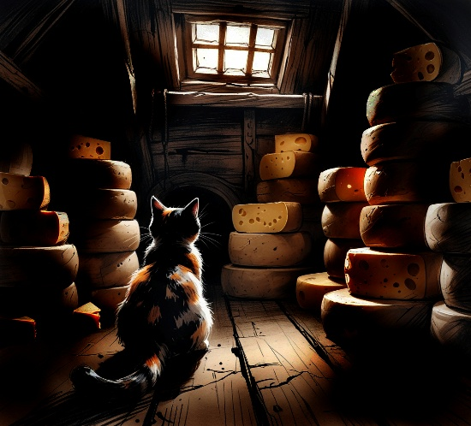
Once her nose recovered from the spillwater, the feline noticed a more familiar smell – cheese! In an enclosed area between the rudders, she discovered a little room of cheese wheels, stacked to the ceiling. Unwelcome visitors had already chewed holes in several rounds, the wax rinds were obviously pulled open by little teeth. This was a welcome sight, as it meant there were more fat rats to be caught!

Just then, several men noisily clambered down the steps, oblivious to the stowaway. They were concerned with other matters, but now that the hatch was open, it presented an opportunity.
Instantly she leapt up the ladder two steps at a time while the men were distracted, popping out on the half-deck amongst the crew bunks. Now exposed, she took off towards the aft galley. Several sailors saw an orange streak shoot past them and disappear in the darkness, but they were more focused on the uniformed man barking orders at them.
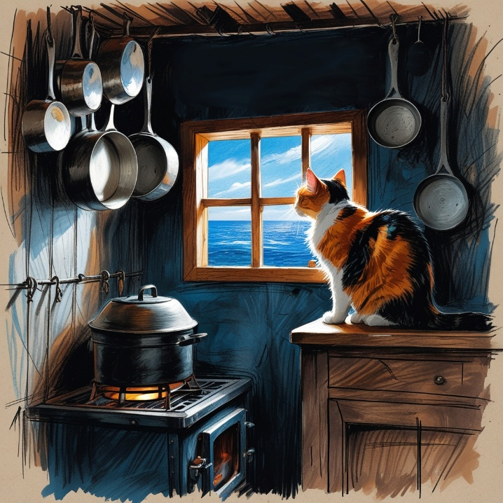
Once in the dark galley, Reggie hid in a cupboard with some shiny pots and pans. She waited for the commotion outside to subside before she began exploring. Soon enough she crept out, drawn out by the gentle warmth from a potbelly stove. But when she jumped up to the galley window to take a look, she got the surprise of a lifetime!
Beyond the glass stretched a canal so big it swallowed the horizon. But there were no people, no trees, no houses, and no city to explore anymore. There was nothing but water as far as her eye could see. She was trapped in a boat on a vast river that we call an ocean, but for Reggie it was a world she had never seen before.
The cat starred out at the open sea for awhile trying to figure out what was happening. Frightened and confused, she compulsively tended her shoulder wound and cleaned herself out of nervousness. But at least she was safe for now – or so she thought.
Just then, the galley door swung open and a red-haired cabin boy stepped through, carrying a crate of small fish. The two locked eyes for a moment and quickly Reggie realized there was no escape. The window was shut and the boy blocked the only exit to the tiny room. So instead of running, she turned on the charm with meows and purrs, tail high, all while pressing her face into him. This was how Reggie seduced the townsfolk, being so cute - because everyone likes a friendly cat!
As for the youngster, Joost van de Velde was delighted to meet the adorable newcomer. All ships needed a cat or two to control rodents, so the boy figured this was the latest arrival. Before long, furry throats were being scratched, nervous ears were being tickled and fresh fish scraps were disappearing by the mouthful!
Joost had no idea the calico was a stowaway, so she showed off his new crewmate to the other sailors below deck. They also assumed the cat was brought aboard and met the animal with rough hands petting her velvet fur. With toothy grins and approving nods they brought her into the sun to show the deck crew.
Even as Reggie was passed around among the men like a bag of peanuts, she didn’t care. They all seemed happy to have a “lucky cat” aboard and all assumed someone else had brought her here. Eventually, this surprise guest was presented to Captain Maarten van de Velde, who came out of his quarters when he heard all the fuss. The well-dressed officer was elegant and tidy in his fancy uniform and wore a feathered hat to cover his balding head in the sun. The seaman was charmed by the animal but soon ordered all the hands on deck to get back to their duties. He gave Joost a knowing wink before returning to his cabin.
“Ik denk dat de kapitein je leuk vindt” (“I think the captain likes you”), Joost told his new pet. “Dat is mijn oom Maarten, dus ik denk dat je nu deel uitmaakt van de familie en de crew” (“That’s my uncle Maarten, so I guess you’re part of the family and the crew now”).
As they sat on the deck in the autumn sun, he stroked the purring kitty for a few minutes more. Just then, the quartermaster Jop Rutte hollered across the foredeck for Joost to finish boiling the fish for the midday soup. The boy scampered off, so the cat found herself alone on the deck of the overwhelming craft. High above, huge sails bloomed in the salty breeze atop tall wooden masts. What Reggie saw were three huge willow trees with large white blankets caught in their rope-like branches. It would take her a while to truly understand her new home.

CHAPTER THREE – LIFE ONBOARD

T
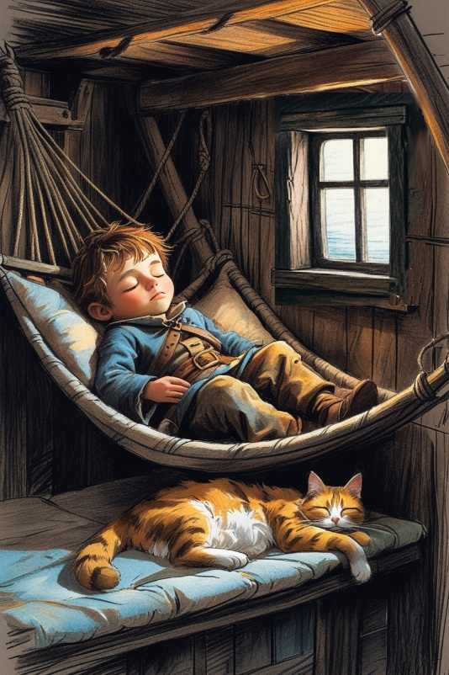
wo weeks later, an amazing transformation had taken place. Not only was Reggie nearly free of fear and concerns aboard the ship, but she knew the vessel well now. With free run of the boat every day, she was a welcome friend to the sailors, and had proved herself a useful crewmember too.
“Kaatje” as she was now called, was a natural mouser, and every new catch would elicit approving smiles and hollers from the men. She provided plenty of rats not only for herself, but as bait for crew fishing as well. Her climbing gifts were regularly on display as she scaled the masts for a bit of alone time and the fantastic view. Naps in the crow’s nest reminded her of the treetops of Utrecht, Gertruyd and her home.
Before long, the cat became the ship’s mascot and an active part of the team.
Joost van de Velde became her owner, protector, bunkmate, confidant, colleague and friend. They were inseparable once the chores had been done, and spent hours together chasing around topside or playing hide and seek down below. They often stole away for an afternoon nap or to steal a snack from the galley.
One of their favourite games was ‘catch’ with an old wooden ball made from a cork. However, it was always getting lost, so Joost changed it to a bamboo stick, which didn’t roll. In time, the cat became trained to return the branch on command, nearly every time. It was very impressive, and soon the crew got into it as well, tossing the stick time and again with Kaatje returning it - until the Captain showed up.
When the commander called ‘Kaatje’ by name, the animal happily came over with the twig, ready for a throw. All the men watched as the big man hurled the bamboo over the foredeck behind some crates. The rascal ran immediately over to the correct spot, but then disappeared. After a long moment, Reggie showed up behind the Captain! She had taken a short cut below deck and now sat proudly with the prize in her mouth. Joost watched his Uncle smile, which was rare, especially in front of the men. But these same men were gathered together for an important discussion below deck as evening overtook the skies.
Kaatje heard the talking go deep into the night, with a fair amount of drinking and laughter as well. The furball stayed with Joost for awhile but eventually got bored and wandered off topside for another nap. As the cat lay dozing in the moonlight, something white and hairy raced underneath her, and then disappeared. She jumped down to establish a scent trail but the varmint was so fast only a trace of it remained. But one sniff was enough to tell her a little monster might be onboard!
For the next hour, the mouser searched all over the ship without success until bedcall. With the ringing bell the crew dispersed, closing their lanterns and filling the bunks and hammocks for a good sleep.

In the morning Reggie awoke to a sound she recognised immediately – horses! Home! Excited, she ran straight to the galley to see for herself. She jumped up into the window frame, nearly pressing her face to the glass. The bright sun was blinding for a moment, but then the amazing scene unfolded in front of her.
It was a town, but it wasn’t Utrecht.
The ship was tied up at a port town with streets full of dark-skinned people dressed in colourful flags. The locals from Mouri, a coastal village in Africa, had gathered on the docks to trade with the De Zeeroos
In the 1670s, Mouri (now Moree, Ghana) was a busy trading port on Africa’s west coast. Fort Nassau was built nearby to store goods and protect Dutch ships, supplies and interests.
It was all so overwhelming topside that Kaatje shadowed Joost for protection. Together they crept upstairs into a wall of hot and heavy air. The thickness of it got the cat’s attention and slowed her breathing - it made her dizzy after her run up the stairs, so she was a bit lightheaded.
When she popped out into the morning sunshine, her head was still spinning from it all. Awestruck by the landscape before her, Kaatje sat gracefully on the gangway and breathed in her new world with concern.
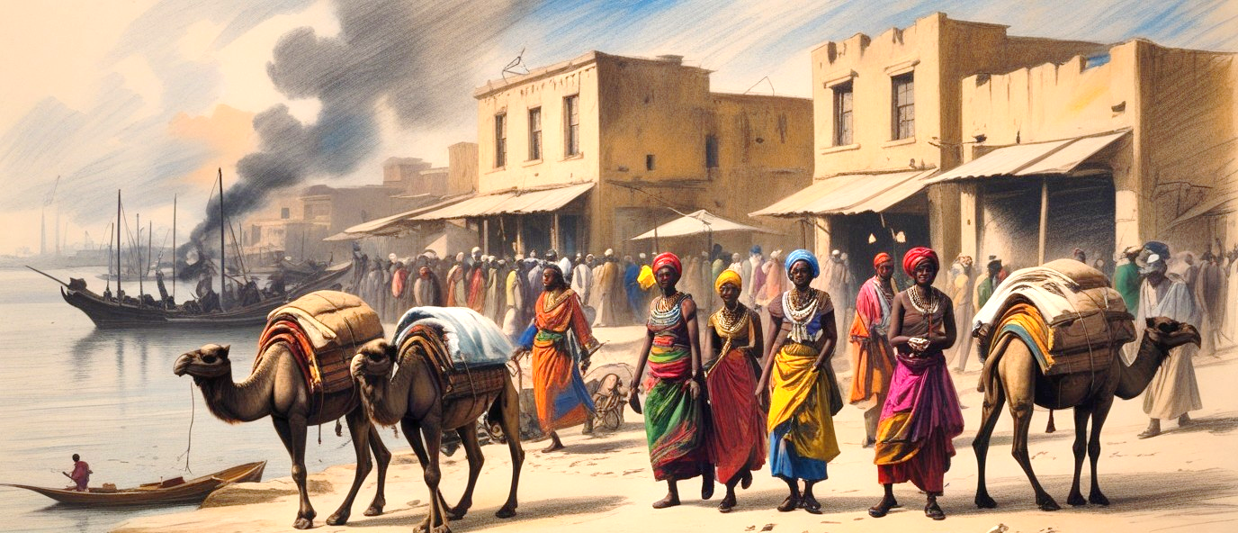
Everything seemed different. The trees were without branches, just huge acorns protected by a few big, floppy leaves. These “palms” offered little shade to the market stalls and tiny shops—which were also strange, as none had storefronts, doors, or even street signs. Trading carts stacked with ivory tusks littered the dusty, unpaved streets; some were drawn by a wild, strange breed of stallions.
Unlike Dutch horses, these creatures were too tall, too dirty, and too ugly to love—burdened with a curious hump on their back. But the most unusual difference for Kaatje was the people.
The market was crowded with unusually dressed local shoppers, most of them blacksmiths and chimney sweeps thought Reggie, with their dirty, blackened skin shimmering in the hot sun. The villagers were tall, gentle and friendly with bright eyes, dark hair and huge white smiles. A few even carried jars or bundles on their heads!
The cat noticed how the natives seemed fascinated by the pale Dutch crewmembers, who stood out amongst the crowd of negro villagers like white sails in the night. Through the dusty haze, the ship’s pet recognised Joost and Jop Rutte near the gangway, and her first instinct was to join them. But the outpost was just too busy for the animal, so she decided to jump atop the wheelhouse and simply observe. Just then, Captain Maarten came outside and suddenly they were eye to eye. The commander smiled and gave Kaatje a bit of a head scratch before barking orders up to the crane keeper. During that moment of affection, the stowaway’s anxiety melted away as she was accepted by the most important man on the ship.
________________
As sunset started revealing tiny stars over the harbour, many men were still not back aboard the ship for suppertime. The cook Willem vigorously rang the dinner bell, happy to have fresh vegetables and sweet fruits to serve, but was disappointed at the half-filled dining table. Some crewmen eventually took their meal up on deck, enjoying the cool night breezes that offered such relief from the daytime sun. Others were still in town dining with the town folk - trying the native foods, drinking the local rum or enjoying the charming villagers.
Joost had been doing just that with a pretty local girl named Asha, exploring the village on a rare ‘day off’ for the little sailor. Now exhausted from the heat, they settled on a marathon game of Choko (an African puzzle game with sticks) that lasted all afternoon. They laughed and teased each other with wildflowers and played hide-and-seek in the market until sunset. The girl then gifted the boy a red ribbon from her hair as a keepsake and Joost traded a nail for it. Just then, the ship bell tolled, stealing her attention.
Joost said, “Ik kan maar beter teruggaan naar het schip, het is al etenstijd!” (“Best I return to the ship, it’s already dinner time!”)
“Oh, mais non,” argued the girl, “ma maman prépare déjà à manger pour nous. You stay, oui?”
Joost knew this was French but only knew ‘manger’ meant ‘to eat’ – he figured out the rest and was more than happy to have a home cooked meal. Before long, the cabin boy was tearing through golden mangos and dried plums with sweet meats from the grill. He barely had room for the fish, plantains and rice that followed, but did his best before finally leaving the table with a bit of a tummy ache. He asked to lie down until it passed, and a home remedy was offered. Asha’s father gave him a dark tea with a lemon slice that soothed his belly and drew his eyes to slumber and before long, Joost was fast asleep.

Back on De Zeeroos, Reggie was finishing a fine meal as well - since there were plenty of crew leftovers to be had. She also had settled in for a nap afterwards with her full belly rolled up towards her face in a crazy sleeping position. However, as full as she was, she wasn’t completely satisfied because she had lost her person. Joost was still not back after his adventures in town, which caused concern for the animal. But soon sleep overtook her and she was dreaming of her Dutch family and home again.
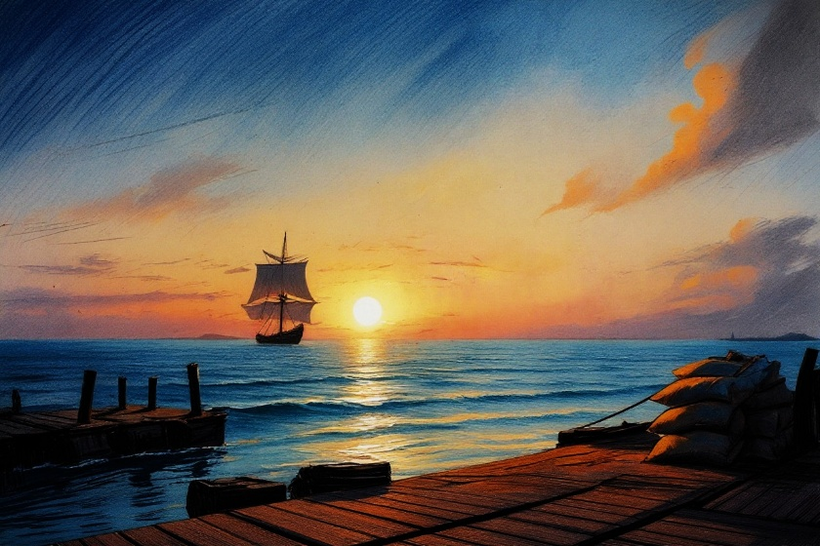
The loud chatter of the anchor chain woke the animal with a start. She noticed Joost was still missing in the morning light and began to march around the hold searching for him. She got so desperate she began complaining to her shipmates, though most were too busy to talk. Then she felt the big boat move and fear ripped through her as she sprang up the steps into the misty morning. She jumped to the rail and the gangway was gone! The ship was leaving the port and the cat could think of only one thing. Where was Joost?
About this same time, the sleepy cabin boy was waking up with the morning light when suddenly he sat bolt upright, his eyes wide open with the realization that his ship was leaving ‘first thing in the morning.’ He jumped up and began to run towards the docks without saying goodbye. As he arrived at the harbour, he saw De Zeeroos far in the distance, sails casting long shadows from the rising sun. The ship was gone; it had left without him!

CHAPTER FOUR – PIRATES ATTACK

R
eggie was in a quiet panic looking for Joost - who was definitely not on the ship. Willem the cook took note of the restless animal and tried to calm her down, but instead the cat began to meow loudly, getting the crew’s attention. Jop wondered where Joost was so he could deal with the cat!
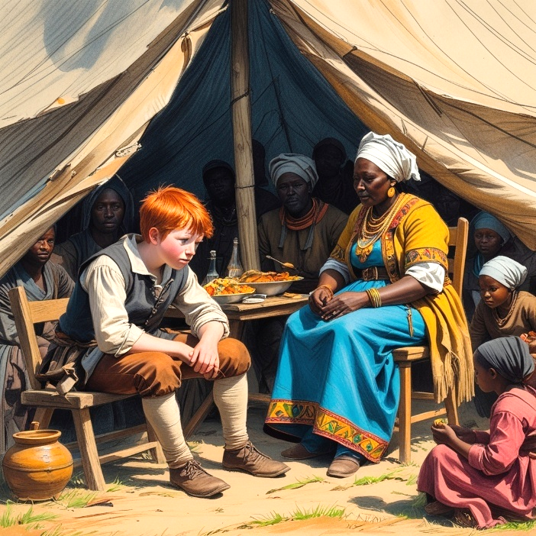
Back on the dockside in Mouri, Joost was also in a quiet panic. But after hours of waiting, hoping for his ship to turn around, he could see no trace of the mighty vessel on the horizon. A few tears later he sadly walked back to Asha’s place and explained as best he could what had happened. The family was very concerned and provided some water, shade and a blanket. The girl’s father brought over a multilingual old woman named Albani from the local Asebu tribe to help understand the situation. She also appeared to be the wife of the Chief.
Once Albani and Joost got together, the nervous boy couldn’t stop talking. The elder explained to the family (in French) that Joost was left behind but was blood related to the captain, which was promising. She then comforted the boy in Dutch, convincing him that his uncle would be back for him soon.
The kindness of the Asebu didn’t stop there, as soon neighbours were showing up with sweets and toys for the lost white child in a successful effort to cheer him up. Even the Chief came by dressed in exotic African garb. He brought the boy a stick of sugar cane and some dried fruit as his wife translated his good wishes. With all this attention, Joost forgot his troubles for a while – which was exactly the plan.

Leaving the Captain’s nephew behind was not the plan of Pim Kersten, helmsman of De Zeeroos. He was anxious to have to knock on the Captain’s door and tell him the bad news; that a thorough search had revealed Joost was not onboard. Crewmen below deck winced when they heard the powerful voice of the raging commander and had pity for Pim, he was just the messenger. But it was no surprise when the rigging crew was called in to change the ship course back to Mouri at full speed. Still, they were sailing against the wind, so tacking back and forth would take time, and it could be midnight before they returned.

As a beautiful ocean sunset closed the day, a worried Captain Maarten stayed at the helm with his spyglass, searching for land in the fading light. He started to call for Joost to climb to the crow’s nest with a telescope for a look too, but his stomach dropped with the realisation that he loved and missed his nephew. He sent Jos up there instead, despite his hatred of heights, knowing he would stay vigilant until they were reunited.
Evening darkened the village and Joost began to worry once more as the distractions wore off. He dined again with Ashe and her clan, resting in their shanty as the night dragged on. Albani had instructed the Asebu to patrol the docks and report the ship when it reappeared. She expected the boy would be reunited with his crew by morning, but no one could predict what it would take just to get through the night.
Hours later, Joost was awakened and taken to the harbour – a boat had been spotted in the moonlight! A group of natives followed the boy to the docks and handed him a spyglass. The relieved kid was all smiles looking through the scope, but then his face dropped in disappointment.
“Er zijn slechts twee masten” (There are only two masts) he stated and shook his head no, “Dat is niet mijn boot.” (That’s not my boat). The villagers were immediately confused, and they began talking amongst themselves. Even so, the vessel approached rapidly, and natives began to panic with one word on their lips: “Pirates”!
Locals showed up with muskets about the time that Joost was ushered away from the harbour. Ashe, Joost and her family ran not to their hut, but into the nearby jungle. Not long after, the report of ship cannons, the crack of gunfire and the shouting of men filled the air. It was dark and confusing in the woods, but it was safe, so most residents disappeared into the forest with them as the firefight raged in the harbour.
Meanwhile, Captain Maarten was still scanning the horizon when she saw a tiny speck of light in the distance, but the slim crescent moon offered nothing more. He adjusted his telescope and could barely make out some flashes of orange in the blackness: cannon fire! The veteran seaman knew exactly what was happening and in an instant rang the ship bell in full alarm, calling for all hands on-deck.
The commander activated his crew to action – bringing up gunpowder kegs from below, prepping the deck cannons and pulling weapons from the armoury. He set the gunners at their post in the crow’s nest and put the rigging crew at the ready as they barrelled towards the troubled township.
The raiders didn’t even notice the mighty ship approaching from behind, as most were too busy in a shootout with the small militia defending the port. Several pirates were also in longboats, sneaking to the docks amid the smoke and chaos. Apparently the scallywags had waited until after the De Zeeroos left port before attacking. They never predicted the powerful frigate would return, and now they’d have to deal with a real battleship.
It didn’t take long for Dutch justice to arrive. In silence and without candlelight, De Zeeroos crept up on the invaders without notice. Once Commander van de Velde was close, he ordered all twelve starboard cannons to fire on his signal - the ship’s bell. It was the last thing the enemy captain heard before the air erupted with thunderous explosions. A dozen 24-pound cannon balls ripped open the side of the pirate boat, knocking the outlaws off their feet. At such close range, the damage was fatal and the raiding ship violently lurched to port, spoiling the use of all the cannons onboard as they rolled out of place. The breached hull was snapping apart, its huge wooden beams beginning to splinter. As it tilted further, a great hole on the side suddenly cracked open, spilling cannons, cargo and men into the harbour as seawater gushed into the doomed vessel.
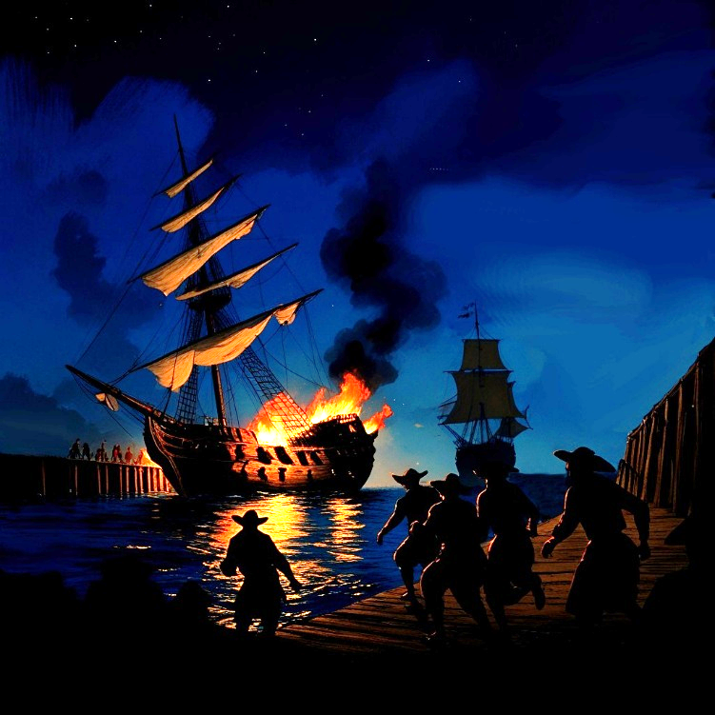
This deluge upset the tar barrels inside, and soon rivers of horrible crude oil began to float from below, floating up to the surface and covering some survivors with globs of sticky black tar. Just then, a pillar of fire climbed up the aft sails and illuminated the sky with a tower of flames. The heat was so intense that the villagers ran for their lives, fearing a powder keg explosion.

With their ship ablaze, the remaining pirates abandoned the raid and paddled their longboats furiously away from the mayhem. Captain Maarten let them go for now, as he aimed to get De Zeeroos away from the dangerous flaming wreck. With a wide port turn, she doubled back just in time to see an explosion light up the sky for a moment and the burning pirate ship begin sinking into the water. Then the night was dark and quiet again, save the sound of sizzling wood and the calls for rescue by injured men in the oily sea.
Hours later, sunrise slowly brightened the sky, prompting Joost and the natives to emerge from their jungle hiding places. The village elders, including Albani and the Chief were already on site surveying the carnage with the town militia when the cabin boy arrived.
In the full morning light, the scene was captivating. The wreck of a 150 ton, two masted Flynt lay capsized by the pier, it’s rigging now a twisted skeleton of blackened, steaming timbers. A dozen broken pirates were shackled sitting on the docks, guarded by locals with flintlocks provided by the Dutch.
When the lost cabin boy finally presented himself, relieved crew members charged over to welcome their missing mate back with backslaps and smiles. Captain Maarten was holding Kaatje at the top of the gangway and reunited his nephew with his beloved animal in a heartwarming reunion. Afterwards, Joost gave his uncle an unexpected hug that almost embarrassed the regal commander. Almost.
Kaatje could not stop purring and nuzzling the boy, and decided Joost would never leave her sight again. After all the deckhands had welcomed the stray back home, the captain called the boy into his cabin and closed the door. The cat waiting outside could never know this, but inside, Joost’s uncle was torn between his love for his nephew and his duty as an officer. In a sense, the boy had saved the port, but it was only luck that saved the boy.
Still, forgetting curfew and missing the boat launch must be dealt with, so the captain issued a stern warning and assigned him double duty for a fortnight. And what did he want Joost to do an extra seven hours a day? Train that cat!
CHAPTER FIVE – PART OF THE CREW

E
veryone onboard felt the cooler trade winds move in after a few weeks at sea, and appreciated the relief from the tropical heat. Equatorial Africa was no place for a hairy cat unless you’re a lion!
As the voyage went on, the crew of De Zeeroos became a real family under the commander’s ‘tough but fair’ leadership. As part of that leadership, the clever cat was getting taught all sorts of useful things.
Building on the bamboo game from before, Kaatje was now delivering small notes hidden in her bamboo shoot to certain crewmembers. Joost would throw the stick and yell the name of whoever it was for - usually the captain, Jop, Jan or Willem – and off she would go! Through trial and error, the calico learned to whom and where to take her prize. Once it was received, the cat patiently waited for a return message or to be rewarded with a snack or a bit of cheese.
Kaatje learned quickly, inspired by the crew who cheered her on during training sessions. The animal saw how excited the men got, so she tried to impress them with every toss. Eventually, the bamboo shoot was removed and soon she was taking important scrolls all over the ship. Weather reports from the crow’s nest, navigational notes from the helmsman, official orders from the captain and even jokes were all delivered by the smartest cat on the seven seas!
The ship’s movements, sounds and routines became a new life for the Dutch castaway. Much of her work was done at night, searching out critters in the cargo hold. In particular the weird white ‘ghost cat’ was a constant challenge – although Kaatje would later discover it was a huge albino rat in reality. Though the mouser often encountered the menace, the rodent always escaped somehow, earning tail twitches of frustration. This, in turn, made her think about ‘ol Shade and her old patch. She missed home.

Days later as the great ship approached Cape Town, the seas became a little rougher with each watch. The cool breezes became cold winds and Kaatje spent more and more time below deck. The cat was fully integrated into the crew now and the men befriended the animal as one of their own. They would dine together, play together, work together, sleep together and even suffer together when things were tough. The mascot was beloved by most of the crew – most of them. But then there was Dorus.
Tall, wide and heavy, Dorus was forced to sleep on deck because no berth below could accommodate him. Aside from leading the dinner prayer every night, he was usually grumpy and quiet. He memorized Bible verses and practiced reading the holy book, yet he was not known for his faith, attitude or intellect.
What he was known for was his incredible strength, which was very useful on a trading ship. The brute could work at twice the rate of the other men, and rock the whole boat by himself for fun! In battle, Dorus could realign a 100kg cannon with one hand that usually took three men to move. Unfortunately, his brain was not as big as his brawn, so there were problems. One of the biggest problems for him was cats.
Dorus was taught in Catholic school that these pets were evil, especially black cats which were associated with Satan – the devil. But onboard the giant was alone believing in cursed cats, as most of the crew were delighted with Kaatje, calling her their geluksbrenger, their ‘lucky charm.’
As De Zeeroos approached Cape Town, the sailors knew there would be old friends to catch up with, young women to flirt with, and fresh ale to enjoy. The crew was excited, so Dorus and a few men had washed their clothes in preparation, hanging them along the rigging to dry.
With only two shirts to his name, the big man was horrified when a gust of wind had them dancing across the deck towards the railing. Just before they went into the sea, a calico cat ran out from nowhere and spiked one garment with its claws - full stop. As the other shirt sailed by, she used her other paw the stop that one as well. Kaatje now lay belly-down like a starfish, holding down two flapping garments and causing most deckhands to howl with laughter, except for Dorus.
When the grumpy sailor lumbered over to get his saved clothes, the crew got quieter, watching the scene. But then a smile cracked open the heart of the veteran sailor and his giant hand reached out to the furball for a symbolic head pat and chin scratch – the cat curse was broken!

In the 1650s, the Dutch East India Company (VOC) built a colony at Table Bay on the southwestern coast of Africa to help ships get ready for the long, dangerous trip around the Cape of Storms. Cape Town was set up there by vrijburgers—former sailors, officers, and VOC employees who stayed behind to build a safe harbour for the company. With shops, taverns, inns, and even a church and hospital, the growing Dutch outpost was a lifesaver; sometimes literally.
Scurvy, or scheurbuik was a food sickness caused by a diet without fruits and vegetables that affected nearly half the crew. The men feared the long, slow death scurvy promised, so they were anxious to make port and eat well. Just outside the settlement, the locals had planted gardens full of greens and fruit trees to feed these hungry men and save them.
Beyond fresh produce, sailors traded with local African shepherds for cattle and sheep meat - all cured and salted, ready for a long voyage. Occasionally sun-dried pork, smoked bushmeat, or mutton sausages could be had, but these were rare. And as always, live chickens or guinea hens were brought aboard in wicker coops for Kaatje’s eternal entertainment.
The animal also liked making port because the men were happy, and their good mood meant more pets, more play and more treats. Indeed, the crew were in fine spirits knowing a hot bath, a warm meal and a cold brew were just around the peninsula.
As the boat dropped anchor in the harbour, Joost was preparing his cat for their next adventure – they were going into town together! He affixed a red handkerchief around his pet’s neck, which Kaatje promptly removed. A second attempt seemed successful until moments later when, again, the cat pulled it off. After a third effort was frustrated, the boy shifted gears and instead tied his red ribbon on as a collar, which the calico accepted. The kerchief was then rolled and knotted into a leash, and the two were off. Together they practiced leash walking on deck but the furball didn’t need long to understand. As the ship was tied onto the dock and the lines secured, the pair stepped forward in anticipation; after two months at sea, they couldn’t wait to get off the boat.
Kaatje hadn’t left the ship since Holland, so her first few steps down the gangway were hesitant and slow. Joost became impatient so after a tug of encouragement the cat finally stepped onto the worn boardwalk and the two took in the lively settlement by foot.

Cape Town was an active place with busy people of all sizes, ages and shades doing a dozen different jobs. Some were tending horses and taking carts to the market. Others were clearing space or hauling cargo to warehouses that lined the harbor, where merchants and buyers were inspecting their wares. As the boy and his pet approached, they got curious looks from the locals, as most had never seen a trained cat before!
When the pair ambled towards the hangers, Joost noticed a few darker workers were in shackles, while others were not. These must be criminals, he thought, and kept his distance. But then they came upon a couple dark children also in chains and Joost was confused – surely they couldn’t be outlaws, they’re just kids!
Just then, a tall tan man in a uniform hustled them away, speaking a foreign tongue; but the message was clear – move along and forget what you saw. But Joost couldn’t forget the children and worried: if it could happen to them, it could happen to us.
Turning into town, a row of stone buildings with whitewashed walls and thatched roofs led to an open market in the square. The echo of blacksmiths, carpenters, and cobblers filled the air with work sounds which spooked Kaatje. All this activity was making her nervous. The bazaar itself pulsed with merchants and traders haggling in loud voices, overwhelming the already anxious cat. When a shopkeeper suddenly shook out their dusty rug into the street, it scared the poor animal such that she took off, ripping the leash out of the cabin boy’s hand and disappearing into the busy marketplace.
Joost chased after the rogue and the two zipped through the plaza, weaving through the crowd, upsetting displays and causing chaos amongst the vendors. The sight of a chapel ahead stirred Reggie’s memories of the safe churches of Utrecht, so she made a bee line to the sanctuary. The doors were open, so once inside, she disappeared behind a statue, startling the two young priests giving a service.
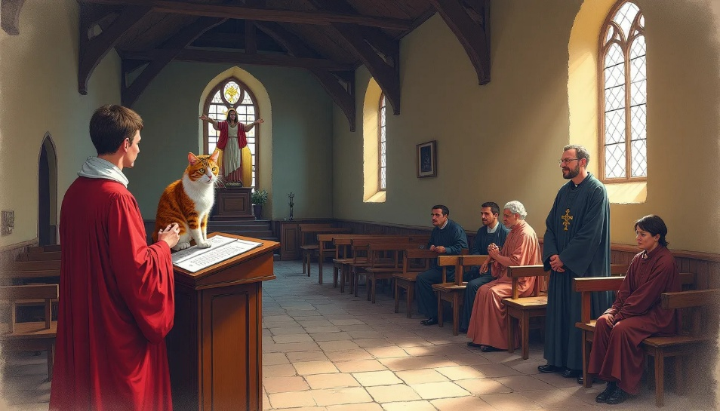
The boy followed into the dim interior, stopping briefly to adjust to the dark and unfamiliar surroundings. After kneeling, he crossed himself (as he was taught) and made eye contact with one of the clergymen. The grinning pastor pointed to a statue near the tabernacle and Joost saw a twitching calico tail behind it. When he called Kaatje by name, the tail disappeared, and suddenly the cat was high up on an altarpiece.
When Joost approached, the rascal leapt over to the pulpit and stood on the lectern like she was giving a sermon. The whole scene had stolen the attention of a half dozen parishioners present, now amused by it all. As if on cue, the cat let out a plaintive cry that echoed throughout the nave, creating giggles and smiles amongst the faithful. For the boy, each step forward elicited another meow and more laughter, but eventually the two were reunited and escorted out of the sanctuary. Certainly, this was the most peculiar sermon ever given at the little chapel!

Later, back on the boat, Commander Maarten chuckled as his nephew told him of their funny church adventure. When he retold the crew, the whole ship erupted in laughter loud enough to be heard in town. That night, Joost was allowed to stay in the captain’s quarters so his uncle could read him ancient stories by candlelight. Before long, all three were fast asleep after a very busy day.
CHAPTER SIX – THE GROUNDING DISASTER

A
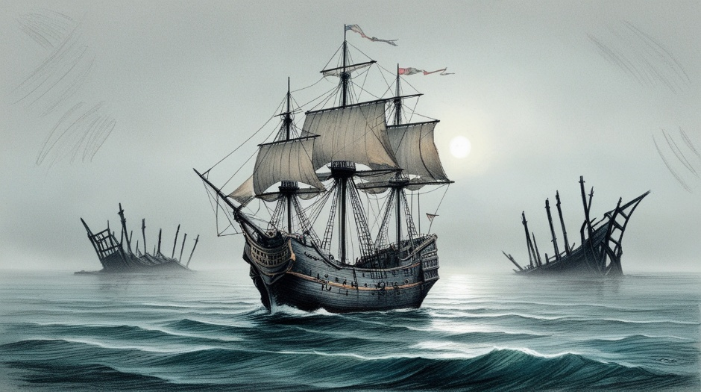
fter the resupply at Table Bay, the crew braced for the worst part of their voyage – rounding the Cape of Storms (later renamed the ‘Cape of Good Hope’). The waters around the headland were the most dangerous in the world, known for violent squalls, extreme winds and massive swells.
The coastline was littered with shipwrecks, their charred ribs jutting out of the breakwaters, clawing at the sky above. Drifting by these burned-out skeletons in the morning fog was a stark reminder that one out of five ships would not complete the crossing intact.
Kaatje could feel the shift in the voyage – rougher seas, colder waters, higher waves and noisy winds -- the warm sun disappeared for days. The men looked more serious and tensions were high because the risky Agulhas Current was pulling them in. Once the ship was snared by it’s swells, the boat was at its mercy.
A sullen crew meant there was no chasing, no play, and no Joost to be found onboard – again?!
The calico went on a dedicated scent hunt to find the boy and his unique smell led the mascot to climb the main mast up to the crow’s nest. There, she found the redhead up top shivering in the cold wind. The platform was swinging twenty meters above the broiling sea, reason enough for the cat to jump in the bucket for safety. The unexpected appearance of a furry friend was a welcome sight for the boy, and they sheltered together beneath his leather raincoat.
Joost was posted on watch for the next morning and noticed the ship’s increased speed, despite little wind. Aside from storm debris, there was little to report for hours. But just before noon white waters were spotted ahead only five degrees off the port bow. His spyglass confirmed Joost suspicions; it was an exposed reef just over a league (3 miles) to the east, and at this speed less than five minutes away! On its current course De Zeeroos would likely miss the crusty outcrop, but this needed reporting anyway.
Storm clouds gathered to the north as the boy reported the heading and details on a scrap of parchment with a broken crayon. Just then the great ship rocked, turning directly towards the reef, perhaps to evade the thunderhead. But suddenly the situation was dire.
Joost instructed Kaatje with conviction, “Captain. De captain. Breng dit naar de captain. Ga!” (Captain. The Captain. Take this to the captain, go!)
The ‘crewcat’ took the note in her mouth and used her sharp claws to climb down the main mast in seconds, just as she had in the trees of Utrecht. She discovered the captain’s quarters were locked and began to meow as loudly as she could. Moments later, the annoyed commander burst through the door, knocking the poor animal halfway down the foredeck before she regained her footing. Undeterred, Kaatje darted back up and dropped the note at the big man’s boots.
The confused mariner snatched up the scroll and it was immediately understood. He barked, “Hard naar stuurboord – ondiepte vooruit!” (Hard to starboard—shoal ahead!) and helmsman Pim repeated the order while pulling hard on the rudder wheel, swinging the ship again.
Poor Joost was nearly thrown out of the crow’s nest with this maneuver and was grateful for his harness. As the great ship turned, a few sailors staggered and lost balance with the tilt of the boat. Riggers were stumbling around on deck trying to wrestle the sails against inertia and gravity. When Joost’s uncle ordered the men to “Haal de zeilen binnen, zet je schrap!”(Cut the sails and brace yourself!) the boy climbed down the mast as fast as he could, but slow compared to a cat. A hundred feet is a long way down on a swinging ship, and his heart was racing with every careful step.
Meanwhile, a frightened Kaatje stayed behind the captain, avoiding the ocean spray from angry waves. The boat was now trembling as it strained to veer away from the reef, but it was too little, too late. Instantly a horrible grinding noise shook the craft as the belly scraped hard against the side of the outcrop, the keel grounding into splinters that left a trail of driftwood confetti in the wake of the ship.
Luckily, Joost reached the deck just when the impact occurred, so he avoided a nasty fall. The captain, sailors and the helmsman traded frantic orders to help recover the ship, and thankfully the boat returned upright quickly. Captain Maarten needed a damage report and sent his quartermaster Jop Rutte with some men to check down in the hold. They may have left the shoal behind, but not the trouble it caused.
The news wasn’t good; there were cracks in the hull. The bilge—the lowest part of the ship—was now a foul soup of trapped seawater, spilled tar, oily debris, and soaked cargo - all sloshing around in the hold. Churned by the ship’s motion, the foul odor of ‘the devil’s chamber pot’ was noxious and sickening. Even hardened men gagged, forced to use perfumed kerchiefs to deal with the smell.
Jop was still gasping for fresh air when he reported back topside to the commander ten minutes later. But before he could even get a word out, a thunderbolt ripped across the sky and the heavens opened up with grey sheets of icy cold rain. With all this madness happening at once, Kaatje and her person made a hasty retreat into the captain’s stateroom to wait out the deluge.
After an hour the soaked captain returned to his quarters for a dry uniform and a warm tea. As he changed clothes he explained to Joost that while the ship was damaged, it was not a fatal blow. For now, crewmen were pumping as much sludge out as possible to bring the water level down so repairs could begin.
He then sat on the cot and hugged his nephew, thanking him for spotting that shoal in time to avoid disaster. They both agreed that Kaatje’s quick actions saved precious time, and maybe the ship. For her part, the humble cat was too busy licking her backside to notice the conversation. Urgent knocking startled them both as Jop appeared with yet another crisis to report.

Most of the sailors had gathered top side to see the unreal situation themselves. The rain squall had passed, but the endless cloud cover created a surreal scene for the seasoned crew - the ship was sailing backwards into a white void!
Caught in the current with a damaged rudder, the craft was spinning slowly as it drifted. The men were dumbfounded as the vessel slowly performed a full rotation until it returned to normal position - only to repeat the cycle again and again. Even Kaatje noticed this weird reality as De Zeeroos had never moved like this before - the sun was flying around the ship like an albatross.
The cat could not know this was a real dilemma, as fixing the rudder required stopping the ship – and that wasn’t happening in these waters. The Agulhas Current was simply too powerful without a serious headwind, so the boat might be spinning for days, maybe weeks. A clever solution was needed – fast.

CHAPTER SEVEN – A SALVAGE SOLUTION

A
s darkness closed out the day, the officers were still considering what to do. The creaking ship continued to spin slowly, thankfully away from the dangerous coastline, but still with no control of speed or direction. After sunset, the skies cleared a bit so the sailors ambled topside to watch the half moon circle the boat like a shark. Once the cold night winds chased them off deck, the crew tried to sleep in the ever-swinging hammocks below, but the men were too anxious and confused to really rest.

In the morning Kaatje and Joost were awakened by the sound of the anchor chain and men in motion up top. The sleepy pair came up to the foredeck to see the matter and noticed the deckhands were busy trying to slow the boat by dragging the anchor. The cat jumped onto the wheelhouse for a better view as the crew hollered commands and the riggers worked to raise the sails. A quarter league ahead portside, a half-submerged shipwreck lay bow deep in the water directly in the path of the turning boat! No wonder everyone seemed in such a panic, they were on a collision course!
As De Zeeroos approached the wreck, a few sailors drew forward with harpoons at the ready. For the riggers, it seemed to take forever for the rudderless ship to get in the right position. Eventually the boat rotated so that Kaatje could just see the wreck a couple hundred feet ahead, and coming in fast.
On the captain’s order, the sails were suddenly twisted open by all the riggers at once, momentarily jarring the ship with a sharp bump to starboard. The commander rang the ship bell and four deckhands threw their spears like javelins towards the stricken vessel in an effort to snag it.
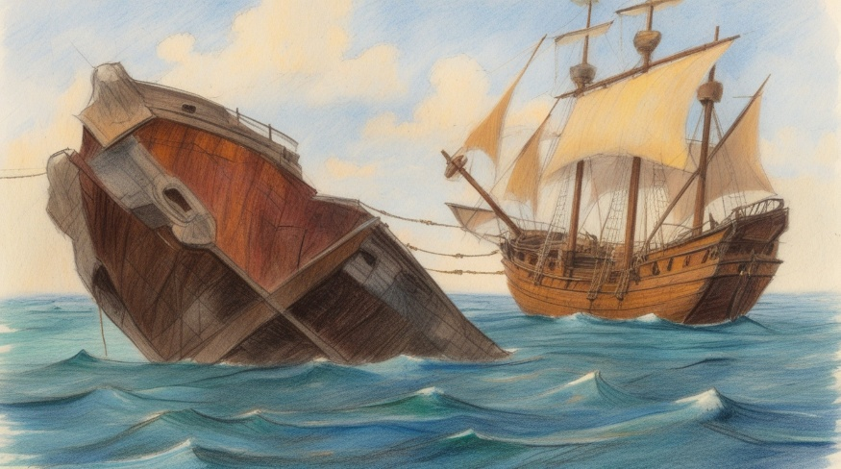
The first two harpoons never reached the wreck, but the third one made contact and stuck in the wood like a dart – only to be yanked into the ocean moments later by the tow rope. But the fourth harpoon, thrown by Dorus, flew all the way over the entire wreck. Its tether unspooled in a blur until it ran out, jerking the spear out of the sky and down onto the boat. The metal pole clattered up the hulk’s port side and got hung up between two railings. Instantly the tow line snapped taut and the De Zeeroos rocked violently as the huge frigate finally stopped moving – at least for now.
Commander Maarten quickly ordered the bow anchors dropped and two more harpoons were tossed, but neither reached the wreck. Dorus picked up the last harpoon and with a mighty throw the big man scored another bullseye. Once his spear found purchase, the men pulled in this second tow line and the ships became aligned.
The sudden chattering of the tow winch scared Kaatje off the wheelhouse as the frigate was pulled toward the wreckage. Once the vessels were within reach, grappling hooks secured the boats together so work could begin. With the tide set to change in five hours, there was no time to lose.
The VOC men were not here to plunder cargo; they needed something more precious – a rudder! While the wreck was stuck bow deep in the shallows, it’s rudder was still hanging right there for the taking.
With the crew constantly battered by the cold waves coming ashore, it took hours to detach the vital part. Even with the sunny day, the work teams had to be changed regularly to avoid freezing to death in the chilly waters.
Inside, Joost and others were moving everything in the cargo hold to the bow of the ship. Once Dorus had dragged all the cannons to the bow, the boat inclined forward, making it easier for the rest of the men to roll barrels, cheese wheels and slide boxes into place. This shift in weight eventually tilted the rudder assembly out of the water, revealing a clean break that might easily be repaired.
With so many busy people filling the hold, Kaatje tried to stay clear of all this unexpected activity. However, the removal of a large wardrobe trunk revealed quite the prize; a huge albino rat was exposed in the half light and went scurrying across the floor – right into the crewcat’s razor tipped claws.
A noisy and intense struggle began, the vermin’s red eyes glowing with hate as it hissed and struggled to break free. The two tumbled around the interior of the ship, knocking over cargo and nearly tripping crew members. Before long, the mouser had clamped it’s whole body around the rodent and used her powerful hind legs to hammer into its vulnerable underbelly. The animal’s frantic thrashing slowed and then stopped to the delight of a few tired deckhands. Joost appeared and inspected the furry hero with concern, but that then turned into pride and respect for a job well done.
By late afternoon, the tide receded and both ships were now grounded on the sandbar offshore. Using ram jacks and prop rods, the exhausted men of De Zeeroos raced to attach the new rudder before the sun disappeared. By nightfall, the last of the work had to be done by lanterns by souls that were now blue with the cold. But the brave sailors persevered and by midnight the vessel was fully repaired, although it would be morning before the high tide would release them from the grounding. When the anchors were raised at sunrise, the frigate finally floated free and drifted back into the moody Indian Ocean.

CHAPTER EIGHT – A FLYING CAT

A
week after De Zeeroos rounded the dangerous peninsula, the ship began a northern turn towards Madagascar and points beyond, into warmer waters. Along the route, the frigate had picked up a few annoying seagulls that lived in the rigging while out at sea. Their constant presence and eternal screeching was a daily grind, especially at mealtime. Many deckhands had their lunch snatched away by the feathered thieves, only to endure a second insult later as the bird’s rain of poop painted everything white. When this nasty shit flurry stained the decks and soiled the Captain’s uniform, the seagull’s fate was sealed - Kaatje was called into action!
It's not like the cat hadn’t noticed these flying rats before, they had already been a target of many failed attempts at capture. But the captain and his nephew planned out a sneak attack that would deal with the invaders for good.
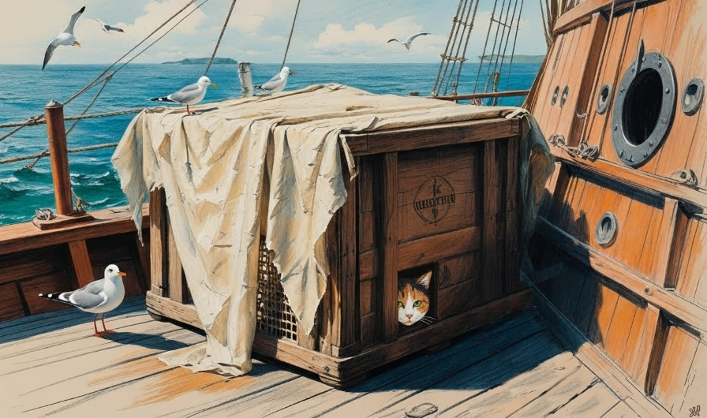
The next afternoon at chow time, the ship bell was rung for lunch, which always excited the gathering gulls. This time, however, Joost was hiding with Kaatje on deck in a large wooden crate, placed on its side and hidden with cheesecloth. As the men finished their rations on deck, the birds descended on the leftovers just feet away from the box trap. The squirming cat leapt out of the boy’s grasp once released and pounced into a flurry of feathers with predictable results.
The seagull stew that Willem and Dorus prepared that night wasn’t really enjoyed by the men, as it was salty and bitter - like Dorus himself! Still, one whiskered crew member loved it all and licked the pot clean. Afterwards, the fat calico laid on her side so fellow sailors could come by and pet their respects.

The next morning the air was sweet with birdless silence; save the sounds of a creaking ship and busy men. Jop Rutte noticed how elegant the cat looked on deck, facing a soft breeze that gently brushed her fur. Beside him sat her loyal red-haired friend, who was growing up so fast that new clothes were needed.
Later, the captain appeared with a teacup in hand, standing by the quartermaster for a quiet discussion. Helmsman Pim Kersten joined the group and soon maps and a compass were spread out on the flag locker - then even more men gathered in curiosity. Kaatje and Joost could tell something important was going on, but they were not invited to crew meetings...yet.

What Kaatje could not know was the De Zeeroos was in troubled waters again. Nasty spills discovered in the bilge had caused some casks to rot out, and a half dozen barrels of precious drinking water had been lost, forever tainted by the disgusting sludge in the bottom of the boat. Willem the cook estimated four days of water remained to serve the 45 men onboard without rationing; maybe a week if everybody drank the minimum. Helmsman Pim determined only the water on Bourbon Island, 400 km east of Madagascar, was within sailing distance for the frigate.

At the time, Bourbon Island (later Réunion Island) was French, though only a few dozen soldiers lived there. The plan was to get on and off the isle quickly, without notice, as the Dutch were unwelcome due to trade rivalries and the ongoing Franco-Dutch War.
They planned to anchor at southeast end of the island behind a dead volcano, hidden from the settlement on the north shore, St. Paul’s. Fortunately, wayward trade winds had them arriving five days later under the pale light of a full moon.
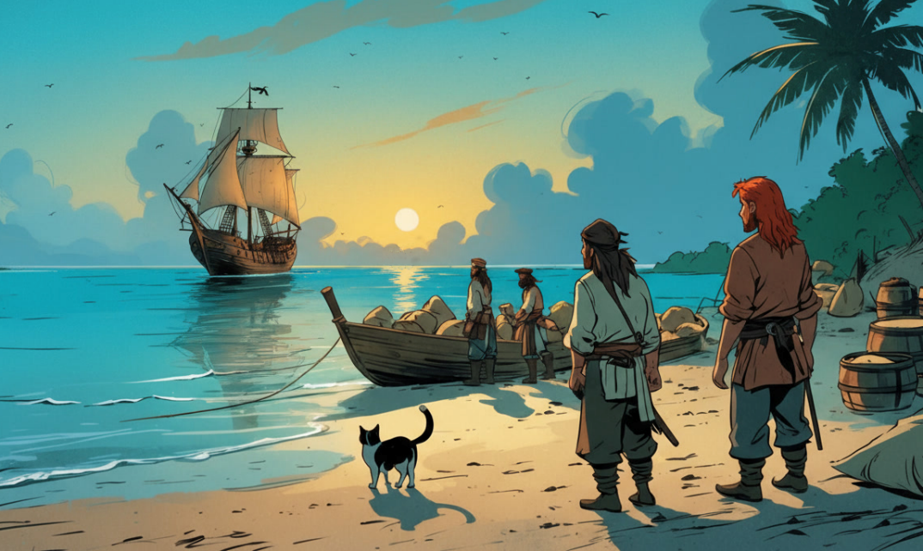
Just before dawn, Joost and Kaatje found themselves riding the waves in a big brass kettle as it was towed ashore by the landing party. The clinking of a hundred bottles cut through the night air as the tender was rowed to the shoreline under the moonlight. The low tide made beaching the boats easy, and by daybreak a little camp had been established.
The captain then directed a group of armed men to gather all the barrels and bottles onto a wooden cart and head into the forest. It was hoped the rainwater atop the volcano’s rim would have captured enough fresh water to share, but it was an hours-long climb to the top to find out. Joost and his pet were held back, as this was an uncertain and dangerous mission.
While the explorers were away, the other crewmen prepared a firepit and made a lean-to of banana leaves. The day became warmer, then uncomfortable in the morning sunshine, so this shelter was useful to all. Joost was tasked with gathering foodstuffs like pinenuts, papaya, coconuts and bananas, while the mouser busied herself with the many crabs scattered on the beach. The cat tried several different attacks, but only ended up with a nasty pinch from a walking seashell. About the time she gave up on the sand crawlers, a sea iguana raced from the ocean straight towards her with frightening speed.
Alarmed, the cat began to move towards a groove of coconut palms with increasing speed. The angry reptile seemed fearless and flurries of sand danced in its wake as it ran directly for the animal. Kaatje relied on her old standby, and suddenly climbed up a 30-foot palm tree, settling near the crown. It was just like the treetops in Utrecht, and once again she left her assailant frustrated below.
Joost saw none of this, but at some point he noticed that Kaatje was nowhere to be found. He found paw prints in the sand, but they ended at the tree line. His search was interrupted to gather wood and help with the fire, so he decided to find his buddy later, now there was work to do.

The hike to the caldera had tired the men, who were all gasping, sweating and thirsty in the tropical heat. Tragically, the lake turned out to be no more than a dirty pond of slimy green liquid – a big disappointment to all. The filthy water would now have to be filtered with cheesecloths and boiled, just to be drinkable. Still, every bottle and barrel was filled with the cloudy liquid and then it was all carefully hauled back down to camp, spilling a little every step of the way. The mountain path became muddy and many sailors cursed the undertaking in frustration as they slipped, fell and recovered, time and again.
While waiting for the explorers to return, the captain decided to hold off on the bonfire until after dark, to avoid a French surprise. Already Willem was setting up the distiller for the brass kettle, sinking a wooden tripod deep into the sand. Once the rig was set up, the firepit below was stocked with the dry wood and kindling in anticipation of the water crew’s return.
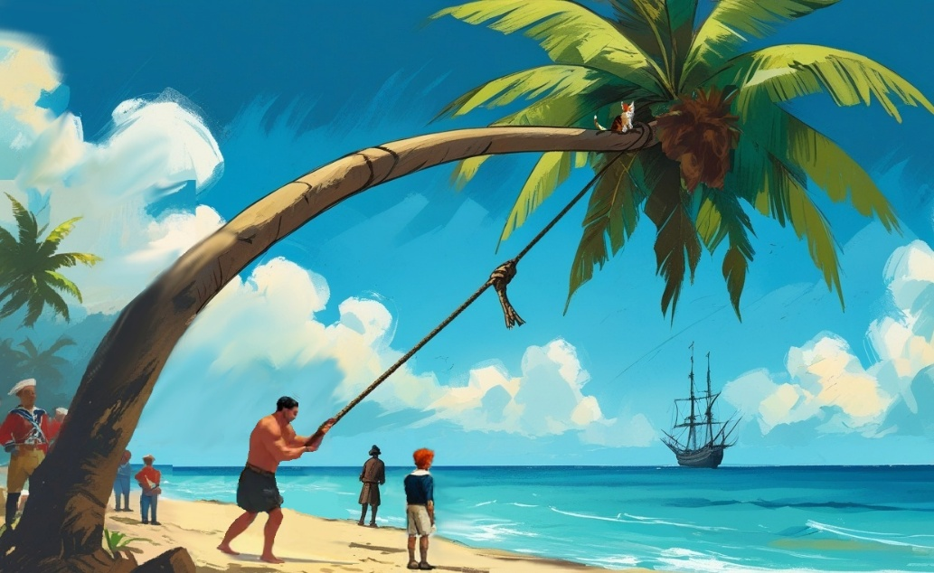
Later, Kaatje woke up abruptly because her palm tree was shaking wildly, despite the windless day. She was barely able to hang on through the violent thrashing when she saw Joost and Dorus were to blame. The giant had swung a grappling hook over the treetop and was yanking hard on the rope in an effort to harvest coconuts. He was bending the crown down to Joost’s reach when he finally saw Kaatje; but Dorus let go of the rope in surprise!
Instantly the poor animal was catapulted into the air as the palm snapped forward and the crew gasped in horror, amazed by the sight of a flying cat!
Joost saw her splash into a lagoon nearby and went after her. The boy splashed straight over to the aid his friend, who was now frantically paddling towards the shore. The pair came together in waist-deep water, where the redhead scooped up the soaked, trembling furball and carried her back to camp. Soon, men showed up bringing towels and a blanket to swaddle the frightened critter. As for the calico, she had no idea what just happened - suddenly she was flying like a bird and then swimming like a fish! She didn’t know much except she wanted back on the ship as soon as possible – this world was too crazy for her.
Dorus was so concerned the other men started to tease him, but his earnest love and concern for the animal won them over instead. As he was thanking God in prayer, the water team was returning through the jungle, heavy laden with supplies. The filthy explorers were exhausted from toting the poisoned water back to camp, so the last of their fresh water was given to them to share as evening approached.
After speaking with the shore party, the captain stepped over to check on the cat situation. By now, ‘The Calico Kite’ (as Jop called her) was fast asleep in his nephew’s arms, exhausted. The commander ordered the two to return to the ship on the first skiff available.
Meanwhile, twilight meant the firepits could be lit and the water purification could begin. The men poured all their bottles and barrels into the brass kettle to boil out the diseases. The steam was caught by thirsty towels wrapped over the caldron, and then clean drinking water could be wrung out by the gallon.
The whole process took nearly all night, so it was in the dark early morning before Joost, Kaatje and the rest of the crew were back onboard De Zeeroos. The sailors couldn’t wait to nap in their bunk, but just as they were nodding off, the ship’s bell rang furiously in alarm - all hands on deck!
Despite a thick morning fog, daybreak revealed a couple French warships from the north closing in fast.
The big question was: Had they seen De Zeeroos yet?

CHAPTER NINE – THE GREAT DECEPTION

T
he Calico Kite was still resting from her first flight when the alarm woke her. The panicked crew ignited her curiosity, so she sprang up on deck the to see the matter. Joost was already in the crow’s nest, reporting that two French corvettes were approaching from the north, patrolling the island’s coastline. It was unclear whether they had spotted De Zeeroos yet, and Commander Maarten had a plan to keep it that way.
Without the ability to outrun her foe, the captain pulled anchor and skillfully moved his ship northeast, rather than running away to the south. This daring move would put the ship directly into the rising sun, hopefully blinding the French crew with its sunbeams. He also trimmed the mainsails to reduce their silhouette, and relied on the smaller, jib sails instead.
As the sun continued to climb, the fogbank was illuminated and became blazing wall of white mist. This was useful, as the French ships were now to the rear west and thus perfectly aligned with the glare of sun. For nearly half an hour, De Zeeroos secretly crept away from the island without detection.
But what the relieved crew didn’t know was that the French had just found their beach encampment and knew of their presence. With the firepits still aglow, it didn’t take long for them to realize they were only hours late. What they would do with that knowledge was anybody’s guess, but the captain feared it was the beginning of a race he couldn’t win.
Indeed, by the end of the day, Joost reported the outlines of the two French warships chasing the frigate, barely visible in the twilight. Corvettes were simply a faster boat and at this rate they would catch up within a day or two. For now, they were shrouded in darkness as the night revealed its stars.
The frigate’s lanterns were dimmed and now Maarten van de Velde had a choice. With a thick hull and superior firepower, De Zeeroos could turn and fight. The problem was those fast corvettes would ‘swarm,’ a tactic where faster ships circle a larger one and hammer away with continuous cannon fire. Large vessels can’t maneuver for a shot quickly enough to stop these attacks, and eventually De Zeeroos would be beaten down by the assault.
The other choice was to run and try to make it to the protected Dutch port of Batavia (now Jakarta) and safety. For this to work, the captain had a bold but risky plan to outrun the French – but he would have to lighten his load. That meant dumping their twenty-four heavy cannons into the Indian Ocean, leaving them defenceless. When this idea was presented to the crew, their silence wasn’t agreement—it was the sound of men weighing survival against surrender. Even Kaatje could feel the change in the atmosphere.
Hours later, in the dead of night, the men grumbled as Dorus and the other crew members unchained the iron artillery from the gun deck. Breaking open a rear gunport, the deckhands reluctantly pushed the heavy cannons out one at a time, each one bucking the ship with the weight change, followed by a mighty splash. When Kaatje went and sat down atop the last cannon to go, Dorus expressed his belief this was a divine sign. Most crew agreed, and Jop the quartermaster took this message to the captain, who decided not to tempt fate and kept this last weapon onboard as a safeguard.
The night sky was extra dark and filled with stars due to the new moon, another advantage. With the ship now several meters higher in the water, there was far less drag when the full sails were deployed and the vessel surged forward with surprising speed. A chip log was tossed to clock the vessel, and soon six knots was achieved on the open water, fast for a frigate.
A chip log was a wooden board attached to a long rope knotted at regular intervals. When it is tossed overboard, it’s allowed to run freely for 30 seconds as sailors count how many knots pass their hands in the interval – hence the term ‘knot’; representing one zeemijl (nautical mile) per hour.
Pim had also convinced the commander to head due north before making a hard turn east at sunrise. That way, the faster French might miss De Zeeroos altogether on the wrong latitude. It was a smart move, and the men acknowledged the helmsman’s genius with a rousing toast at dinnertime.
By late afternoon the next day there was no sign of the enemy and the happy crew relaxed as their new faster ship was now making eight knots towards Batavia. Sea birds started following the boat over the next few days, and soon other trading vessels were in view; all headed towards the Dutch sanctuary.
Two days later, the looming walls of the VOC’s fortress, Batavia Castle, could be seen rising behind the shoreline like a stone crown. The shallow bay meant large ships like De Zeeroos had to anchor offshore and smaller boats brought in the men and cargo dockside. The crew were giddy with excitement as a big paycheck and dry land was just a few hours away.
Once the big boat was in anchorage, Kaatje climbed to the crow’s nest to get a better look at the VOC township. She saw Batavia was city with narrow canals, red-tiled buildings, and well-worn cobblestones - like Utrecht! Yet unlike home it was hot, moist, and crowded - with an amazing diversity of people, products and animals from all over the region. As the ship floated into the calm bay, all could hear the sounds of the busy town, even sitting out in the harbour. Before long Dutch sailors had loaded onto the tender to help row out to shore.
Meanwhile, a couple local skiffs left the harbour docks and headed toward the frigate, hoping to be the first traders to reach her. The deck hands tied their boat along side when they arrived and unrolled a rope ladder to help get the well-dressed group aboard. Once the merchants were introduced to Maarten van de Velde with forced smiles and handshakes, they all went into the captain’s quarters to negotiate in private.
About this time Joost was preparing to go ashore as well, sadly without Kaatje. After the ‘cat slingshot’ incident, it was decided the mascot would best remain on the ship in these waters; an idea the cat was onboard with as well.

Over the next two weeks the men of De Zeeroos adjusted to the changes to their daily routine, which Kaatje noticed immediately. Deckhands were constantly hanging over the rails, waterproofing the hull with tar and packing loose seams with pitch. The sounds of barnacles and seaweed being scrapped off the boat drove Kaatje up to the crow’s nest for peace some days, while other times the monsoon rains made that impossible. The ship was almost as busy in port as it was out at sea.
The calico also noticed that large amounts of their cargo disappearing from the hold daily, replaced by new and unfamiliar products from the Spice Islands. The scent of this merchandise was exciting; as the feline had never smelled the likes of nutmeg, cloves, or pepper before. In the aft compartments, pungent bales of tobacco tickled her whiskers while in the bow, the unique fragrance of coffee beans filled the air. Combined, all these odours in the stuffy cargo hold were distracting, which made scent hunting difficult. It wasn’t as bad as the reeking bilge, but the overwhelming stink down there had the cat coming up for air on the regular - nose burning and eyes watering.
Joost was strangely absent for much of their time at port, like many young crewmen. Their ‘lucky charm’ was accustomed to the boy’s constant attention onboard, so his disappearance was unsettling. She spent much of her time near Dorus or the captain, and sometimes Pim would throw the stick for the mascot, but the kitty missed her person.
The situation made more sense when Kaatje saw Joost with an actual girl visiting the ship. The teens met his uncle and Jop together, smiling and chatting in a most casual and familiar way. The furball instantly pranced over to make her presence known, lacing herself between the boy’s legs and then around the boots of the commander for attention.
When Joost finally picked her up, she was placed in the girl’s arms and memories of Gertruyd flooded back to her. Though this maiden was taller and raven haired, her gentle smile and adoring eyes reminded her of her person at home and the purring began. Her nose started stinging, her eyes watering once again - but this time it had nothing to do with the foul air.

CHAPTER TEN – A SECRET PASSENGER

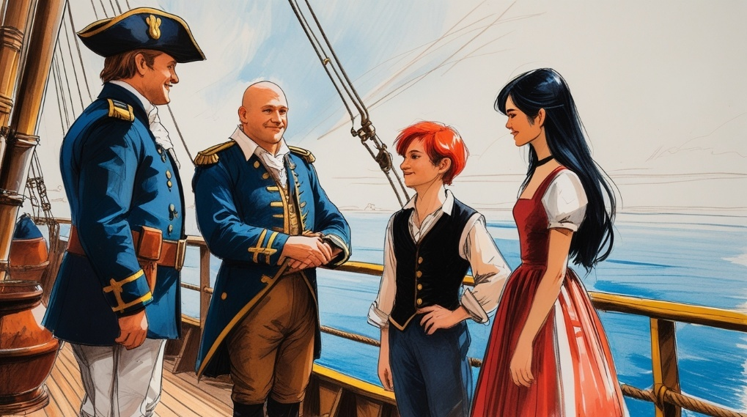
S
ophie Maatsuyker, daughter of VOC governor Jan Maatsuyker, was a tall, black-haired beauty by age fifteen, though still very much a teenager. She was glad to meet Captain Maarten and Jop, as Joost had already told her all sorts of stories about their many adventures.
Sophie admired most how they had somehow replaced their rudder at sea, and how they slipped past the French Navy by shedding their cannons. As they talked, her admiration gave her the confidence to ask the commander something very important.
Studious and clever, Sophie had already finished the eight years of schooling provided by the Dutch East India Trading Company (VOC) and was now tutoring other students. Yet since childhood she had dreamed of opening a bookstore of her own, and now De Zeeroos could turn that vision into reality. All she had to do was convince Captain Maarten to take her aboard, as she desperately needed something from her Dutch homeland: books!
The idea was a hard sell for the mariner, since his vessel was not a passenger ship and ill-equipped to carry an unmarried young woman 12,000 nautical miles around the world. Of course, her passage would be well paid, but that was little consolation if she arrived sick or dead, which was a real concern.
So far, Kaatje’s shipmates had been lucky, as most VOC ships lost a fourth of their crew due to fighting, accidents, diseases or despair. De Zeeroos seems to sail under a lucky star, but one sick sailor could bring the whole crew to ruin. Storms, pirates, and a hundred other dangers of the ocean were also mentioned, yet the socialite was undeterred.
Captain Maarten explained all this to the headstrong Sophie, but the defiant young lady seemed more than determined to get her way. Joost chimed in a few times about how he would take care of her onboard, and she could teach him to read in exchange. It didn’t hurt that the captain’s nephew had a bit of a crush on the girl, although the height and age differences made them an unlikely pair.
As the four toured the ship, the conversation seemed to go on forever and Kaatje was ignored. The ship cat found a shady spot to nap and fell asleep wondering what all this was really about. She took no offense when Sophie left a few hours later so the mascot could reclaim the attention she deserved.

The next day, the full crew returned to the ship, which was then moved from the harbour using jib sails to a mooring north of the bay. They docked off a pier a few leagues from town, far from most warehouses. It was here that Kaatje watched the heaviest cargo get loaded onboard from her perch on the wheelhouse. Timber posts, wine casks and barrels of fresh water were rolled up the gangway and onto the vessel by tanned deckhands. New cannons would have to wait, as there was no extra cash or space at this point. The ship’s fortunes now rested on clever strategy rather than brute firepower.
Joost joined Kaatje topside, but soon focused his spyglass on some important approaching visitors.
A well-dressed middle-aged couple was fronting a parade of Dutch men up the pier, chatting and smiling with each other. Sophie Maatsuyker was among them, followed by some darker people transporting a guitar and several large trunks. She was holding hands with the couple, who turned out to be her parents, Governor Maatsuyker and his wife Elizabeth - trailed by a group of advisors. A trio of military musicians in dress uniform moved into place behind them, and when Commander van de Velde came forward to receive the visitors, the air filled with the sound of regal fife, drum, and bugle music. Kaatje had never heard anything like this before, and she was both fascinated and frightened by it in equal parts.

During the ceremony it was announced that an important female passenger was on board, and that she was to be considered the most valuable consignment on the ship. The men were informed that ‘Miss Sophie’ would be staying in the captain’s quarters, and that the commander would now bunk with Pim, the navigator. Grumbling erupted amongst the crew at first, as some thought a woman onboard to be bad luck. But later when each sailor was handed extra wages from her extravagant fare, all was forgiven.
For now, Captain Maarten encouraged his men to enjoy the town one more time before the long voyage back. The rowdy sailors, now flush with coin, followed the governor’s entourage back to Batavia, riding in the same carts that brought out the freshwater barrels and extra timber, so vital to the ship.
When they arrived back in town people were buzzing with news of the Governor’s daughters departure for Europe. They also repeated her story about how Captain Maarten had cleverly outrun the French by dumping their cannons. The heroic crew was congratulated, drinks were bought and more tall tales were told. Unfortunately, this gossip found the ear of Captain Cornelis Jansen, a Danish privateer who decided to turn this news into profit.
Specifically, Jansen decided to sell his story to the French Navy, then at war with the Dutch, in exchange for a bounty. At daybreak his Jagt (yacht) left port, bound for Bourbon Island—a French outpost a week away. There he planned to reveal that De Zeeroos was sailing without guns, defenseless, and soon to pass nearby. The Dutch would be less than a day behind the Danes, a reality that spelled trouble for the VOC ship, her men and their secret passenger.

Of course, Captain van de Velde knew nothing of this betrayal when he cast off from Batavia the next morning, and instead saw their departure as a happy and gallant affair. A decent crowd of townsfolk had gathered to bid farewell; joined by tradesmen, dignitaries, and musicians whose parting melodies lifted the spirits of all present. Kaatje was again on deck witnessing all this and noticed the crew standing straight at attention for the occasion, a rare move usually reserved for the captain alone. The cat could feel that this was going to be a very different journey home.
A week later, Jansen’s crew sighted Bourbon Island during rough seas. Unable to land, they dropped anchor to wait for calmer water. Soon, however, two French corvettes charged toward them at ramming speed. But not long after, two French corvettes were driving towards them at ramming speed, so Jansen produced seinlaggen (signal flags) on the rigging to communicate his peaceful intentions. The Dane ordered his crewmen on deck, their hands raised and free of weapons in a wordless pledge of surrender.
Satisfied, the French naval commander lashed the boats together and came onboard with entitled confidence, backed by a serious group of armed soldiers.
Captain Jansen took the officers aside and made a deal to reveal the big secret for big money. Once an agreement was struck, uniformed Frenchmen were instructed to retrieve a chest of silver for the Danish spy, while the French captain returned to his ship. But once on board, the gangplank was suddenly dropped into the ocean, the boats were unlashed, and the two vessels began drifting apart.
When Captain Jansen saw the corvette gun ports open up, he realized his mistake too late. He was frozen in fear as his men scrambled for cover and weapons, but explosions announced French cannonballs from both ships that smashed into the Jagt hull and rocked the smaller craft. In moments, another barrage was unleashed, and a Danish soldier was knocked overboard by a 24-pound iron ball.
The astounded Danes were so dumbstruck they immediately raised their hands in surrender, but their fate was already sealed. The betrayed men watched the French silently sail away as thousands of gallons of gurgling seawater filled up the boat’s interior compartments and their ship began to sink. Crew members dropped a skiff into the water as a life raft, but only a dozen men could fit on board. Once full, the traumatized sailors rowed away from their drowning crewmates for fear that the boat would doom them all.
Meanwhile, miles away back on De Zeeroos, Miss Sophie was the talk of the ship all week long. The crew was fascinated by the delicate young girl, and treated her like a princess. Captain Maarten had given up the most comfortable room on the ship for her, mainly because of the lock on the door—the only way her security could be assured. It kept her many books and possessions safe, as well as a furry little secret that was about to be revealed.
It seems that right after the boat began its return voyage, Kaatje caught a whiff of something remarkable in the commander’s former stateroom—another cat! For days, the feline camped out by the Captain’s quarters, driven by curiosity and that unmistakable scent. Her interest peaked when she clearly heard a wailing cat behind the thick cabin door one morning while Joost and the girl were strolling on deck. When they returned to the stateroom for a reading lesson, Kaatje slipped inside with precise timing before anyone knew what happened.
The dim interior took a moment to adjust to, but the mascot quickly focused on a large white kitten that leapt onto the girl’s lap with a soft, purring meow. Both cats froze at the sight of each other. For a few heartbeats, nothing happened—but suddenly the newcomer hopped down to meet Kaatje with her white tail held high in curious confidence.
Suikerzoet (Sugar Sweet) went nose to nose with the calico with an unspoken dialogue of curious looks, gentle touches, new scents, and quiet trills. The two inspected one another in a delicate ritual of feline diplomacy, even as their owners enjoyed quiet smiles of their own.
Satisfied, Suikerzoet returned to her owner’s lap, while Kaatje nuzzled Joost, scent-marking him in a possessive claim that earned her sweet talk and constant petting from the cabin boy. By the time the lesson ended, everyone was eager for fresh air, and the four spilled out into the sunshine. Soon the couple was having tea on the foredeck with the officers while the cats chased each other around the ship.
Days later, both animals became a popular mascot team for De Zeeroos, and had the run of the vessel. The crew liked the distraction, and noticed the cat couple was always together, as were the teenagers on board.
Those teenagers were a problem for Captain Maarten, who already had words with Joost about his duties, especially in the crow’s nest. The boy had proved to be an excellent lookout, his young eyes catching details far out on the horizon others missed. The commander noticed his skill and made certain his watch was always at sunrise and sunset—the most important times of day.
Unfortunately, this meant his other duties (rope mending, deck swabbing, laundry, and galley work, etc.) pushed his ‘reading lessons’ with Sophie until late afternoon, if there was time at all.
His demanding schedule forced the teens to grab any chance they could to be together, sometimes in secret. They would fish together, play the guitar, invent games, make toys, carve wood, or just talk quietly under cover of night. The crew would gently tease the boy about it sometimes, but also found it nice to be reminded of their youth with these fresh-faced youngsters around.
The next day, the young Van de Velde reported for duty at daybreak under threatening skies. An hour later a heavy rain shower forced everyone off the deck except for the riggers, who were curling the sails into funnels to catch rainwater in barrels below.
For the Dutch kids, it was delightful. They spent a few hours in the galley making a shrimp bisque with some buttermilk that was about to go bad. The girl knew her way around a kitchen, and the warm soup they made was a big hit with the crew on such a dreary day. Willem learned the simple recipe from the princess, and soon ‘Sophie Stew’ was in the cookbook whenever milk was available.
The day cleared up just as the sun was setting, so the boy hauled himself up the main mast to the lookout with his climbing calico. He noticed something on the horizon the moment he took his seat, and for some reason it struck fear in his heart.

CHAPTER ELEVEN – A CLEVER DECEPTION

S
winging twenty meters above De Zeeroos as it roared over the waves, Joost was concerned by what he saw on the horizon. Squinting west into the setting sun, he could clearly see an outline with a murky shadow that sharpened with the use of his telescope.
The lens revealed the silhouette of a small boat without sails to the northwest. It was at least two leagues away and barely visible in the fading light. The boy scribbled a message about it and had his furry friend deliver it to his uncle, yet there was no course change. But once night fell, the lantern lights of De Zeeroos must have excited the distant crew, because Joost could now see a torchlight waving back and forth in the darkness. This was a distress call, and once the boy climbed down and explained this in detail, helmsman Pim Kersten reluctantly steered the ship northwest on orders from the captain.
Two hours later the frigate pulled up alongside a skiff loaded with ragged, desperate men. Different languages in the dark of night meant an explanation would have to wait until morning, so Captain Maarten ordered a tow rope be cast. Dorus obliged with an accurate throw and soon the overloaded craft was tagging along a ship’s length behind them, waiting for daybreak.
At dawn, Kaatje saw the battered boat as it came along portside and nets were dropped to allow what turned out to be Danish sailors to climb aboard—thirteen in all. Only one of the strangers spoke any Dutch, so he was immediately taken to see the Commander and his staff behind closed doors.
Søren Mikkelsen, a rescued crewman with Dutch roots, privately confessed Captain Jansen had betrayed De Zeeroos to the French, who turned around and attacked them, sinking their ship, leaving the crew to drown.
Captain Maarten was alarmed at the news and realized his own ship was danger - these waters were crawling with enemies who knew his boat was defenceless! If discovered now, it could mean the end of their voyage—and their lives.
The rest of the captured Danish crew had been chained behind the deckhouse for security, but soon it was obvious they weren’t a threat; they didn’t want to die either! In due course, Captain Jansen was put in the brig, a holding cell, but the other grateful men temporarily became part of the crew—the details to be worked out later. For now, time was critical, as the French were certainly out looking for Commander van de Velde’s frigate to plunder, so the Dutch needed all the help they could get.
In fact, the clever corvette captains had split up to cover more sea, each confident it could overwhelm the slow, unarmed vessel by itself. Though these ships were smaller, they were armed with two dozen six-pounders, referring to the weight of their cannonballs. This was more than enough artillery to take down the three-masted giant, though Captain Jansen was hoping for a surrender. A loaded, undamaged VOC frigate would be worth far more as a plundered prize.
Commander Maarten devised a shrewd strategy. First, he ordered men to bring up a huge timber post on deck to be cut into a dozen cannon-sized logs. Next, Sophie, Willem, Dorus, and a few other crew members began carving the logs into crude cannon shapes, convincing enough to fool the eye at a distance. Then each was coated in thick black tar to complete the illusion of cast iron.
After Kaatje had approved each replica, the fake artillery was taken down to the gun deck and secured onto the twelve empty starboard gun ports. While the men thought this clever, it was still a gamble and there was much that could go wrong.
In due course, the ship’s bell announced the sighting of a two-masted vessel approaching from the north. The captain ordered the only real, working cannon onboard brought to the bow, along with a couple of 24-pound cannonballs and a firing team. The heavy gun was mounted on the bowsprit at the front of the ship—an unusual move, but part of the plan.
Minutes later Joost confirmed that an armed French corvette was bearing down fast on De Zeeroos, likely in firing range within the hour. But instead of running, Captain Maarten turned north to face his enemy head-on. Riggers prepped the sails for sharp turns and sudden manoeuvres. Pim remained at the wheelhouse with charts, while Joost stayed up in the nest to help avoid shallows and give weather and position updates. Dorus and the firing team stood ready with the deck cannon, now chained to the bow. Even Sophie helped, leaning off the port side with a spyglass to observe enemy crew movements, which she reported to the officers as mass confusion .
The French sailors were confounded. This frigate was supposed to be defenceless—yet now it’s attacking! Was this even the same vessel? For the corvette crew an armed Dutch three-master was no joke, and with heavy guns it could obliterate a corvette in a single pass. A single well-placed 24-pound shot could send them to the bottom—so was this a trap?
By the time this reality was understood, the French ship came within range of the big cannon on deck and the Dutch fireteam prepared a warning shot. On command the iron ball was released with a deafening roar, sending Kaatje running up to the crow’s nest for safety.
Joost could see the hostile deckhands from his height, tearing at their sails in a frenzy. The cannonball screamed over the enemy ship and splashed down just behind it, but it had the intended effect. When the corvette dropped sails to change course, Commander van de Velde turned hard to the west, so their starboard side faced the French. He revealed the “cannons” by opening all twelve gun ports at once, and completed the show by raising his hand high to “prepare to fire.”
The rival captain nearly dropped his telescope seeing this, with the realization that this vessel seemed fully armed and ready for battle. This was a trap!
Through her lens, Sophie laughed at the chaotic crew onboard the corvette as they fumbled to tack southeast in a hasty retreat. Their turn was so severe the vessel popped a beam with a loud crack, listing over and sending several sailors into the water. Though a lifeboat was released for them, the French ship still sailed away at full speed, leaving their countrymen castaways at sea.
The crew of De Zeeroos cheered as they fled, and soon they were toasting their veteran captain for the brilliant deception. But the celebrations were short-lived, as darkening clouds forecast a serious thunderhead over the western horizon, with the storm brewing directly in the vessel’s path.
It wasn’t as if the frigate hadn’t weathered squalls before, but during monsoon season these tempests in the Indian Ocean could become proper hurricanes. Soon the sky collapsed into shadow as if Poseidon had hurled night across the world with a god’s fury. Towering walls of cloud rolled forward, their bellies split open with spears of lightning striking the waves below. The winds low, unearthly howl whipped the rigging and torn at the sails with invisible claws. The ocean heaved into liquid mountains, each swell higher than the last in a relentless carnival ride from hell.
For Kaatje, the near-constant lightning and thunder terrified the poor animal, so she took refuge deep in the aft hold. The rest of the crew gathered below deck to ride out the storm in the berths—except for Joost, his uncle, Sophie, and Suikerzoet, who were in the captain’s quarters.
Outside the stateroom window, continuous displays of flashing arcs and angry seas had the trio inside holding tight to their bunks using rags and ropes tied to the bedframe. The white cat was under the bed somewhere, claws dug into the wood planks, hating it all. The noise was tremendous. Even the growl of thunder barely cut through the roaring storm, so speaking in the flickering darkness was impossible. But the worst was yet to come.
At some point, a rogue wave pitched the nose of the ship so high that everything inside slid toward the rear of the vessel like an avalanche. Chairs, fruit, men, tables, barrels, boxes—anything not tied down cascaded into the aft hold, tossing groaning sailors onto piles of loose cargo. Then the boat slammed down again, and the mess slid forward briefly, only to be pulled back once again by the next swell. This dance with the devil continued for half an hour until a thunderbolt from Zeus changed everything.
The iron cannon (still chained to the bow) drew a massive lightning strike, causing the front of the ship to explode into a thousand splinters. The heavy cannon splashed into the water while the jib sails were ripped apart by gale-force winds. The fore beam and the beautiful De Zeeroos figurehead vanished along with their rigging. Worse yet, the frigate now had a huge hole in the front hull just feet above the waterline. With every wave, seawater poured inside, soaking the battered crew, ruining the cargo, and endangering the vessel.
After nearly an hour of this insanity, the seas calmed a bit and then, strangely, the sun came out. The beaten sailors staggered on deck, unhappy because they knew this was a trick of nature, the ‘eye’ of the storm. Captain Maarten figured within an hour the downpour would return, but something had to be done in the meantime to close the smoking hole now in the bow of the ship.

CHAPTER TWELVE – THE STORM

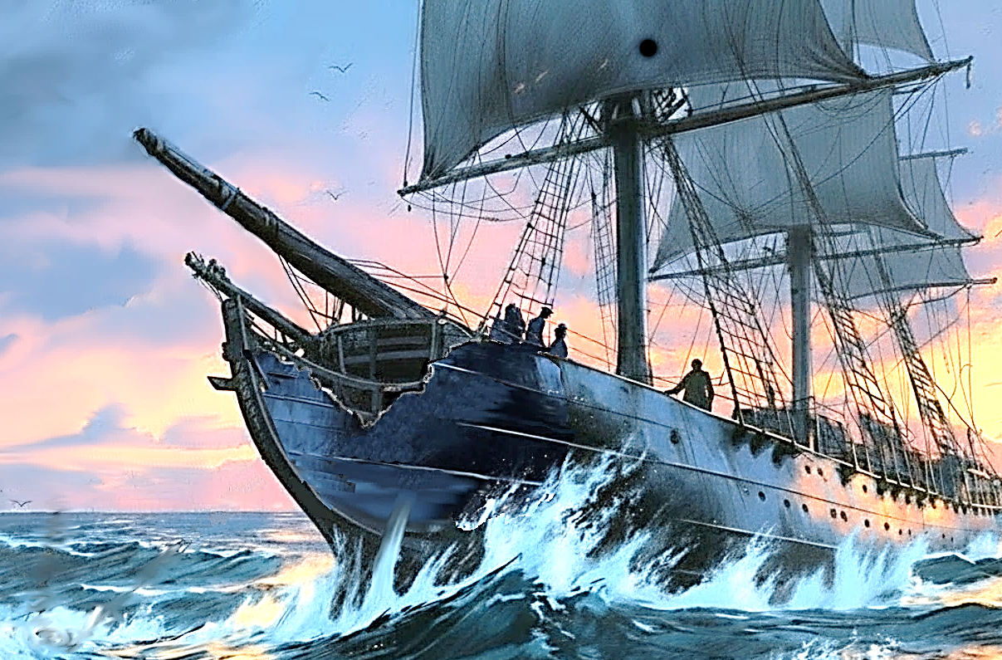
T
he bright sunshine wasn’t fooling anybody on De Zeeroos; everyone knew in less than an hour they would face the maelstrom again, so the men were busy. The captain had deckhands fetching replacement timbers for the damaged hull, while Willem, Sophie, and others gathered reams of fabric and torn sails to protect the interior from the ocean spray. The plan was to pull together the ragged gash on the forward section like a surgeon. Crews would use a lattice of ropes to cinch the wound together like stitches, made waterproof by a tarred sailcloth covered by a sheet of silk as a bandage. To do this, they needed only one more man.
Dorus was called topside to pull it together—literally. The big man would need all his strength to bend the ship frame with the strongest tow ropes onboard. These lines would be laced over the intact supporting ribs (bulwarks) on either side, then Willem could weave the towlines across it like lacing a boot. Once done, both cables had to be pulled back manually to the main mast together, and that’s when Dorus earned his pay.
This idea was explained to the men several times, but finally the captain called for parchment and quickly drew a rough sketch illustrating his idea. Only then did everybody really understand what was happening.
The tow ropes would require a tremendous force to bend the boat frame and draw the broken sections together, and there was a real risk the beams might split in the process. However, the darkening skies and a jarring thunderclap hastened the matter, so the Dorus grabbed the lines and began to pull them with the strength of an ox.
The straining hemp fibers creaked as he slowly dragged the incredible weight, one aching step at a time. When a dozen sailors joined the effort, the fore timbers began to give, and the gap began to close a little. The rope was nearly stretched to the breaking point when Dorus and the crew finally pulled the cables around the masthead with the help of even more men, who tied the lines to cleat hitches on either side of the ship to finish.
Soon, the seas started to boil once more. A flash of lightning showed the front hull still with a gap, but much smaller now. Exhausted, Dorus tied off the ropes and stumbled to the front of the ship to recover. Quickly, Sophie and the deckhands pulled the sailcloth over the hole with leather straps and wrapped it all in undyed silks to waterproof the cover. But the worsening storm and vicious sea spray drove them off before they could really finish, as they risked being washed off the ship. The result was an ugly, wet clump of dirty fabric, flapping wildly in the rainy wind.
Dorus saw that this “bandage” wouldn’t stay long unless someone held it down against the gales. The giant took the straps in hand and wedged himself between the foremast and the flagbox, bracing against the winds. He waved off crewmen who beckoned him below deck and prayed for the strength to hold that fabric down as it whipped and struggled to break free. If successful, the fore section wouldn’t flood and the giant would come out of the mess a hero, but it would be a long night until then.
Another thunderclap drew everyone else inside except for Joost, who was still looking for his missing Kaatje. But as the song of the raging tempest grew louder, he was driven back into the stateroom and the next dance with the devil began.

In the morning, seas were calm once again, but everyone looked dazed and exhausted. The crew staggered topside to make sure the sun still existed, and along with Sophie, Joost, and the officers they thanked the stars for their survival. But at the moment, most souls onboard were looking for a clever calico cat that had disappeared.
As for Kaatje, she couldn’t see anything—it was total darkness. But she could hear the waves slapping below, so that was comforting. Her right side ached, and when she tried to rise she failed. Even in the dark, her whiskers, her curious paws, and her restless tail helped the cat figure out she was trapped under a tea crate and covered with dried mint leaves. It hurt when she drew a big breath, but she was able to speak with some effort. But after only a few cries she was already exhausted and laid back down in the blackness to recover.
Two decks above, everyone was still looking for Kaatje. Joost had climbed to the crow’s nest, Willem checked the forecastle galley, and the other sailors were exploring the rest of the boat, calling for her. The fear began to build that perhaps the cat was swept overboard during the hurricane, a thought that terrified all. That fear took hold when the search got to the aft cargo compartment, and the crewmen discovered the dire situation.
The entire rear cargo hold was now a huge pile of jumbled furniture, coffee sacks, busted barrels, broken bottles, splintered wood, and nearly everything else that was being shipped. Willem suspected Kaatje might be buried under the mess, so deckhands were called down to unpack the clutter, forming a human chain to remove the debris. Some of the furniture was heavy, so Joost went to fetch Dorus to help with the big stuff.
After a few minutes, the soft cry of the missing kitty could just be heard over the wave noise. Willem froze, his hand outstretched to quiet the men and locate the sound. He pointed, and quickly the crew removed about a dozen crates of tea that had spilled, uncovering a traumatized feline lying on its side, obviously in distress. The cook Willem came forward and carefully cradled the wounded animal, who was growling quietly in pain. Helpful hands pulled her up out of the heap, and immediately they went to the sickbay on the bow end of the forecastle.
When word about Kaatje got to Joost, he ran below deck just in time to see the ship’s surgeon, Doctor Zwaar, heading into the sickbay with his medical bag. The physician had never treated a pet before and asked that all leave the room, except for Joost, while he worked. The healer inspected the cat’s injuries and cleaned her wounds with diluted alcohol. A morsel of cooked fish was offered, but after a bite there was little interest. Strangely, the patient was purring the whole time as her person spoke softly and gently stroked her fur during the examination. The friends were back together.
Afterwards, the surgeon voiced concerns that Kaatje may have internal issues, like a collapsed lung or cracked ribs. Otherwise, she seemed most in need of a few days of rest. He instructed Joost to keep her calm and stable, with clean water and hand-fed fresh food. It looked like the mascot was going to be okay.
Yet just as one crisis was resolved, another tragedy was revealed. And while Joost was reluctant to leave his pet alone, he desperately needed to speak with the captain.
The officers thought this was about Kaatje. It wasn’t.

CHAPTER THIRTEEN – A TRAGEDY

E
veryone knew as they gathered on deck what Commander van de Velde was going to say, but they all needed to hear it to make it real. Sophie was comforting Joost as he cried a little and held his hand. The officers looked devastated as the captain began to speak.
It seems after a thorough search of the ship, Dorus could not be found onboard. Sometime during the night, he announced, the big man was swept overboard during the storm and likely drowned at sea.
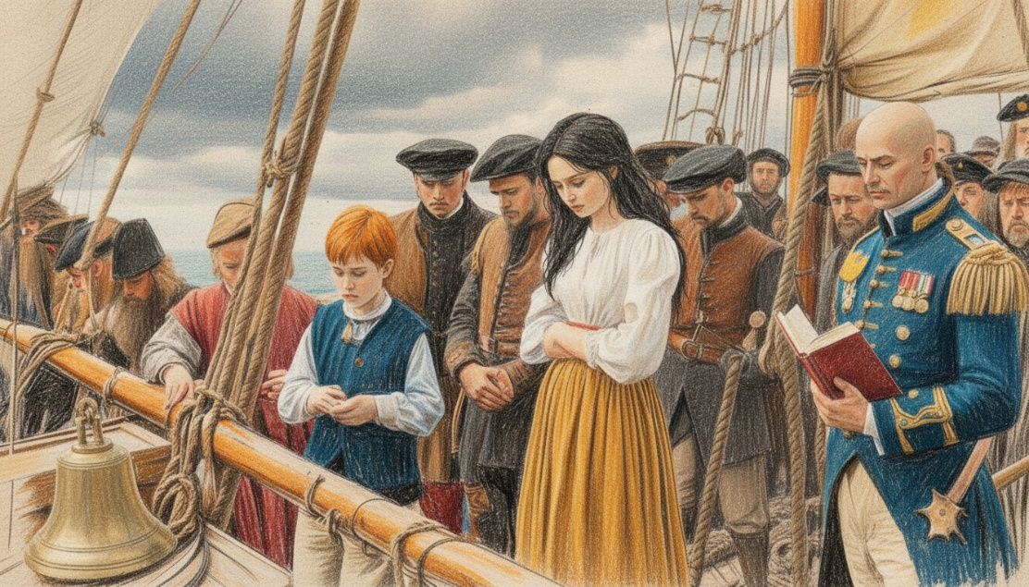
When the news was confirmed there was utter stillness for a long moment, save the wind and the passing waters. The sails flapped gently, a few waves slapped the hull. The Dutch flag waved proudly on the foremast as tears welled in the eyes of strong men.
Jop rang the ship bell three times, so the officers and sailors removed their hats and bowed their heads. Willem came forth with the same worn Bible that Dorus once owned, and read a passage aloud. Everybody stared out at the cruel sea as the words washed over them, but no one was listening. Even after the crew were dismissed, nobody moved for a long, long time.

A fortnight later De Zeeroos had rounded the Cape Agulhas and was now just another week from Cape Town, bound for the outpost where the bow could be repaired and lost stores replaced. Kaatje was already walking again, but had not been topside since the accident. Sophie and Joost stayed with the animal for hours, until the Doctor Zwaar allowed her move from the sick bay to the stateroom with the Suikerzoet.
Belowdecks the cargo team had cleaned up the hold and rebalanced the shipments as best they could. The storm damage was costly, and about a fifth of the merchandise was lost – mostly silk fabrics, spilled coffee, broken wine bottles and ruined sugar. Of course, the boat rats loved the mess and the new foodstuffs had them running all over the ship. With Kaatje still in recovery, it was time for the Suikerzoet to earn her keep!
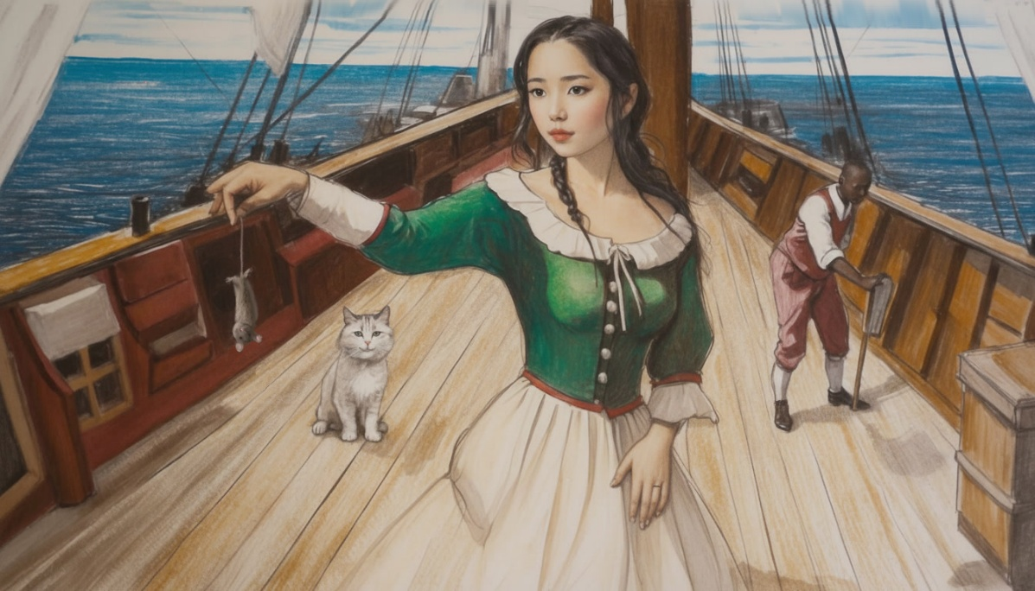
The worst of the varmints stayed in the lowest hold (bilge) right along the keel, so that’s where Sophie brought Suikerzoet by lantern light. Unfortunately, the cat’s pretty white fur made it easy to see in the half light, so the mice avoided the mouser altogether. But the little aristocat could slip into narrow spaces the calico could never enter, and once she caught a scent she cornered prey with quiet precision. And while there was no escape for many, none were eaten either – this was purely sport for the aristocat.
Miss Sophie surprised everyone by showing off a rat to the men, dangling from its tail. Between that and her heroism during the storm, the crew’s concept of her as a princess was quickly abandoned.
In fact, the young woman had changed after a couple months at sea, replacing frilly dresses with practical skirts and bundling her hair under a hat for convenience. In short, she was fast becoming a part of the crew.
When Kaatje inspected these trophy mice on deck she immediately knew her friend Suikerzoet was responsible. A sniff confirmed these rodents were local stowaways from Batavia, likely hiding in the tobacco leaves by the smell of it. The feline was a touch jealous, as she had been getting a little restless during her recovery and yearned to get back in service to De Zeeroos, her home on the sea.
A couple days outside Cape Town, the ship rounded the sheer cliffs of Cape Hangklip under fine sails, the favourable northwest trade winds driving the vessel forward. They passed the graveyard of wrecks again, a grim reminder of how close they’d come. Sophie, Joost, and Kaatje practiced leash-walking Suikerzoet on deck; it would be her first time ashore in months. The rest of the men shaved and washed on deck while teasing each other about women and beer.
Twenty-four hours later, locals greeted the ship as it turned into Table Bay, with docks of smiling locals with waving arms. But these same faces turned to looks of concern as the bandaged vessel got closer and limped into port. The frigate had obviously seen better days, and Scheepstimmerman (ship carpenters) were called up by the harbour master. Upon inspection it was determined the bow damage on De Zeeroos was so severe that repairs required an extended stay at the outpost. But no one was complaining.
The sunny port was busy and once docked, the crew had a long list of jobs to be done. One of those tasks was to deal with Captain Cornelis Jansen, the Danish renegade taken onboard a month ago. For his betrayal he was arrested and chained onboard a tender, and then rowed to Robben Island, a Dutch prison just across the bay. There he would be dealt with on a return voyage, as time was short just now. The other Danish were happy to be spared and were grateful to the Dutch for their lives.
Back at the docks, Kaatje was ready for adventure again and both cats were leashed so they could be walked into town. On the boardwalk, Joost beckoned Sophie to a specific area near the warehouses he saw before, and showed her a dozen black children chained up in the shade. Being a little older, she knew exactly what this was and began to feel uneasy about their safety. Just then, a large African man appeared in front of them both, yelling at them in a foreign tongue and leading them away - even as they protested.
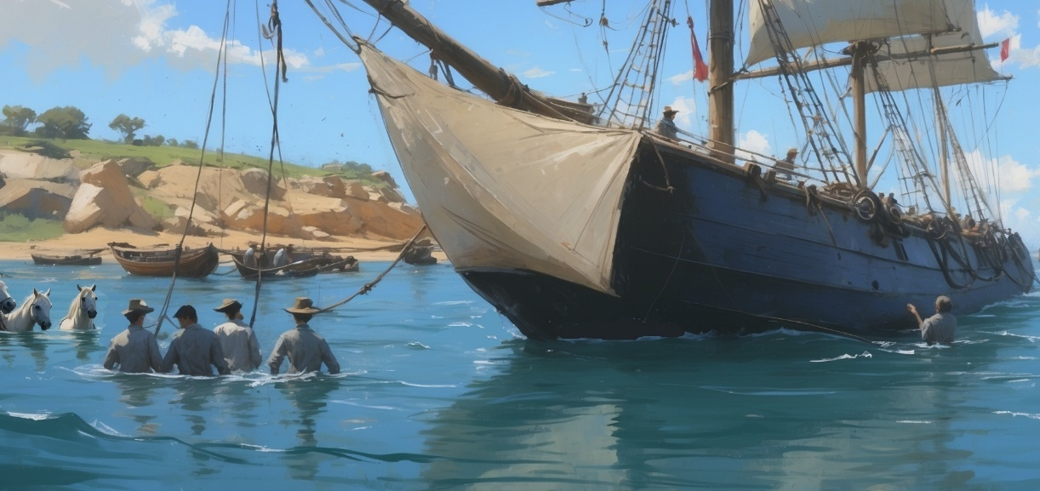
Meanwhile, the ship was taken for repairs. After the officers disembarked, the deck crew was tasked with moving the huge vessel ashore to the shipyard for work. Several bigger crewmen waded into the shallows with hired horses to pull the boat up the slipway with thick ropes. They were all wishing Dorus was there to help, but soldiered on out of respect. Once the bow was mounted on the boat ramp, the stern was secured and service could begin to reconstruct the front of the ship.
In town, Sophie tried to make peace with the shackled children she witnessed. She had heard about slavery in the governor’s palace in the past, but she had never seen forced labour herself. Now, looking into faces of enslaved kids, she had the overwhelming sense that this whole enterprise was wrong - in all sorts of ways. She felt the need to know more, perhaps write her father about it, to do something. But for now, a bustling market with hollering merchants and two nervous cats were stealing her attention.
The level of activity seemed a bit much for the pets, and both animals were soon being carried like babies through the marketplace. The couple found a shady spot near a musician who was playing a strange flute melody and a native girl selling candles. Joost paid a black woman nearby a couple coins to buy a warm bowl of pap, a fig porridge sweetened by honey served with cornbread. It was warm and delicious, even the cats seemed to like this new treat, as they licked the bowl clean purring for more.
All at once, the peace was broken by a tiny hairy man that ran by and boldly stole the wooden bowl from them all. The soup woman abruptly gave chase after the monkey, as both cats tucked behind their owners, overwhelmed by the scene. The little robber moved quickly and expertly amongst the merchant stalls and slipped away, with the shopkeeper reappearing minutes later, mad and empty handed. Sophie spoke to her in Afrikaans, an African dialect of Dutch widely used by natives.
The curious girl learned that Squirrel Monkeys were clever, social animals trained by street thieves to steal and run. None of the Dutch visitors had seen one before, so the explanation reassured them that some race of furry midgets weren’t terrorizing the locals. But they kinda were, because a moment later that SAME MONKEY raced by the again, chased by another shopkeeper – now with a live game hen in it’s mouth!
It was probably just instinct rather than bravery, but this time Kaatje bolted out from behind Joost and tackled the crafty bandit in a cloud of dust. The guinea fowl ran off squawking while the predators fought on before shocked shoppers. When the smoke cleared, one could see the cat had wrapped herself around the culprit in a death grip, and now the two were twisting like a knotted snake in the dirt.
Just then, a very tall negro man came over and barked a name at the tangled animals. This startled Kaatje, so the monkey broke free, jumping up onto the man’s shoulder, obviously his pet. The feline was dismayed at first but then puffed and hissed at the man for taking her kill. Suikerzoet jumped down and joined her, a tiny voice mewing from a bristling ball of white fur - which was adorable.
The soup woman went on a rant against the towering African and the two argued loudly in a foreign language, gesturing wildly. As people gathered, the Dutch kids grabbed their pets and slipped away, bumping through the crowd towards the ship with haste, holding hands as so not to lose each other.
As they came out to the harbour, they realized De Zeeroos wasn’t in port anymore but still in repair at the shipyard. They also realized they were still holding hands, and dropped them when Captain Maarten and Willem appeared. They walked towards them from the warehouse district with important news – they were all invited to meet with the provincial governor tonight at his mansion.

CHAPTER FOURTEEN – THE RECEPTION

T
he late afternoon in the port was particularly warm and breezy as trade winds brought the sweet smell of nearby orange groves into town. While the deck crew were having a barbecue at the fort barracks north of the city, the officers had dressed up in their finest with other plans.
Cape Town Governor Simon van der Stel had invited Captain Maarten and his nephew, along with his advisors and Miss Sophie Maatsuyker, to a formal reception in their honour. The Governor’s House was originally an elegant greenhouse, but the old Tuinhuis (Garden House) was recently converted into an assembly hall for entertaining visiting dignitaries.
For Joost and Sophie, the moonlit evening was magical. Lanterns flickered along the garden path leading them to the grand pavilion, casting golden light on Dutch flowers reflected in the polished windows. Inside, a rotunda of carved teak columns supported a gracefully vaulted ceiling, providing a canopy of glass skylights that revealed the Southern star constellations and framed the rising moon.
Tailored guests arrived in silks and satins, and the doorman announced them by name before they were welcomed by the governor himself, along with his wife and a few advisors. A handsome guitarist played in the corner as well-dressed Black servants approached the colonial elite with ale, wine, and delicacies.
While Miss Maatsuyker might have been used to this sort of pageantry, Joost van der Velde was not. The overwhelmed teen may have looked like a confident young man, but he felt like a misfit, as if he’d stumbled upon a masquerade without a mask. He spent much of the first hour by his debonair uncle, being introduced to important people with fancy names and even fancier titles. But after a while he was done with it all and hoped to find the delicious meal that was promised.
It was Miss Sophie who was the belle of the ball. Her natural beauty outshone everyone in the room like a chandelier, and despite her age her light attracted more than a little male attention. Joost didn’t love that, which is probably why Commander van der Velde kept such a close eye on the pair. This made slipping away together difficult, so the bored teenagers played their roles well for a time. Yet once the banquet was announced, they both ran to the dining parlour like the kids they were, stealing seats near their favourite dishes despite staff objections.
The servants were about to move them to their assigned places when a sudden stampede of hungry socialites distracted everyone. It turned out well for the youngsters, as they sat with Captain Maarten near the head of the big table, while the other kids sat at the “children’s table” in the kitchen.
Soon, a seemingly endless parade of freshly cooked food was brought to the guests over the next two hours, and the Dutch teens ate until they were nearly sick. With overfull bellies, they were just waiting to be excused, tired but happy with their special evening so far.
But the cats would tell you their evening wasn’t special at all. Not only weren’t they invited to the reception, they were confined and made miserable, missing the feast entirely.
Hours earlier, it was made clear that pets couldn’t attend the formal welcome ceremony, so the furballs were caged in an old chicken coop near the dog kennels. The animals had been suffering there ever since, and between the constant barking and separation anxiety, Suikerzoet was at her whiskers’ end. Once it was dark enough, it was time to escape!
While Kaatje could never fit through the slats in the coop, the sweet white one just might. She tried several spots, nudging her head sideways in frustration, until she found a weak board and pried it loose with her paw, creating just enough space to slip out. The cat was shocked to be free, and for a moment she just sat there, getting her bearings. Then a noise broke the spell and suddenly a servant boy appeared, startling them both. Before the escapee knew what happened, she was thrown back into the cage. But the moment the top came off, Kaatje flew out with an amazing leap, landing claws-deep in a wild peach tree nearby. His partner slipped through the slats again and scrambled up the same tree, both now safely out of reach.
The boy yelled for help and ran off to find someone. Once he left, the fugitives dropped from the tree and began a scent hunt for their owners. The rotunda ruckus caught their attention, so they used the cover of night to approach the party in shadows. Stalking closer, Suikerzoet heard guitar music, like Sophie would make, and dashed toward the sound instantly with the feline close behind.
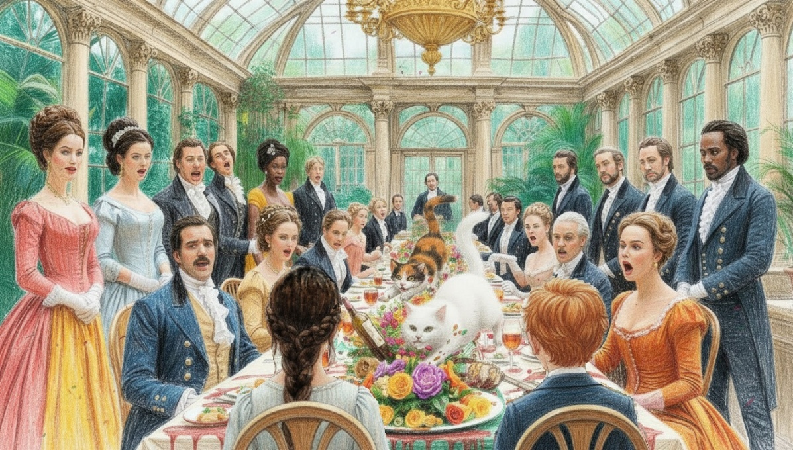
In the dining parlour, the feral cats burst through the thick drapes like cannonballs, launching themselves across the formal dining table toward the two stunned Dutch kids at the far end. Guests gasped as claws tore through embroidered tablecloths, scattering silverware like shrapnel and sending fine crystal crashing to the marble floor. A silver bowl spun like a top, flinging soup into the faces of startled aristocrats. The duo ripped through flower arrangements, which exploded into a confetti of petals. Then a candelabra toppled—igniting napkins in a brief, smoky fire. As a finishing touch, the beautiful peacock centrepiece was knocked sideways into a pot of stew as the excited outlaws found their masters.
The cats’ unbridled display of tail-high affection and purring nudges with their people revealed their motivation, but ignored the battlefield of smashed dishes, shattered glassware, scorched linens, and dazed guests they’d left behind. But soon laughter replaced outrage, and the madcap incident was ultimately met with good humour, grace, and forgiveness.
Locals chuckled as their noble guests dabbed soup from their outfits, while footmen tiptoed through the minefield of porcelain chips and broken glass. Though amused, Captain Maarten was none too happy with the spectacle, but there was really no one to blame. He urged the kids to take their pets back to the guesthouse and lock them inside until he figured out what to do next.
Meanwhile, the cats lounged beneath the table, licking gravy from their paws and watching the cleanup with the smug satisfaction of artists admiring their chaotic masterpiece.

CHAPTER FIFTEEN – CAPE TOWN

O
ver the next fortnight De Zeeroos was repaired and readied for the return voyage back to the Dutch Republic. While the sailors, deckhands, and crewmen stayed behind working in the shipyard, Sophie, Joost, and the cats were treated like royalty. The young travellers enjoyed sunny mornings with ripe fruit and fresh coffee, wonderful afternoons in the giant gardens, and luxurious nights in the heated guesthouse. The cats stayed near the fireplace for the most part, preferring each other’s company to the outside world. But for Sophie and Joost, each day was a little adventure.
Rainy days were spent dealing cards, playing guitar songs, and chasing the cats, while evenings included reading lessons, figure sketches, and letter writing after dinner. Twice they attended the Reformed Protestant service at the same little chapel where, months ago, Kaatje had given a most unusual sermon. And of course, they still enjoyed the bustling market on the weekends—though better without their chaperones or their pets involved.
However, the best days were when the house staff gave them special tours of the vineyards, orchards, and citrus groves that surrounded the outpost. One afternoon in particular included an intimate horseback ride with a guide to the top of Table Mountain. Once at the peak, they dismounted, letting the horses graze while they raced to the cliff’s edge.
When they stood side by side, the view hit them like a gust of wind—Cape Town sprawled below with a quilt of red-tiled houses, rooftop gardens, and brick chimneys with threads of smoke. The sparkling harbour itself was busy with sails and cranes, with the sentinel of Robben Island embraced by the curve of the bay. To the south, they could see the Twelve Apostles mountain range marching along the coast in a jagged line, with the Atlantic stretching beyond it, shifting and endless. For a heartbeat, they felt like real explorers, and their hands found each other. Just then the chaperone broke in and reminded them of the time for the journey back.
The next day was sunny and warm, so the kids slipped away to the beach for the afternoon, leaving a note for their Uncle Maarten rather than asking permission. It was a long walk around the southern arc of the bay, but scrubby forests of milkwood and wild olive trees finally gave way to coastal wildflowers and sea oats. Knowing smiles increased their pace once they could smell the salty air with glimpses of the eternal blue line of the Atlantic on the horizon.
The duo crested the dunes, their feet sinking into the sun-kissed sands revealing shimmering ribbons of waves rolling in, relentlessly curling and collapsing. Once at the shoreline, they dared each other to wade into the surf, then shrieked at the cold shock, retreating from the chilly waters. This reality was unexpected, in stark contrast to the blazing sun and balmy trade winds enjoyed dockside.
The African beach stretched wide and long, its golden strand flecked with rounded stones, broken shells, and clumps of seaweed. The teens spent the afternoon splashing around in the warmer tidal pools and collecting seashells before settling down for a picnic. A few sandcastles later, the setting sun reminded the couple to return, so they started the long hike back, hand in hand, with memories in their pocket.
While the children were away, the cats had adventures of their own, which included disappearing from the guesthouse. Housemaids and servants searched for hours before they had to report the animals could not be found and had likely escaped again.
This was of grave concern to Commander van der Velde, as he knew how much the pets meant to the kids. Worse, an important turn of events meant time was running out.
Earlier, the captain had discovered a VOC convoy under the command of Admiral Hendrik van Haarlem would be sailing by Cape Town the next day. He decided their defenceless frigate should join the fleet for protection on their trip north. This meant the repaired De Zeeroos had just 24 hours to prepare for the months-long voyage. To that end, the ship was pulled from drydock and was now busy being loaded by tenders in the harbour. At the guesthouse, everyone’s belongings were being sorted by the staff in a hurry—except now there were two missing cats and two wayward teenagers to worry about.
It was approaching twilight when the pair arrived back at the guesthouse, and waiting on the steps was a visibly upset Commander, note in hand. He was none too happy with the couple because their cheeky escapade had him worried all afternoon. At the same time, he hated telling them their cats were lost, and that they had to leave almost immediately. They might have to leave the pets behind!
The kids knew there would be some trouble for their antics, but as they approached the guesthouse Joost sensed something bigger had occurred. After a brief exchange on the porch, the group stepped inside and Uncle Maarten had them sit down in the lobby for the bad news. But just as he began to speak, two familiar furballs bounced down from atop the curtain rods and made themselves known to everyone’s shock!
With tails high and lots to say, the rascals had simply ignored the staff’s repeated calls all afternoon, spinning everyone into a tizzy. Now these cats acted like nothing had happened, so a relieved Captain Maarten moved on to the more important topic: their sudden evacuation.
Dawn was just breaking through the fog when Pim rang the ship’s bell to raise anchor and get underway. A few locals and the house staff waved goodbye from the dock, but most of the town was asleep at this hour; there were no musicians or dignitaries for this departure. Once disembarked, they set a course for nearby Robben Island where the ship was to rendezvous with the VOC armada in a few hours.
Newly restored and fully provisioned, the boat itself was ready for action, except it still lacked any real firepower to defend itself. But it was smart to sail with a convoy rather than alone, as a pirate attack was unlikely against such a powerful flotilla. Plus, the Dutch were still at war with the French, so it made sense to travel as a fleet.
Of course, the cats were on deck for this misty farewell, even as their masters were finally asleep after a frantic night of packing and loading. But the rising sun and constant commotion made real rest impossible, so eventually everybody gathered on deck as they approached the west side of the isle. From a distance the island looked deceptively calm, but every sailor knew the truth: this was a prison.
Robben Island is low and flat, with a jagged coastline that breaks the waves into a white spray. Crying seabirds circle above its shoreline, where grey seals bask in the sun on giant rocks. As they approached the stronghold from the south, prisoners could be seen lined up next to a stone building defended by a guard tower. Jop saw one of the inmates wave to the ship through his spyglass, an odd and sad gesture that showed how desperate these men really were. For a moment he mused whether it might be Jansen, and he considered how quickly that man’s fate went from captain to convict.

A distant cannon shot of greeting interrupted his thoughts as a VOC fleet of a half-dozen ships announced itself in the morning haze. With perfect timing, De Zeeroos slipped into the middle of the fleet at full speed as fellow sailors waved and cheered. Signal flags spelled out Captain Maarten’s intention to the flagship, De Morgenster under Admiral Haarlem’s command.
As the vessels got closer, the big Admiral came on deck and waved to the newcomers as his crew sang a Dutch sea shanty of welcome. After the greeting, the crews attempted to sail the boats together, but there was a problem.
The giant ships in the convoy were heavier and much slower, so the riggers on De Zeeroos were constantly adjusting alignment and position to keep from overtaking or colliding with the fleet. Joost and Kaatje’s directives from the crow’s nest were critical for this task, keeping the boats safely in formation.
Unfortunately, the weather in the South Atlantic doesn’t care about keeping a formation—a lesson that was about to be learned as the Dutch ships headed into the open ocean.

CHAPTER SIXTEEN – THE DOLDRUMS

T
he fleet had only been at sea a few days when one morning the sun simply never came out. The dark grey skies remained unchanged, with thick, blinding walls of fog lasting all day. Sometimes it seemed the clouds were so low you could touch them, which was actually the case in the crow’s nest, as Joost could feel the mist and could barely see his ship below. Everyone kept waiting for the weather to rise or burn off during the day, but it never did.
With visibility measured in voet (feet) rather than mijlen (miles), sea fog made convoy sailing a challenge. It also made ship-to-ship communication difficult, as signal flags, lantern lights, and calls or hand gestures were useless at this point. Worse, the constant threat of drifting away or colliding in the soup meant slowing down the whole flotilla, lengthening an already long voyage home.
It was strangely quiet on deck when Joost, Sophie, and the cats finally emerged topside to see the matter. Along with the crew, they were spellbound by the odd scene—sailing blindly into a white void was frightening. At night it was worse; it was like the ship was hovering in outer space. The sailors literally couldn’t see anything, not even the ocean below, so tension grew on board as everyone felt increasingly uneasy.
Helmsman Pim tried to calm nerves by explaining that when warm African breezes move over the colder Atlantic waters, mist forms as the air cools down and a cloudbank is created on the waves. The navigator hoped that by staying the course north they could get out of this mess in a few days.
That didn’t happen.
For nearly two weeks, the same cycle repeated over and over. There was barely any wind, even as strong ocean currents moved them along. The thick fog that formed overnight meant every morning the sun was invisible, just a dark grey sky that made accurate navigation impossible. Only Pim’s trusty compass confirmed their northern course, but it could not tell their position on the map. The nautical term for this is the doldrums, and they were stuck in them.
Sophie used this time to write down all the adventures the crew could remember over the years, including the stories in this book. Joost had fewer duties in the doldrums, so he and Sophie spent more time talking and reading stories of adventure to each other. The reading practice was good for the boy, who was becoming more literate every day, but it was also good for the crew; they listened in. It became an unofficial ritual that after dinner most of the crew would lounge around topside so they could hear Sophie reading books aloud or playing the guitar. It was the only happiness on board, as the featureless voyage was so strange it was beginning to drive everyone a little crazy.
For the cats and crew, these comforting routines gave structure to these weird days. There were still dozens of important jobs to do, and the men relied on each other to get them done. This camaraderie extended into the evening by cooking meals together, making songs and telling stories, playing cards, and gambling—anything to pass the time.
Captain Maarten and Pim’s biggest worry was that the ship was also drifting west every day, away from the African coastline and into the endless Atlantic. The fleet was not provisioned for this extra travel, so each moment off course was a step toward disaster. Additionally, most of the heavy convoy ships had more hull below the waterline to anchor them against surface currents. De Zeeroos was much lighter and thus more inclined to drift, and that’s exactly what occurred.
After thirteen days of blind sailing in dense fog, the winds finally shifted and the morning sky was blue and radiant. The bright sun and clear skies brought everyone up on deck and out of the misty dream of the past two weeks. But now a new nightmare began, as a scan of the horizon showed not a ship in sight, even from the crow’s nest. The Dutch fleet was gone.
It was not until evening that Pim was able to use the stars to reveal their exact position, and the news wasn’t good. They were nearly a thousand miles off course and likely hundreds of miles from the convoy or land. Essentially, they were lost at sea.
Everyone was so happy to see the sun return that news of their dire situation took a while to raise concerns, but a plan was already being made. Pim charted a new heading east, which meant tacking against the current by zigzagging with the crosswinds. This required nearly constant work for the riggers, as sails had to be adjusted continually to catch the air at just the right angle. Three-hour shifts were formed to fight fatigue and boredom, but the crew was anxious to get back on course, so there were no complaints.
After five more days, Pim changed to a true north heading, hoping to reach a safe harbour on the Dutch “Gold Coast” within a fortnight. The ship made good headway, and the air grew a little warmer every day as they approached the equator and escaped the frigid South Atlantic.
For the cats, life together had become a happy ritual, and the two made De Zeeroos their purrfect kingdom. Every morning was met with meows and complaints until a bit of fish or soaked hardtack was provided for breakfast, followed by a nap. Then came some scent-hunting for vermin in the decks below, bringing up any victims as fish bait, followed by a nap. After the sailors’ lunch around noon, they nibbled leftovers and cleaned the plates, soaking up pets and smiles from the crewmen, followed by a nap. After that, some ball chasing with Sophie, and then hide-and-seek all over the ship—well, you get the idea.

CHAPTER SEVENTEEN - LANDFALL

T
wo weeks later, seabirds started following the frigate, a good sign. Soon after, palm fronds, stalks of bamboo, and mangrove branches from a recent storm floated by, proving that land was near. With hope high and food running low, the prospect of landfall was all anyone could think about. The men longed for a break, to stretch their sea legs and walk on Mother Earth again.
The next morning, when Joost spotted a thin trail of smoke on the horizon, the men cheered and celebrated as the coastline was revealed. Captain Maarten had Pim head straight towards the plumes, which appeared to be coming from a coastal village. As they moved closer, the spyglass revealed the familiar town of Mouri and Fort Nassau, the same port in Ghana they had visited on the trip out. But now giant clouds of smoke made it look like the whole town was on fire!
Joost, still up on the mast, was most concerned about Ashe and her family, those amazing friends from last year. Now it appeared disaster had struck, and the officers debated the situation—why was the village aflame? Was this retribution for thwarting the pirate attack last spring? Or maybe the French had burned the town as part of their war against the Dutch. Perhaps it was just a rogue lightning strike that set the port ablaze by accident; whatever the case, answers were needed.
Luckily, the right answer was “none of the above.” It turned out the villagers were simply torching the farmland in a controlled burn to enrich the soil for next year’s crops. Most of the farms were behind the village in the countryside, so from the sea it looked like the whole town was on fire. But as the big ship approached around noon, worries about disaster were replaced by cheers of appreciation. The locals remembered how De Zeeroos had saved the port from pirates last spring, and when they recognised their Dutch heroes, they gathered at the docks to greet them.
This reality was a special relief for Joost, who was anxious to reunite with his friend Ashe and her family. When the ship pulled up dockside, the boy could see the whole clan waiting for him, surrounded by happy Asebu villagers. As the boat was tied up, native women in colourful clothes began chanting a song of welcome, and the scene was set for a great homecoming.
Once the ship was secure, the teens took their cats down the gangway to the marina to join the locals, where Ashe and Joost embraced like siblings. When the boy introduced Sophie (and the cats) to his “African family,” Albani once again helped the love flow by translating the lively reunion. Soon enough they all became fast friends despite their differences.
Ashe was especially delighted to meet Sophie, the first white woman she had ever seen, since nearly all sailors were men. After the meet-and-greet, they gathered together under a baobab tree for a picnic lunch to catch up on a year’s worth of adventures.
Later, Ashe and her father took the Dutch kids to see a special surprise on the outskirts of the village, while their cats were busy hunting down leftovers. As they approached a cluster of neem trees, the natives slowed down, stooped, and urged silence. The group entered the grove with caution because on the far side of a clearing was an amazing sight.
An African savanna elephant was grazing at the tree line with her back towards the team, unaware of their presence. Joost and Sophie were wide-eyed in amazement, having never seen the world’s largest land mammal before, standing a dozen feet tall just a ship’s length away! The clan stayed hidden safely in the forest, watching the giant creature from afar. When the elephant finally turned around, her magnificent trunk and huge ears were revealed, even as her ivory tusks were short and broken.
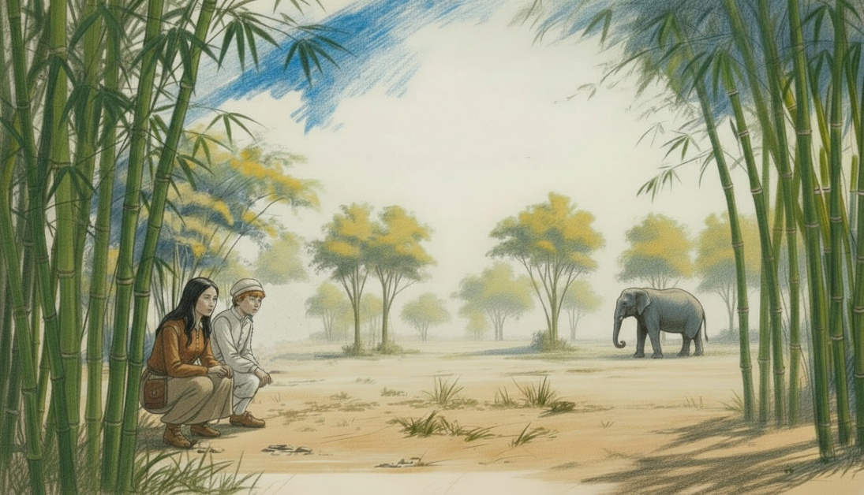
Ashe explained that elephant tusks were made of ivory, a rare, precious, and expensive resource, and thus a prized possession. Lucky for “Elenor the Elephant,” her tusks had been damaged years ago, so she was kind of a pet, and no longer a target for poachers—people who trade in tusks for profit.
Just then the elder broke cover, waved, and got the huge animal’s attention, while still indicating the kids should stay in the woods for now. He called out to the giant in Fante, the local language, and she returned with a glare and a snort before slowly walking towards them. And while the visitors were glad to get a closer look at the huge curiosity, they were rightfully frightened of the ten-thousand-pound creature coming towards them.
When Elenor was just a couple of horse lengths away, the tribesman whistled and the elephant stopped. A few bananas were thrown down, which she enjoyed, and then she kicked up a bit of dust before returning to the edge of the forest. For the Dutch kids, this was a once-in-a-lifetime moment they would never forget, and they talked about it endlessly on their way back to the settlement.
By the time the sun went down, half the village and the entire boat crew were enjoying a beach barbeque with a fire, surrounded by an African drum circle. The rhythms pounded as ale, wine, and stories flowed, along with some tears for Dorus. A touching toast was made for their lost friend, gone but not forgotten.
When twilight gave way to starlight, Sophie unveiled her guitar, and people bundled up near the bonfire to listen and relax after dinner. The cats, lulled by good vibes, familiar music, and a toasty fire, curled up in whatever lap they could find to sleep in peace.
That peace didn’t last long. Hours later a single, distant cannon shot got everyone’s attention. The officers and elders stood up in concern with Commander Maarten, who asked for a telescope while already walking back to the harbour with his advisors. Everyone else was still so relaxed they decided to let the authorities handle it, and the bonfire crowd went back to their gezellig (cozy) evening of mead and music.
As the captain’s group reached the pier, the commander called back for his nephew: “Joost!” to join them onboard. He gave Sophie a helpless look and then took off to help his uncle, with Kaatje on his heel.
While there was no moon to see by, the starry sky revealed enough to be worrisome. Joost was sent up the main mast to confirm the sighting of three large ships on the dark horizon. Over the next hour, the boats came closer and doubled in number, hinting there might be a French naval assault in the works.
Far past midnight, Captain Maarten rang the ship’s bell in alarm, calling every sailor in earshot back to the frigate—a most unwelcome turn of events for the half-drunk Dutchmen. However, once onboard and briefed on the situation, the crewmen sobered up quickly in the light of this new threat.
Of course, De Zeeroos still had no defences except for some painted tree stumps and a few muskets. Orders were sent to open the armoury below deck, where a few more guns and a dozen swords were found. After handing these out, the commander called upon his young nephew to run the two miles to Fort Nassau with his official request to arm the garrison and prepare for battle. Time was critical, as now even in the dark, the outline of six large watercraft could be seen coming straight for the settlement.
Joost van der Velde grabbed the orders and a torch, then headed straight toward the stronghold, without a map or a plan, and in near-total darkness. It took the boy more than half an hour of dead ends, switchbacks, and wrong turns before he found the gated entrance to the castle—which was locked and unguarded. He screamed for attention, waving his torch and banging rocks on the heavy metal gates to awaken the night watch. Eventually, two annoyed soldiers came down to see the matter, but reacted with haste upon receiving the request and quickly relayed the message up the chain of command.
Still, it was almost two in the morning before the Fort Nassau belltower finally rang out a “call to arms” to the settlement, a sound which drew men from all over the outpost, as not all soldiers lived in the barracks. Soon after, local tribesmen blew a loud animal horn to signal residents to go into hiding while the town militia surrounded the docks.
By the time the last troops took their positions, the beaches were deserted, the bars were empty, and the militia was lined up, ready for a fight. Lanterns were shuttered, candles were snuffed, and the bonfire was put out. Nervous Dutch soldiers manned the castle ramparts with loaded muskets and cannons, while Fort Nassau’s commander stayed in the watchtower with his advisors, scanning the horizon. Even though it was a clear night, everyone waited in silence for the coming storm.
CHAPTER EIGHTEEN – A SACRIFICE

A
round four o’clock in the morning, the six giant ships were now large silhouettes against the rising sun and less than a league away. Joost and Kaatje, both exhausted from a night in the nest, continued to send down reports of activity to the bridge, but with the ships this close, the commander himself could see the armada seemed ill-prepared for battle. Their lanterns and torches still burned, a curious practice. The vessels remained in convoy formation rather than spreading out for an attack—another odd choice. And through his spyglass, he saw the approaching crewmen calmly lowering their mainsails rather than gearing up for a fight. Onboard, no one seemed hurried. Strange.
As the sky continued to brighten, so did the officers’ mood as they realized this was no French attack but the return of Admiral Haarlem and the missing Dutch fleet! De Morgenster and its VOC flag were now clearly visible in the morning light, and word spread to “stand down”—these were friends, not French.
Soon the entire town had gathered at the docks to welcome the Dutch VOC fleet to Mouri, and hundreds of grateful sailors poured into the little village in record numbers. They clasped hands with everybody, grateful to be on solid ground and appreciating the warm welcome and the simple joy of being safe among friends once more.
The population of the village temporarily doubled as nearly five hundred Dutch sailors enjoyed some well-deserved rest and relaxation before their final push north. With the Nassau barracks full and no hotels in town, generous locals allowed many sailors into their sheds, stables, barns, and homes. Even the warm beach offered a better night’s sleep than a swinging hammock; crewmen lay on the sand like sea lions, barking like them at times as well!
With his uncle’s permission, Joost and Sophie stayed with Ashe’s family, pampered guests who were constantly visited by well-wishers and tribal elders. It was quite an honour for the locals to host such important guests—the captain’s nephew and governor’s daughter were treated like minor celebrities. No surprise that even as the fleet was resupplied, nobody wanted to leave.
The departure was especially hard for the Dutch kids, as they had grown quite fond of their kind-hearted hosts, enjoying all the food, stories, and attention they provided. Dockside, their hugs goodbye were moving and genuine, given by an open-handed culture that valued people over profit, friendship over fortune.
Two weeks later De Zeeroos was rounding the west coast of Africa headed towards the Cabo Verde islands, their last stop before Amsterdam. Though they were well supplied and most of the crew was rested and fresh, a few sailors began to report sick to Captain Maarten. He immediately knew what the matter was and locked down the sick bay to prevent the spread of disease. Joost and Sophie, their precious human cargo, were asked to stay in the stateroom.
Typhus is a highly contagious and serious illness requiring isolation and rest. Often called “ship fever,” most of the victims were men who had spent the night in the garrison, including Willem the cook. He didn’t know that infected head lice in the barracks had caused the infection, but now he was suffering the consequences.
In a few hours a half-dozen sailors were struck down with high fevers, headaches, and an angry red skin rash. Many grew weak and couldn’t finish work, but it was Willem who worried the commander most. As an older gentleman, the cook wasn’t as strong as most crewmembers, and Doctor Zwaar was concerned that without proper hospital treatment he wouldn’t survive. What made matters worse was that the next day, the doctor himself caught the fever, putting the whole ship at risk.
Unfortunately, the closest medicine was in Cape Verde, an Atlantic port under control of the Portuguese—their old adversary. It was only two sailing days away, but getting there presented a big problem for Captain Maarten. He couldn’t just sail the Dutch fleet into port; that would be seen as an act of war. But he couldn’t send a lone ship either, as it would be seized, looted, and burned.
What was needed was a way to get into the port without the Portuguese knowing. But even as a plan was being formed, signal flags on other ships reported more bad news. The disease had struck five crewmen on the De Morgenster, and nineteen on the smaller pinnace De Kleine Valk (“the little hawk”). Finally, Admiral Haarlem decided to stop the entire fleet to deal with the situation, so over the next hour the half-dozen vessels were pulled together within shouting distance.
With the boats now loosely tied up on calmer seas, Commander Maarten and the other ship captains were picked up by a tender from De Morgenster so all the officers could meet and decide what to do. It was a dire situation, as more men were falling ill every hour. Without quick action, Typhus could wipe out the whole armada in a week.
Once discussions started it was obvious the crew of De Kleine Valk had the worst of it. Their captain reported two deaths overnight, and now twenty-four men lay in their sick bay. Luckily, the four remaining ships of the fleet were not infected yet, so those commanders were returned to their boats and cut loose. Hopefully, these would remain free of disease and provide a sanctuary for those onboard. For the rest, a difficult decision had to be made—one nobody liked, but there seemed no other choice.
In the midafternoon, De Morgenster was tied securely to De Kleine Valk, where its upper deck and crew quarters were converted into a floating hospital. Once established as a medical ship, much of its cargo was transferred to the other boats in the fleet, a slow process which took until nightfall. The cannons and ammunition were last, along with any extra tools or rigging. Then all the sick sailors from all the boats were transferred to the pinnace for treatment in Cape Verde. De Kleine Valk would be sacrificed to the Portuguese to save the lives of the crew.
A dozen healthy men were needed to sail the 30-hour voyage to the port, and the Danish sailors (picked up months ago) volunteered to man the pinnace. This made sense, because under a white flag the Danes were unlikely to be harmed by the Portuguese as their nations were at peace. Plus, with some clever negotiation by the new captain, Søren Mikkelsen, perhaps De Kleine Valk could be kept as payment for this risky mission—if he could somehow keep it out of Portuguese hands.
The plague ship departed the fleet at sunrise with a skeleton crew and the good wishes of two hundred Dutch crewmen. The remaining ships were disinfected with vinegar and the crew quarters cleaned of lice, to make sure no new cases of Typhus flared up. Linens, hammocks, and clothes were cast overboard as the convoy returned to formation for the final leg of their journey home.

CHAPTER NINETEEN – AMSTERDAM

A
lmost two months passed before the fleet finally sailed into Port of Amsterdam on the morning of May 6, 1675 - ending their eighteen month adventure on the high seas.
At first, only the outlines of the city appeared in the fog—church spires, dock cranes, canal bridges, and smokestacks all slowly came into focus. The smell of chimney fires drifted across the misty water and the clang of ship bells cut the air with welcome. As the harbor mouth widened, the waterways grew busier, with small craft darting past colourful bobbing buoys, harassed by laughing gulls and seabirds overhead.
Waving crewmembers lined the railings of the convoy boats as excited Dutch residents cheered on their arrival. The turn towards the docks revealed the familiar sounds: rattling carts, busy dockworkers, rolling barrels, hammering blacksmiths and music from taverns along the waterfront.
For Kaatje, it was a world of scents and sensations. The smell of pepper, nutmeg and cinnamon from open warehouses competed with the oily musk of fish guts, tossed from boats and fought over by gulls. Moments later the fragrance of sweet Dutch flowers mixed with the clean odor of boiling soap, only to be overpowered by the smell of cured tobacco bales on the landings.
The other ships followed the harbour master to their respective berths, with De Morgenster swinging out in front to tie up at Dock 8. In turn, De Zeeroos lowered her sails as she drifted into her position at Berth 5 of Dock #21. Sailors tossed lanyard ropes to secure the lines for tie up and dropped the anchors with perfect timing, forcing the giant vessel to come to an elegant stop, barely tapping the pier. This made Helmsman Pim smile and the crewmen cheered as they flocked off the ship.
Some sailors kissed the ground and embraced friends, family, and occasionally strangers – all glad to be back in their native land after so many exotic ports of call. For most of the Dutch crew, Amsterdam is more than a port—it was home.
Unloading the boat would occupy the deckhands for the next several days, so Captain Maarten allowed his nephew and their secret passenger leave to explore the town and find book sellers for Miss Maatsuyker. Though glad to be off the ship, Joost and Sophie were overwhelmed by the largest city in northern Europe, so Jop Rutte escorted them as a chaperone and protector.
The harbour city of over 200,000 people was overwhelming for the Dutch kids, as neither had been to a place this crowded or this noisy before. Amsterdam’s streets teemed with sailors shouting in half a dozen languages, rattling street carts, and merchants calling from storefronts at the endless press of people. The incredible scale was as dizzying as it was unforgettable.
Every canal seemed to bristle with masts, ropes, and sails, all lined with leaning shopfronts and gabled houses, their shuttered windows painted in deep greens and reds. Yet tucked between taverns, inns, and coffee houses were the many bookshops—small, crowded rooms where booksellers displayed shelves of their wares and printers plied their trade in the basement with noisy machines.
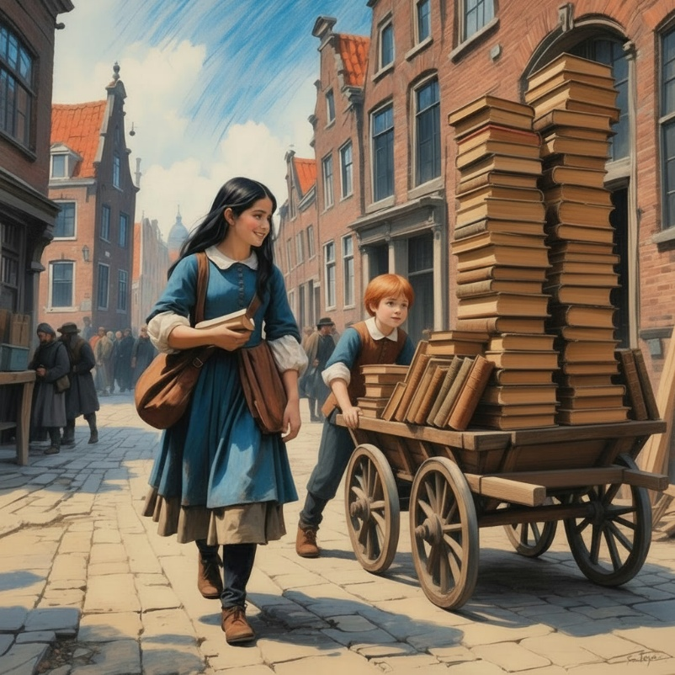
Sophie was delighted to find them all, visiting each like a bee in a flower garden and taking notes, making deals and buying fine literature at every stop. She had to hire a wagon to hold all the books she was buying, and the volumes just kept piling up with every visit. Joost was surprised how excited she got with each discovery, but even as a reader himself, he was getting a bit bored and tired with pushing the heavy cart around.
In 1675, Amsterdam was the publishing capital of the world, its presses humming with newspapers, Bibles, books, maps, and pamphlets, 24 hours a day—over 12,000 books a year. Yet the sheer number of printers alone proved Amsterdam’s wealth was not only in spices and silver, but in words and ideas. Sophie took notes about everything, from the way the shops were organized and managing inventory to advertising and display techniques, the woman was learning ‘volumes’ about the business.
Jop and the boy finally chose to set off on their own, leaving the aristocrat to her shopping while they chased adventure through the busy streets. Meneer Rutte was keen to visit a tavern or two, while Joost enjoyed a parade of jugglers, mimes and street performers marching by. After too long at the pub, Jop made up for with a visit to the suikerbakkers (candystore) where sugar drops, candied nuts, dried figs and spice cookies were bought, with a few extra for Miss Sophie.
A nearby curiosity shop amazed them both with stuffed animals, exotic seashells, quirky inventions and military artifacts, all displayed in candlelit windows. But as the market day drew to a close, the trio found each other and returned to the marina for dinner with the captain and his officers.
While work unloading De Zeeroos was being completed, most sailors remained onboard. But Joost and his uncle hired an elegant room at the Oude Stadsherberg (Old City Inn) for themselves and Sophie, and another suite for the officers. At the inn, part of the voyage’s earnings was divided into shares to pay the crew, and plans for the future were discussed. Among those plans was the transfer five dozen bales of tobacco, a hundred reams of fabric and a big load of balsa to a pakschuit for delivery to the wharves of Utrecht. What they could not know was that this town was also Reggie’s home—and their final adventure awaited them.

CHAPTER TWENTY – HOME AGAIN

A
s the parcel boat glided down the narrow Vecht River, Dutch trees seemed to wave hello while fish darted playfully in the current. Horses along the riverbank pulled the heavy craft along the shallow waterway, overburdened with lumber, tobacco bales, textiles four passengers and two cats. Hours later the riverfront of a picturesque medieval town appeared off the port side and the craft slowed to a crawl. When they merged onto the Singel (city moat), Kaatje came topside and froze; a familiar scent filled her nose. She sniffed again. And again. Slowly, she recognised the fragrance: it smelled like home!
Once the watercraft was steered towards Utrecht’s canal district, Joost and Sophie leashed their anxious cats in preparation for a visit. Riding along Kaatje didn’t recognise her hometown at first, having never approached from the riverfront before, but a special sound quickly revealed the truth.
When the mighty Dom Toren bells chimed on the hour, the cat instantly knew this was where her story began. She paced nervously, and started talking, her plaintive calls and restless demeanor worrying Joost and Sophie. As they boat turned into the canal lock, the calico was perched on the bow, tail twitching in anticipation.
By the time the boat docked the visitors next to the Oudegracht, (the city canals) Kaatje knew exactly where she was and where she wanted to go. Once she leapt onto the Utrecht wharves, she pulled on her leash, driving Joost toward the great church tower. The boy was pulled along quickly, but Sophie and her pet struggled to keep pace, so Suikerzoet had to be scooped up to hurry things along. Reggie led her entourage to the werftrappen (canal stairs), hurried them up to street level, then guided them through a confusing series of streets and alleys.
Memories flashed back to her as the ensemble raced through the old neighbourhood, but the spell was broken when she rounded a corner to find her old enemy Shade, looking sadder and older than ever.
The longtime rivals stared at each other: fur rising, tails jerking, growls rumbling, each deciding what to do. But with her people right there, the bully was outnumbered, and just crept away. Both cats knew their time had passed, and Shade was now no match for this younger, globe-trotting opponent. A chapter closed perhaps, but not the end of the book.
Refocused, Reggie moved on even more determined, weaving through town toward something special. Finally, she turned onto Boothstraat, where her former family home appeared, with beloved Gertruyd tending flowers there in the front yard.
The ecstatic cat bolted toward the redhead, snapping her tether from Joost’s hand. The Dutch kids gave chase, shouting stop which caught Gertruyd’s attention. A red haired lass looked up to see a familiar friend racing toward her, and her confusion melted into a smile. The rascal vaulted the garden fence and straight into her arms. The girl spun with her catch, briefly dancing with the cat as onlookers smiled. Shock gave way to joy as she realized her Reggie had truly returned. They embraced and nuzzled while she gushed her gratitude to the entourage and called out for her family.
The commotion brought out her mother, Maria van Schaik, and two curious brothers who quickly understood and lit up with excitement. In Maria’s arms was another surprise for the calico: a newborn baby sister for Gertruyd and the newest member of the Van Schaik household. With bright eyes and happy smiles the whole ensemble was welcomed into the modest home, and the sweet reunion brought tears to visitors and family alike. But the baby wasn’t the only surprise!
As if on cue, Lucas bounded down the steps to reunite with his long-lost sister! The cat leapt down and the siblings pressed their faces together, familiar scents awakening chirps and purrs as their affection bloomed. Suikerzoet, though a newcomer, was also adored and passed around like a furry collection plate. Just as everyone settled, Gertruyd’s father arrived, sparking another round of joyful commotion and heartfelt reunions commenced.
Later, Joost fetched his uncle, Captain Maarten, who returned for a celebration dinner at the Van Schaiks’ home that evening. The humble family was honoured to host a real uniformed VOC commander, and as soon as the meal was served, the stories began.
The Van Schaiks listened to more than a year and a half worth of wild adventures from across the world, with Kaatje (Reggie) playing a vital role. As the tales unfolded, Joost couldn’t help noticing Gertruyd’s soft features and flowing red hair—like his own. While she and Sophie talked and giggled, Joost caught her shy glances and stolen smiles. By evening’s end, all three teens had become fast friends, and plans were made to visit De Zeeroos as guests soon.
With empty glasses and tired tongues, the Captain, Sophie, and his nephew got directions to a guesthouse and were about to bid a fond farewell. But one question remained: Would Reggie stay in Utrecht with her old family, or would Kaatje return to De Zeeroos with her new one?
The answer, dear reader, is another story, another book, and another adventure for The Cat Who Went ’Round the World – the smartest cat on the seven seas!

